Welcome to Year 3
Your child is going to be in 3AA. We can’t wait to get to meet you!
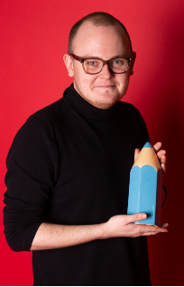  My new teacher is Mr Amos. | 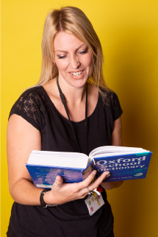  The teaching assistant in 3AA is Mrs Carter.
Other adults that work in year 3 are…
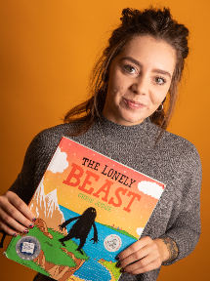
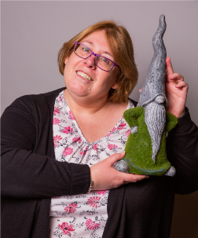
Mrs Pavey (yr 3 teacher) Miss Chilvers (year 3 TA)
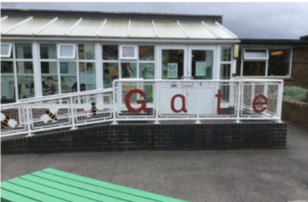  The door into school. | I will hang my coat here.  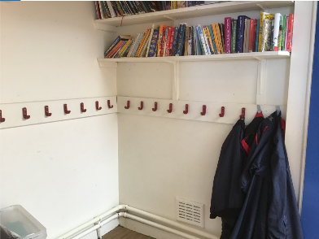
This is my new classroom.  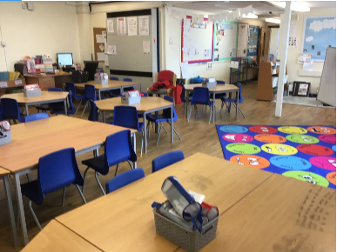 | This is my playground.  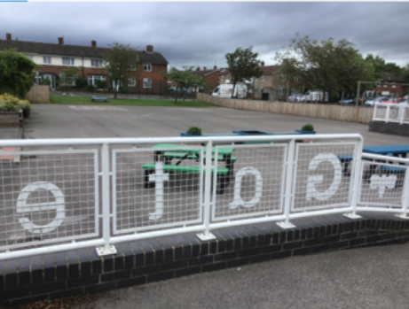
The school door opens at 8:45 am The end of the school day is 3:10 pm
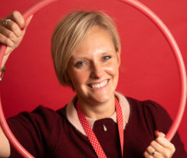

Mrs Galt- Principal Mrs Holloway – Vice Principal

