Welcome to Year 3
Your child is going to be in 3NP. We can’t wait to get to meet you!
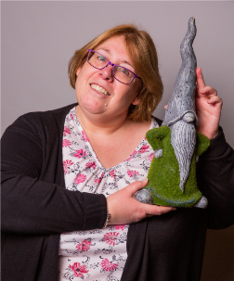  My new teacher is Mrs Pavey. | The teaching assistant in 3NP is Miss Chilvers.
Other adults that work in year 3 are…
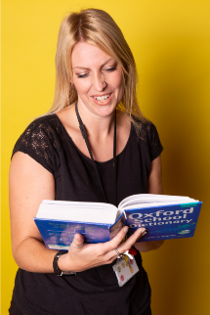
Mr Amos (yr 3 teacher) Mrs Carter (year 3 TA)
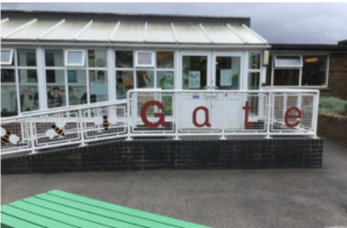  The door into school. | 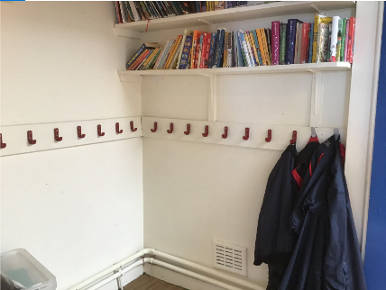  I will hang my coat here.
This is my new classroom.  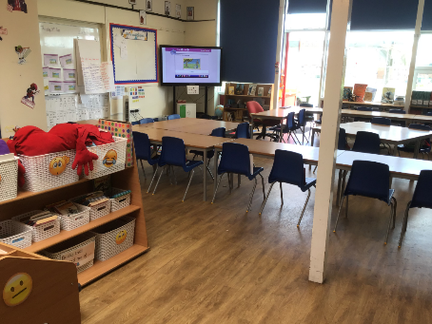 | This is my playground.  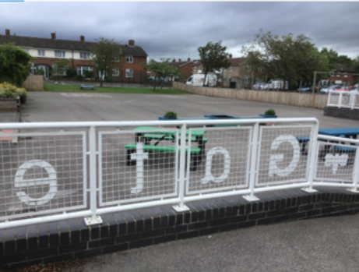
The school door opens at 8:45 am The end of the school day is 3:10 pm

Mrs Galt- Principal Mrs Holloway – Vice Principal

