VOCABULARY | SYMBOL | 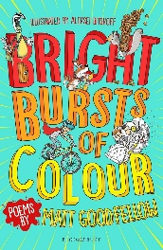  DEFINITION RELATED TO POETRY
poem |  | A poem is a piece of writing in which the words are chosen for their beauty and sound and are carefully arranged, often in short lines which sometimes rhyme.
timbre |  | Changing the tone of your voice to make a vowel sound stand out.  Vowels: a, e, i, o, u
tempo | 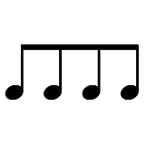 | The pace of the poem.
rhyme | 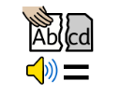 | Two words sound the same when spoken out loud.
rhythm |  | The beat and pace of a poem.
intonation | 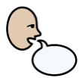 | The changing of tone in a person’s voice when saying particular words.
volume |  | How loudly or quietly you speak.
actions | 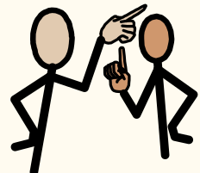 | How someone moves their body to match spoken words.
opposition | 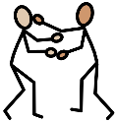 | Opposition is strong, angry, or violent disagreement and disapproval.
verse |  | A verse is one of the parts that a poem is  divided into.
free verse poem | 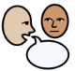 | A poem with no set rhyme or rhythm.
List poem | 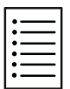 | A poem made up of a list of things.
narrator | 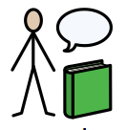 | The person who is telling the poem
character | 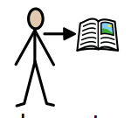 | The person that the poem is about
emotion | 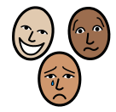 | An emotion is a feeling such as happiness, love, fear, anger, or hatred, which can be caused by the situation that you are in or the people you are with.
animated |  | If you are animated you are lively and showing your feelings
draft | 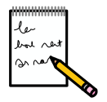 | To write the first version of your poem
edit | 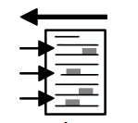 | Adapt and make changes to improve your poem
structure | 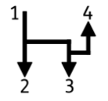 | The way that your poem is arranged into a pattern
publish | 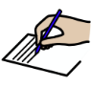 | To prepare and arrange a poem for the public to read.
perform | 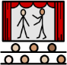 | If you perform a poem, you do it in front of an audience.

