Vocabulary Organiser
Rainfall | is the amount of rain that falls in a place during a particular period.
Weather | is the condition of the atmosphere in one area at a particular time, for example if it is raining, hot, or windy.
Seasons | are the main periods into which a year can be divided and which each have their own typical weather conditions.
United Kingdom | a small island made up of 4 countries including a small part of the next country.
Country | is a particular area that the world is divided up into. They have their own way of managing itself.
Features | something is an interesting or important part of a place.
Temperature | is a measure of how hot or cold it is.
Spring 1 Learning
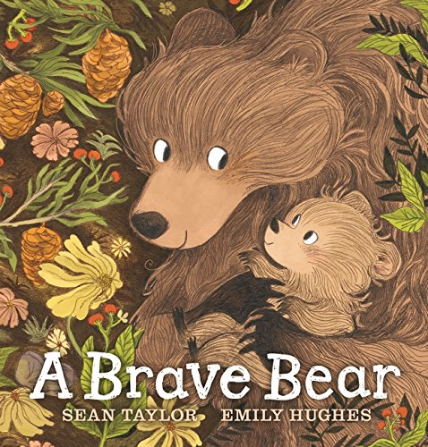
Synonyms
Using synonyms will help to expand your child’s vocabulary and allow them to experience new language! While reading The Brave Bear book I will expose the children to new words. Home challenge, see if you can use synonyms while talking to your child.
Book language | Synonym | Book language | Synonym
Hot | Boiling,  scorching | Slipped | Skidded, stumbled
Shade | Shadow, cover | Helped | Aided, supported
Pair | Two, team, couple | Sad | Gloomy, depressed
Probably | No doubt, likely | Hurting | Aching, stinging
Good | Fine, quality | Wait | Pause, linger
Idea | Plan, intention | Carry | Transport
Cool | Chill, refreshing | Decided | Certain, concluded
Quite | Totally, rather | Brave | Confident, fearless
Grassy | Lush, meadowy | Bravest | Heroic, boldest
Bushy | Thick, prickly | Splashed | Plunged, sloshed
Jump | Leap, bound | Cooled | Chilled
Jumpiest | Excited, skittish | Wet | Drenched, damp
Careful | Cautious, vigilant | Wettest | Soggiest, dampest
Small | Tiny, minute | Glowing | Flaming, gleaming
Big | Huge, considerable | Tomorrow | The future
During the next 5 weeks we will be looking at the British landscape. What it looks like, how do the seasons change it and the different weathers we experience during the 4 seasons. We will be looking at the physical features of our own environment in the town and how it compares to that of the countryside. We will be looking at a map of the United Kingdom, discussing the features of this map and labelling the 4 countries that are part of the United Kingdom.

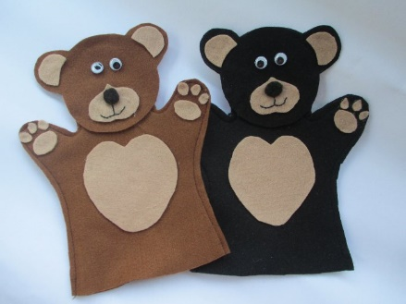
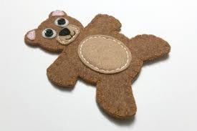
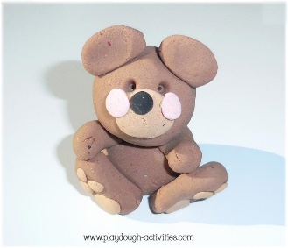
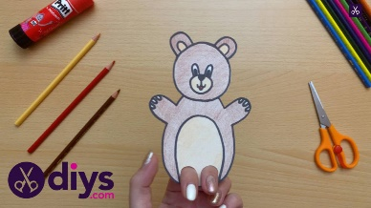
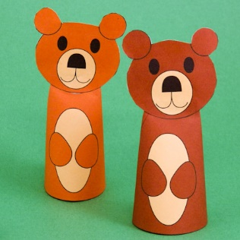
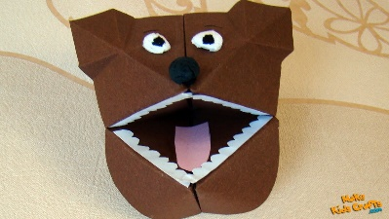
Home Learning
Challenge 2
Can you go on a seasonal walk in your local area? Look for different signs of winter (frost, ice, bare trees, snow, no flowers etc) and take a photo of what you can see. Post these pictures on Dojo so we can discuss as a class.

Home Learning
Challenge 1
Can you use what you have learnt in class to create your own bear puppet?
Please make your bear puppet and bring it in on Friday 5th February.
All the puppets will be judged and the best will win a prize.
Puppets can be made using craft materials, a sock puppet, paper plate or plasticine.

