English Vocabulary Organiser
poem | A poem is a piece of writing in which the words are chosen for their beauty and sound and are carefully arranged, often in short lines which sometimes rhyme.
rhythm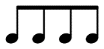 | The beat and pace of a poem.
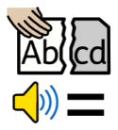  rhyme | Two words sound the same when spoken out loud.
visualisation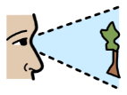 | Making mental pictures of things you read which change as the reading goes along.
perform | If you perform a poem, you do it in front of an audience.
poet 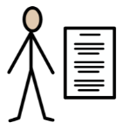 | A person who writes a poem.
illustrator 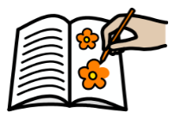 | A person who draws or creates pictures for book, magazines or advertising.
nouns 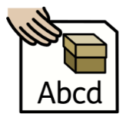 | The names of things, places, objects or person.
adjectives 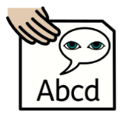 | An adjective describes a noun and gives it characteristics.
free verse | A poem with no set rhyme or rhythm.
alliteration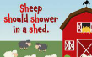 | The sound at the beginning of most words in a sentence is repeated.

