Reception Weekly Plan 13.7.20
Everyday your child must;
Daily work out:  Andy’s wild workout-Beach  https://www.youtube.com/watch?v=DqAOMrZkht0  P.E. with Joe |  | Practice their;  - Write my name  - Practise saying the letter names and sounds using the sound mat, “the name is…the sound is…”  - Practise saying the non- decodable words on the sound mat.  - Count from 0-20 then from 20-0.  - Practise handwriting one letter in your book.  - 10 minutes of reading.  - Listen to a story. | Sing the rhyme:  Sing and listen to the rhyme every day.  Under the Sea  https://www.youtube.com/watch?v=nQV7DKBqGdk |  | Discuss the Weather  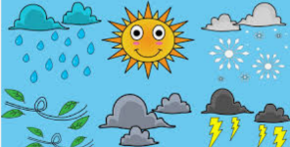  Discuss the weather and record on a daily weather chart- what is the temperature? Do we have to take any measures against the weather? (Sun lotion and a hat).
 | Phonics/ Maths |  |  | Power of Reading and Topic
Monday | Today is a phonics day  Phonics day 1 - Monday  Recap the air Trigraph.  https://www.youtube.com/watch?v=uZHKK9jnfFQ  https://www.youtube.com/watch?v=T3rWZYN5jno  Ask your child to write the words on their whiteboard. As an extra challenge, write a simple sentence using one or more of the words.  Complete the pages 14 and 15 in your phonics book.  Phonics follow-up activities will be available on your child’s Education City account and must be completed.  DfE daily phonics are showing live on YouTube at 10am. https://www.youtube.com/channel/UCP_FbjYUP_UtldV2K_-niWw |  |  | - Go back to the last two spreads in the book, where Dad releases the whale from the bucket. Ask the children why they think it took six hours, three fire engines, four cranes and a shoe horn to get the whale back into the bucket. As an accompanying text, ‘Is a Blue Whale the Biggest Thing There is?’ by Robert E Wells (https://www.youtube.com/watch?v=80FXUWXR3HI ) would be good to read at this point to put the size and scale of the whale in perspective. Do the children know anything that might be bigger than a blue whale? (29 metres long)
Tuesday | Today is a maths day  Maths day 1 – Tuesday – Weight  Can you find something heavy? Something lighter? Now, find something lighter than the other two objects. Put them in order and discuss the differences in weight.  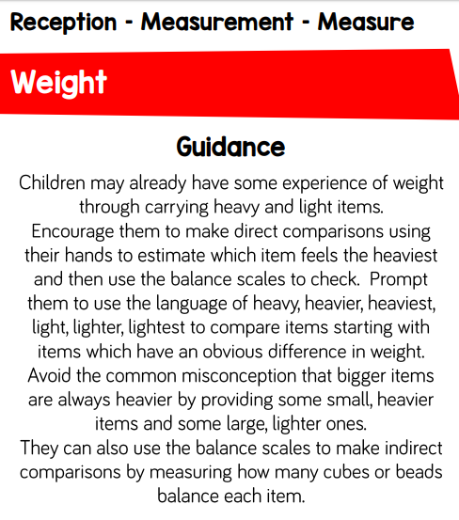  Complete pages 14, 15 and 16 in your Shape and Measure book.  Maths follow-up activities will be available on your child’s Education City account and must be completed. |  |  | Power of Reading / Topic  Show the children the video https://www.youtube.com/watch?v=pWvz0iHE9ko  Ask the children what they saw in the clip and encourage the children to describe what they saw in the video using extended adjectives.
Wednesday | Today is a phonics day  Phonics day 2 – Wednesday  Recap the ure Trigraph.  https://www.youtube.com/watch?v=g_2Oju8WKW4  https://www.youtube.com/watch?v=YwCzf71flBA  Ask your child to read the words and match them to the correct pictures. As an extra challenge, ask your child to write a sentence to match the picture  Complete the pages 14 and 15 in your phonics book.  Phonics follow-up activities will be available on your child’s Education City account and must be completed.  DfE daily phonics are showing live on YouTube at 10am. https://www.youtube.com/channel/UCP_FbjYUP_UtldV2K_-niWw |  |  | Show the children the video  https://www.youtube.com/watch?v=pWvz0iHE9ko  Provide the children with a variety of drawing materials and ask them to draw one animal they saw within the video.
Thursday | Today is a maths day  Maths day 2 – Thursday Weight  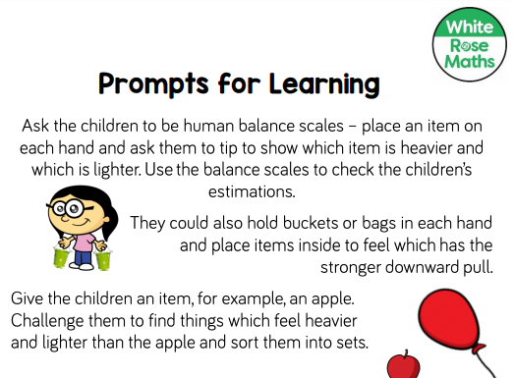  Complete pages book 14, 15 and 16 in your Shape and Measure book.  Maths follow-up activities will be available on your child’s Education City account and must be completed. |  |  | We are going on a virtual visit to aquarium!  Go to our website:  https://www.harrowgateacademy.org/year-groups/reception  and look for the Virtual Tours link. Choose from the various, exciting aquarium tours!
Friday | Today is a topic day  - Listen to the linked story told by Mrs Pybus. Video will be on the class story.  2. Listen to the questions asked by Mrs Pybus and discuss them with your child.  3. Today is the last opportunity to finish any tasks set on Education City to gain extra Dojo points.  4. Watch the video about saving sea creatures https://www.youtube.com/watch?v=hKFV9IquMXA  https://www.youtube.com/watch?v=hE9bDq1UZQA  Can you create a poster about saving the sea animals and keeping the seaside clean and safe.  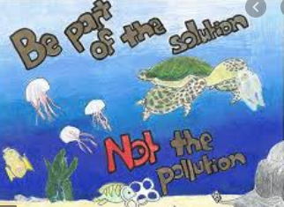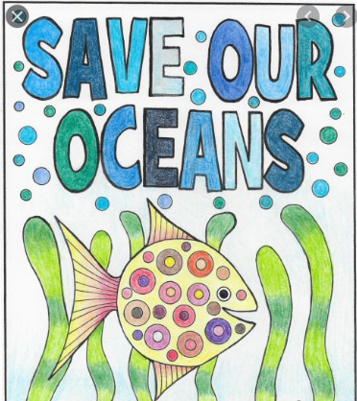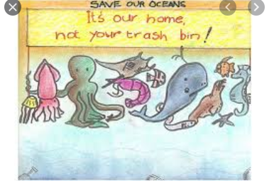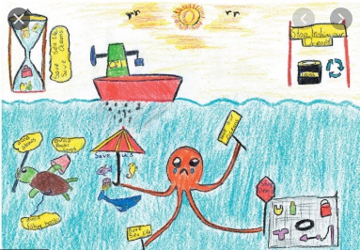
Play- dough challenge
Can you use your playdough to create one of the sea creatures from the story? This activity only needs to be done once over the week.
