Reception Weekly Plan 15.6.20
Everyday your child must;
Daily work out:  Cosmic Yoga – Norris the Baby Seahorse  https://www.youtube.com/watch?v=iFuobePKER8  P.E. with Joe |  | Practice their;  - Write my name  - Practise saying the letter names and sounds using the sound mat, “the name is…the sound is…”  - Practise saying the non- decodable words on the sound mat.  - Count from 0-20 then from 20-0.  - Practise handwriting one letter in your book.  - 10 minutes of reading.  - Listen to a story. | Sing the rhyme:  Sing and listen to the rhyme every day.  Row, Row, Row Your Boat  https://www.youtube.com/watch?v=K2lMJsfoEMw |  | Discuss the Weather  Discuss the weather and record on a daily weather chart- what is the temperature? Do we have to take any measures against the weather? (Sun lotion and a hat).
 | Phonics/ Maths |  |  | Power of Reading and Topic
Monday | Today is a phonics day  Phonics day 1 - Monday  Watch the video https://www.youtube.com/watch?v=uyee7EKTdo4  Ask your child to read and write the words on their whiteboard. As an extra challenge, write a simple sentence using one or more of the words.  Complete the pages 4 and 5 in your new phonics book.  Phonics follow-up activities will be available on your child’s Education City account and must be completed.  DfE daily phonics are showing live on YouTube at 10am. https://www.youtube.com/channel/UCP_FbjYUP_UtldV2K_-niWw |  |  | - Discuss how Billy asks for his bucket using “Please can I have...”.  Talk about how this is a good way to ask for a present and demonstrates good manners. What is the difference between saying “Please can I have...” and “I want”?  - This week’s English writing challenge is to discuss and write what would be in your bucket and why?
Creative Activity
- Look at the images of rock pools. Can the children name the different features? Research rock pool features and scientific vocabulary used for those features.
Using your paints or coloured pencils, draw and label a rock pool.
This activity only needs to be done once over the week.
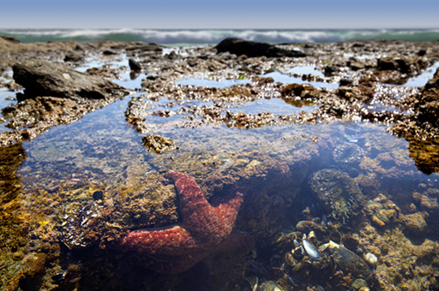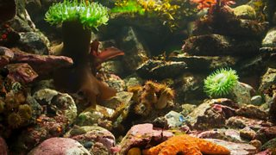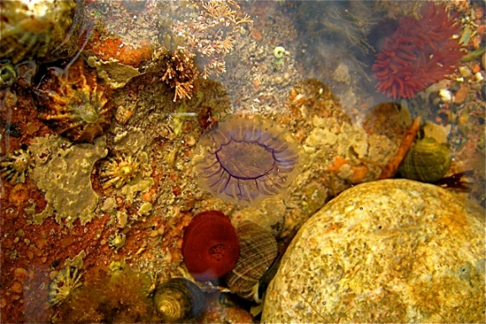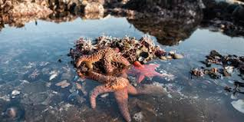
Play- dough challenge
Can you use your playdough to make a starfish?
This activity only needs to be done once over the week.
Tuesday | Today is a maths day  Maths day 1 – Tuesday - Pattern  NumberBlocks Pattern Palace https://www.youtube.com/watch?v=bT7282PUKnY  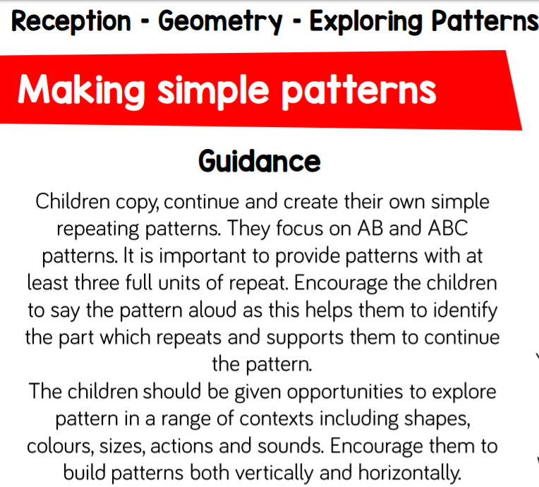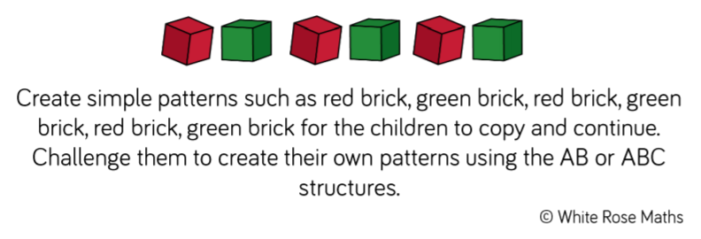  What objects can you use to make a repeating pattern? Send your patterns on Dojo!  Complete the pages 20 and 21 in your Shape and Measure maths book.  Maths follow-up activities will be available on your child’s Education City account and must be completed. |  |  | Power of Reading / Topic  - We will read the story up to a point. After watching the video, discuss the different types of buckets that Billy has looked at. What might you see on a farm bucket? A football bucket? Ask the children what kind of bucket they would have if they could choose a bucket. Draw out and support children in using descriptive vocabulary in visualising and describing their bucket.  - This week’s English writing challenge is to discuss and write what would be in your bucket and why?
Wednesday | Today is a phonics day  Phonics day 2 - Wednesday  Watch the video https://www.youtube.com/watch?v=eCVcdFN-Ov0  Ask your child to read and write the words on their whiteboard. As an extra challenge, write a simple sentence using one or more of the words.  Phonics follow-up activities will be available on your child’s Education City account and must be completed.  DfE daily phonics are showing live on YouTube at 10am. https://www.youtube.com/channel/UCP_FbjYUP_UtldV2K_-niWw |  |  | 1. Draw a template of a bucket and the children can use any writing material to decorate their bucket however they feel necessary. Ask your child to explain why they have decorated their buckets the way they have. Adults to write reasons why and send via Dojo.  - This week’s English writing challenge is to discuss and write what would be in your bucket and why?
Thursday | Today is a maths day  Maths day 2 – Thursday Pattern  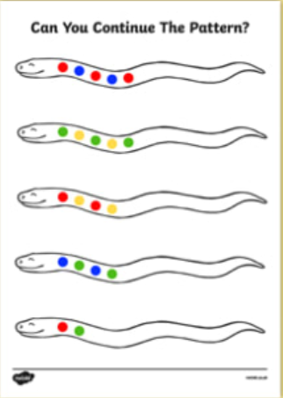Draw a template for a sea snake in your child’s book. Using their paints or coloured pencils, ask them to choose two colours to make a repeating pattern on the snake. Then, draw another and challenge them to use three colours or shapes, such as square, circle, triangle, square, circle, and triangle.  Maths follow-up activities will be available on your child’s Education City account and must be completed. |  |  | - We will post a photo of the page when Billy peers into his bucket and sees a rock pool.  Have the children ever seen a rock pool before? Have the children ever been rock pooling when they have been to the beach. https://www.youtube.com/watch?v=o2dAISu4IfY  Show the children the video of a rock pool and include- crab, hermit crab, small fish, limpits, cockles and star fish. Encourage the children to name the different creatures they can see. Work with the children to name the other creatures.  - This week’s English writing challenge is to discuss and write what would be in your bucket and why?
Friday | Today is a topic day  - Listen to the linked story told by Miss Clough. Video will be on the class story.  2. Listen to the questions asked by Miss Clough and discuss them with your child.  3. Today is the last opportunity to finish any tasks set on Education City to gain extra Dojo points.  4. Look at the images of rock pools. Can the children name the different features? Research rock pool features and scientific vocabulary used for those features.  Using your paints or coloured pencils draw and label a rock pool.  