Reception Weekly Plan 22.6.20
Everyday your child must;
Daily work out:  Cosmic Yoga – Popcorn the dolphin  https://www.youtube.com/watch?v=YR1OxBk8BF4  P.E. with Joe |  | Practice their;  - Write my name  - Practise saying the letter names and sounds using the sound mat, “the name is…the sound is…”  - Practise saying the non- decodable words on the sound mat.  - Count from 0-20 then from 20-0.  - Practise handwriting one letter in your book.  - 10 minutes of reading.  - Listen to a story. | Sing the rhyme:  Sing and listen to the rhyme every day.  I do like to be beside the seaside  https://www.youtube.com/watch?v=W8fhEPSLmfo |  | Discuss the Weather  Discuss the weather and record on a daily weather chart- what is the temperature? Do we have to take any measures against the weather? (Sun lotion and a hat).
 | Phonics/ Maths |  |  | Power of Reading and Topic
Monday | Today is a phonics day  Phonics day 1 - Monday  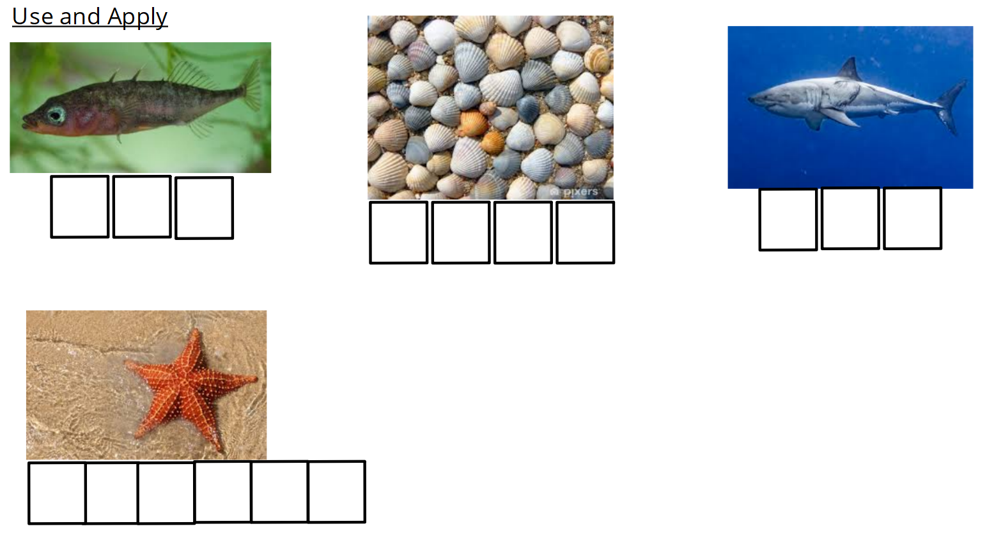  Ask your child to write the words on their whiteboard. As an extra challenge, write a simple sentence using one or more of the words.  Complete the pages 6 and 7 in your new phonics book.  Phonics follow-up activities will be available on your child’s Education City account and must be completed.  DfE daily phonics are showing live on YouTube at 10am. https://www.youtube.com/channel/UCP_FbjYUP_UtldV2K_-niWw |  |  | - I read the story up to a certain point. After watching the video discuss the different animals that Billy saw in his bucket. Can you name the different animals you can see and try and write some of the names of the animals.  - This week’s English writing challenge is to create a list of the creatures that Billy saw in his bucket and use adjectives to describe them e.g an orange and spiky starfish.
Tuesday | Today is a maths day  Maths day 1 – Tuesday – Odd and Even numbers  NumberBlocks Odds and Evens https://www.youtube.com/watch?v=E3uxBI9npas  https://www.youtube.com/watch?v=-kHtGbnYKGc  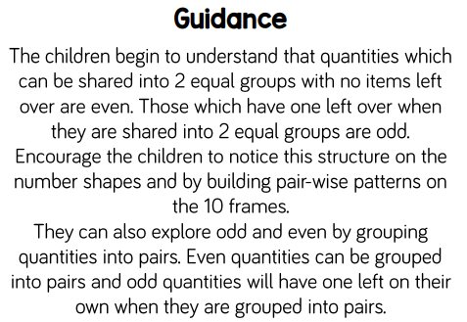  Using the numbers you used to order numbers to 20 can you use them and sort the number cards by odd and even numbers?  Complete the pages 16 and 17 in your new adding and subtracting maths book.  Maths follow-up activities will be available on your child’s Education City account and must be completed. |  |  | Power of Reading / Topic  - Watch the video https://www.youtube.com/watch?v=9kj_vwleR6Q  Discuss with the children the different creatures they could see in the video. How many of the creatures can you name?  - This week’s English writing challenge is to create a list of the creatures that Billy saw in his bucket and use adjectives to describe them e.g an orange and spiky starfish.
Wednesday | Today is a phonics day  Phonics day 2 – Wednesday  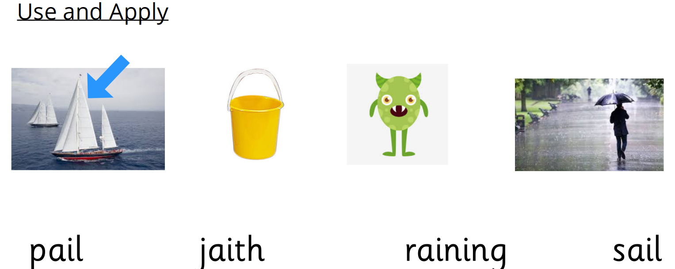  Ask your child to read the words and match them to the correct pictures. As an extra challenge, ask your child to write a sentence to match the picture  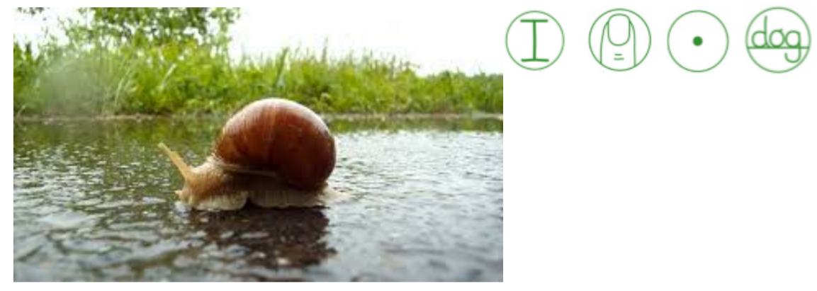  Phonics follow-up activities will be available on your child’s Education City account and must be completed.  Complete the pages 6 and 7 in your new phonics book.  DfE daily phonics are showing live on YouTube at 10am. https://www.youtube.com/channel/UCP_FbjYUP_UtldV2K_-niWw |  |  | - Looking back at all the creatures Billy has found in his bucket discuss with the children where in the world they think these creatures would be found. 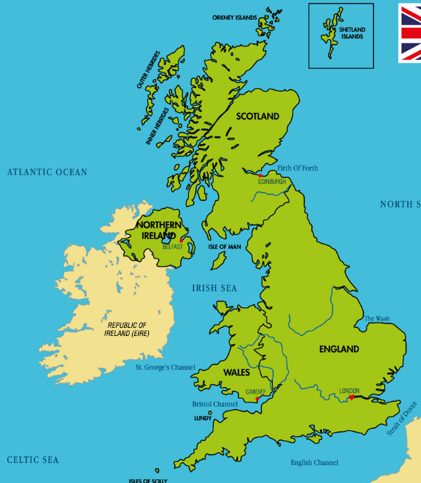  Using the map, can the children remember what the blue parts of the map are called? Using Google can you research which of the creatures from Billy’s Bucket would be found in the North Sea. Can you draw which other creatures you might find in the North Sea?  - This week’s English writing challenge is to create a list of the creatures that Billy saw in his bucket and use adjectives to describe them e.g an orange and spiky starfish.
Thursday | Today is a maths day  Maths day 2 – Thursday Odd and Even numbers  Using 2 teddy bears, 2 plates, and a selection of objects to share. Give the children selection of the items and share them between the 2 plates. Give the children 3, 4, 5, 6, 7, 8, 9 and 10 items. Ask the children to share the items and identify which of the number of items are odd and which are even.  Complete the pages 16 and 17 in your new adding and subtracting maths book.  Maths follow-up activities will be available on your child’s Education City account and must be completed. |  |  | - Watch the video https://www.youtube.com/watch?v=94whXVtZAQg  Discuss which animals you can name. Can you see any sea creatures here that Billy found inside his bucket?  - This week’s English writing challenge is to create a list of the creatures that Billy saw in his bucket and use adjectives to describe them e.g an orange and spiky starfish.
Friday | Today is a topic day  - Listen to the linked story told by Mrs Pybus. Video will be on the class story.  2. Listen to the questions asked by Miss Clough and discuss them with your child.  3. Today is the last opportunity to finish any tasks set on Education City to gain extra Dojo points.  4. Look at some of the creatures that Billy found inside his bucket. Can you make a list of the creatures you would find in the North Sea and those that are found elsewhere?  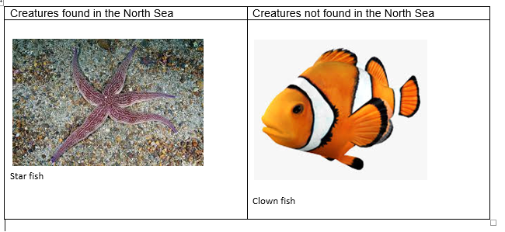
Creative Activity
- Look at the images of rock pools. Can the children name the different features?
Using your paints or coloured pencils draw and label a list of creatures you would find in a rock pool.

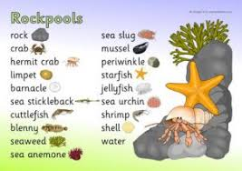
This activity only needs to be done once over the week.

Play- dough challenge
Can you use your playdough to create one of the creatures you would find in a rock pool? You might need to use Google to help you find a different creature.
This activity only needs to be done once over the week.

