Reception Weekly Plan 29.6.20
Everyday your child must;
Daily work out:  Cosmic Yoga – Nibs the octopus  https://www.youtube.com/watch?v=hUBRoLRioiY  P.E. with Joe |  | Practice their;  - Write my name  - Practise saying the letter names and sounds using the sound mat, “the name is…the sound is…”  - Practise saying the non- decodable words on the sound mat.  - Count from 0-20 then from 20-0.  - Practise handwriting one letter in your book.  - 10 minutes of reading.  - Listen to a story. | Sing the rhyme:  Sing and listen to the rhyme every day.  Five Little Fish went swimming  https://www.youtube.com/watch?v=Z3q7r8fUy48 |  | Discuss the Weather  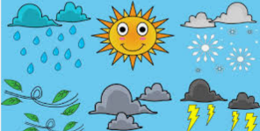  Discuss the weather and record on a daily weather chart- what is the temperature? Do we have to take any measures against the weather? (Sun lotion and a hat).
 | Phonics/ Maths |  |  | Power of Reading and Topic
Monday | Today is a phonics day  Phonics day 1 - Monday  Recap the ur digraph.  https://www.youtube.com/watch?v=9354FVIi0nM  Ask your child to write the words on their whiteboard. As an extra challenge, write a simple sentence using one or more of the words.  Complete the pages 10 and 11 in your phonics book.  Phonics follow-up activities will be available on your child’s Education City account and must be completed.  DfE daily phonics are showing live on YouTube at 10am. https://www.youtube.com/channel/UCP_FbjYUP_UtldV2K_-niWw |  |  | - I will post a picture of our local coastline. Ask the children to point out and name sand, sea, waves, boats, cliffs, rocks, rock pools and a lighthouse. Ask the children to name some of the beaches local to us they have visited.  - This week’s English writing challenge is to create a list of the things we could do to save the sea creatures in the North Sea. Watch the video to help with ideas https://www.youtube.com/watch?v=i1_37YGzXrc
Tuesday | Today is a maths day  Maths day 1 – Tuesday – Length  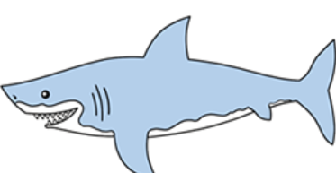  Find 3 objects of varying lengths. Which one is the longest? Shortest? Can you put them in order of length?  In your maths book, draw and colour 3 lengths of squares in order.  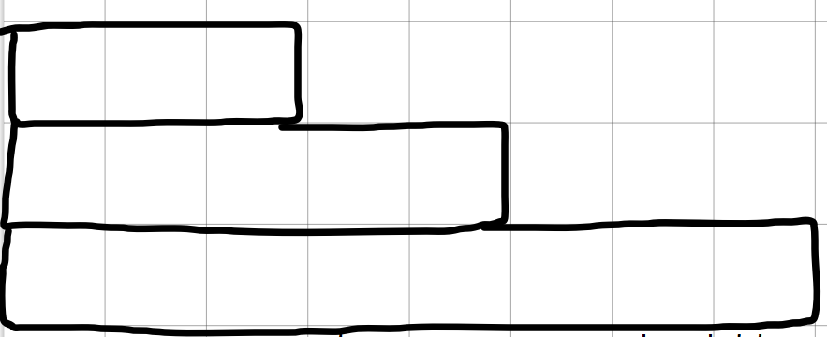  Complete pages 12 and 13 of the Space and Measure book.  Maths follow-up activities will be available on your child’s Education City account and must be completed. |  |  | Power of Reading / Topic  - Look at the picture of Billy looking inside his bucket. Using your own imagination, draw a picture of what would be inside your bucket. Would you see the same things? Would you see something different? Can you label what you would see?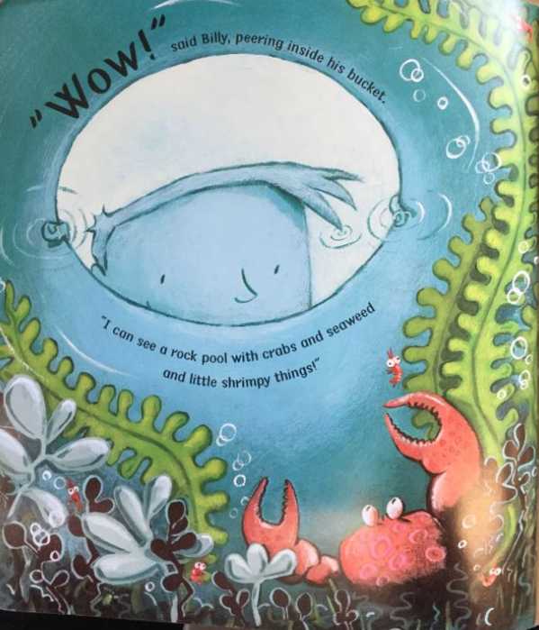  - This week’s English writing challenge is to create a list of the things we could do to save the sea creatures in the North Sea. Watch the video to help with ideas https://www.youtube.com/watch?v=i1_37YGzXrc
Wednesday | Today is a phonics day  Phonics day 2 – Wednesday  Recap the ow digraph.  https://www.youtube.com/watch?v=8UQ_Mls4qa0  https://www.youtube.com/watch?v=9Ph6nnHrVwY  Ask your child to read the words and match them to the correct pictures. As an extra challenge, ask your child to write a sentence to match the picture  Phonics follow-up activities will be available on your child’s Education City account and must be completed.  DfE daily phonics are showing live on YouTube at 10am. https://www.youtube.com/channel/UCP_FbjYUP_UtldV2K_-niWw |  |  | - Provide the children with their paint palette and paper. Listen to ocean sounds and ask the children to create their own illustration that represents the sea/ocean.  https://www.youtube.com/watch?v=qTv8lRXM6Tw  - This week’s English writing challenge is to create a list of the things we could do to save the sea creatures in the North Sea. Watch the video to help with ideas https://www.youtube.com/watch?v=i1_37YGzXrc
Thursday | Today is a maths day  Maths day 2 – Thursday Height  Today we are looking at height. Who is the tallest person in your house? Who is the shortest? How tall has your sunflower grown? Is it taller than you are? Shorter than you? Can you find 3 objects of different heights and order them, starting with the shortest.  In your maths book, draw 3 sunflowers in order of height.  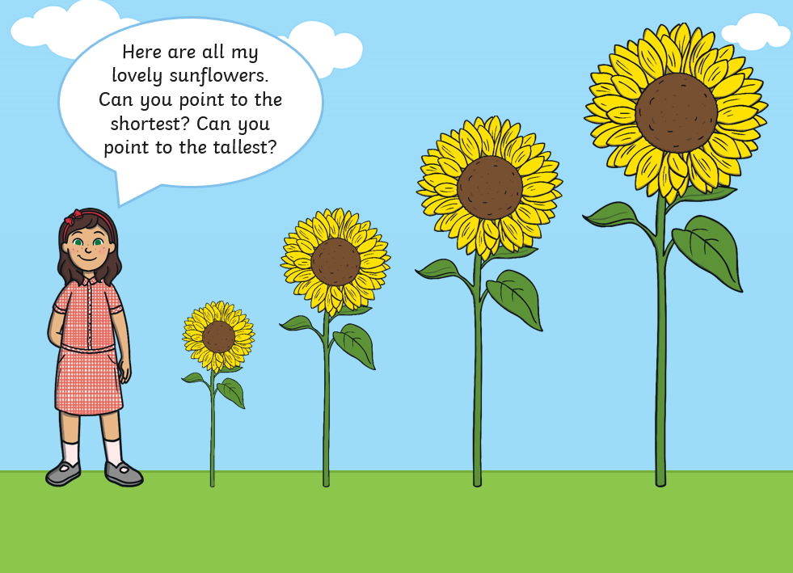  Maths follow-up activities will be available on your child’s Education City account and must be completed. |  |  | - Listen to the poem https://www.youtube.com/watch?v=wLyk9cMvNV8 How does the poem make you feel? What can you see and imagine when you listen to it? Can you draw one of the things you think about when you listen to the poem?  - This week’s English writing challenge is to create a list of the things we could do to save the sea creatures in the North Sea. Watch the video to help with ideas https://www.youtube.com/watch?v=i1_37YGzXrc
Friday | Today is a topic day  - Listen to the linked story told by Mrs Pybus. Video will be on the class story.  2. Listen to the questions asked by Mrs Pybus and discuss them with your child.  3. Today is the last opportunity to finish any tasks set on Education City to gain extra Dojo points.  4. Look at the picture and label the picture using the labels.  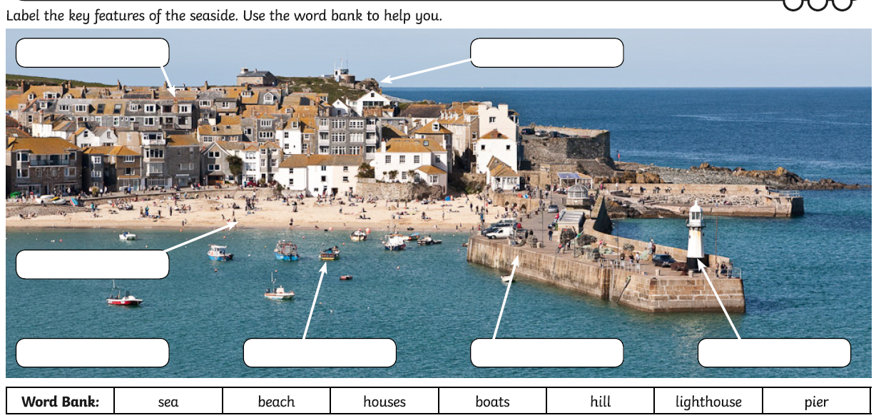
Creative Activity
- Listen to the ocean sounds using https://www.youtube.com/watch?v=uUU_BkBBAZ0 Can you create a picture of what you think you can hear using your paints of your coloured pencils?
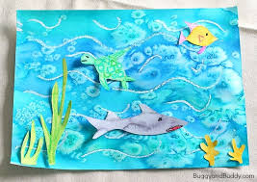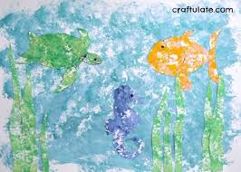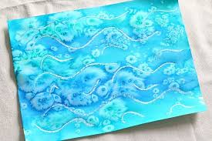
This activity only needs to be done once over the week.

Play- dough challenge
Can you use your playdough to create a shell from the beach? This activity only needs to be done once over the week.
