Reception Weekly Plan 6.7.20
Everyday your child must;
Daily work out:  Andy’s wild workout-Under the sea  https://www.youtube.com/watch?v=TCrFUD98U_Q  P.E. with Joe |  | Practice their;  - Write my name  - Practise saying the letter names and sounds using the sound mat, “the name is…the sound is…”  - Practise saying the non- decodable words on the sound mat.  - Count from 0-20 then from 20-0.  - Practise handwriting one letter in your book.  - 10 minutes of reading.  - Listen to a story. | Sing the rhyme:  Sing and listen to the rhyme every day.  A pirate went to sea  https://www.youtube.com/watch?v=YOA3he2Gv4M |  | Discuss the Weather  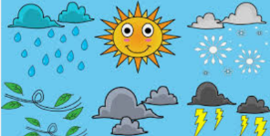  Discuss the weather and record on a daily weather chart- what is the temperature? Do we have to take any measures against the weather? (Sun lotion and a hat).
 | Phonics/ Maths |  |  | Power of Reading and Topic
Monday | Today is a phonics day  Phonics day 1 - Monday  Recap the oi digraph.  https://www.youtube.com/watch?v=Z-0wWdE-Ezg  https://www.youtube.com/watch?v=EMdtke9HZVE  Ask your child to write the words on their whiteboard. As an extra challenge, write a simple sentence using one or more of the words.  Complete the pages 12 and 13 in your phonics book.  Phonics follow-up activities will be available on your child’s Education City account and must be completed.  DfE daily phonics are showing live on YouTube at 10am. https://www.youtube.com/channel/UCP_FbjYUP_UtldV2K_-niWw |  |  | - I will be reading the story of Billy’s Bucket all the way through to the end. What did you like about the story? Why? What did you dislike about the story? Why? Was it a good ending? Why? Was there anything that puzzled you about the story?  - This week’s English writing challenge is to listen to the story of Billy’s Bucket and create a story map of what happened from the start to the finish. The children have created story maps previously but we will post a picture of an example to help and guide the children. The children can use their sketchbooks and pencils to help to create this.
Tuesday | Today is a maths day  Maths day 1 – Tuesday – Capacity  Using 3 different containers with an adults help can you order them using water so one is empty, one is half-full and one is full.  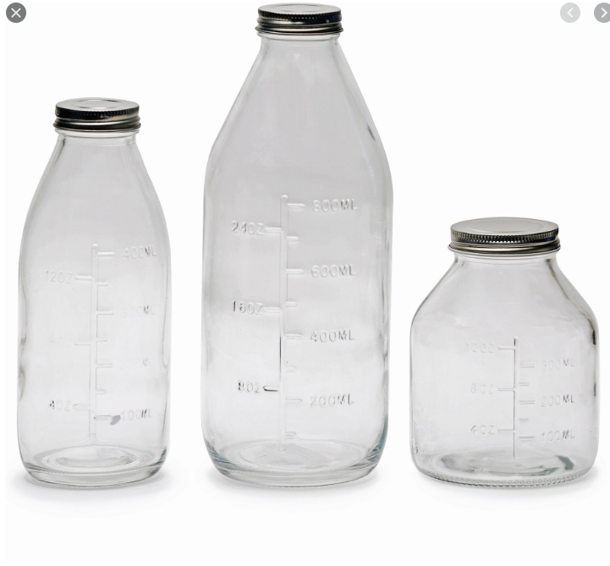  Complete pages 17, 18, and 19 of the Space and Measure book.  Maths follow-up activities will be available on your child’s Education City account and must be completed. |  |  | Power of Reading / Topic  - Using you story map from yesterday can you add key words and speech bubbles to explain what is happening in each part of the story.  - This week’s English writing challenge is to listen to the story of Billy’s Bucket and create a story map of what happened from the start to the finish. The children have created story maps previously but we will post a picture of an example to help and guide the children. The children can use their sketchbooks and pencils to help to create this.
Wednesday | Today is a phonics day  Phonics day 2 – Wednesday  Recap the ear digraph.  https://www.youtube.com/watch?v=4JSwmP61nXo  https://www.youtube.com/watch?v=6-EJF4A-sO0  Ask your child to read the words and match them to the correct pictures. As an extra challenge, ask your child to write a sentence to match the picture  Complete the pages 12 and 13 in your phonics book.  Phonics follow-up activities will be available on your child’s Education City account and must be completed.  DfE daily phonics are showing live on YouTube at 10am. https://www.youtube.com/channel/UCP_FbjYUP_UtldV2K_-niWw |  |  | - Look at the pages  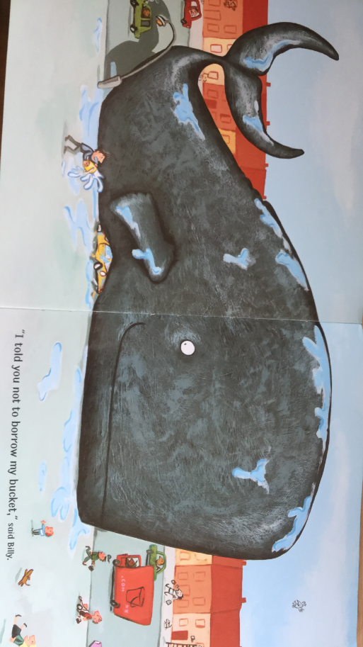  Why do you think it took six hours, three fire engines, four cranes and a shoe horn to get the whale back into the bucket? Do you know anything that is bigger than a blue whale (29 metres long)? Can you draw something that is bigger than a blue whale?  - This week’s English writing challenge is to listen to the story of Billy’s Bucket and create a story map of what happened from the start to the finish. The children have created story maps previously but we will post a picture of an example to help and guide the children. The children can use their sketchbooks and pencils to help to create this.
Thursday | Today is a maths day  Maths day 2 – Thursday Capacity  Working with an adult can you  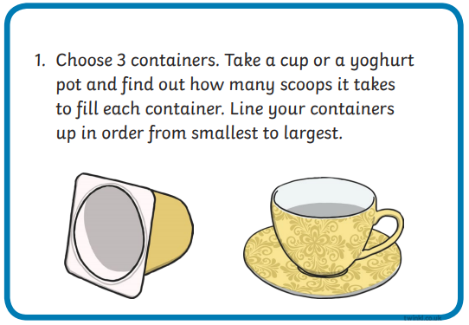  Complete pages 17, 18, and 19 of the Space and Measure book.  Maths follow-up activities will be available on your child’s Education City account and must be completed. |  |  | - Using your chalks in your home learning pack, can you draw on the pavement outside and label some of the sea creatures from the story making sure that the blue whale is the biggest you draw.  - This week’s English writing challenge is to listen to the story of Billy’s Bucket and create a story map of what happened from the start to the finish. The children have created story maps previously but we will post a picture of an example to help and guide the children. The children can use their sketchbooks and pencils to help to create this.
Friday | Today is a topic day  - Listen to the linked story told by Miss Clough. Video will be on the class story.  2. Listen to the questions asked by Miss Clough and discuss them with your child.  3. Today is the last opportunity to finish any tasks set on Education City to gain extra Dojo points.  4. Watch the video about a life cycle of a fish https://www.youtube.com/watch?v=nYZzqZPnzPA  Use the next video to draw your own life cycle of a fish https://www.youtube.com/watch?v=Yv43WYiEcS8  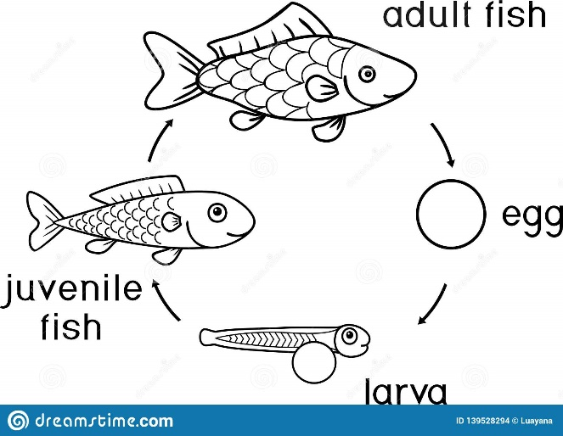
Creative Activity
- Using a cardboard box and your art materials (paint, glue, scissors, coloured pens and pencils and art paper) can you make a cardboard box aquarium? You could watch the video https://www.youtube.com/watch?v=XdEfXhBTp9Q to help.
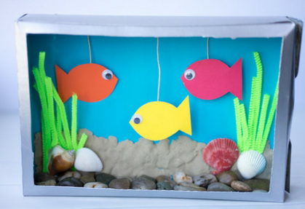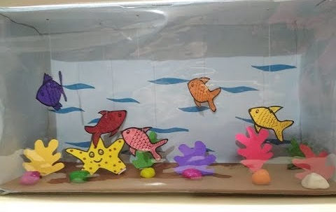
This activity only needs to be done once over the week.

Play- dough challenge
Can you use your playdough to create one of the sea creatures from the story? This activity only needs to be done once over the week.
