Vocabulary
Scientist | Someone whose job it is to teach or do research in science.
Scientific question | A question that may lead to a hypothesis and help us in answering (or figuring out) the reason for some observations.
Hypothesis | Is an idea which suggests a possible explanation for a particular situation or condition, but which has not yet been proved or correct.
Comparative test | A test that compares the effect of different actions or the characteristics of a different material.
Prediction | To say that something will/might happen.
Findings | To learn the facts about something.
Data | Information in the form of facts or numbers.
Question | To ask someone about something.
Grouping and classifying | Putting things that have something in common in a group.
Test | A test is a deliberate action or experiment to find out how well something works.
Observation | To watch something carefully to learn about it.
Absorb | To take in a substance.
Material | A solid substance, for example a cloth.
dissolve | To become completely mixed with a liquid.

Key Diagrams
Key Information
1 | Carrying out a simple comparative test – Is our sense of smell better when we can’t see?  - Lemon  - Mint
2 | Observing changes over time –  Skittles in Water  Skittles are coated in food colouring and sugar. When you pout water over the skittles the coloured coating dissolves spreading through the water.
3 | Group and classify  Sorting liquorice allsorts in a variety of different ways.  How can they be grouped? How many different ways can they be group?
4 | Comparative Test  Which materials are the most absorbent?  Conduct an experiment with materials, finding out which is the most absorbent.

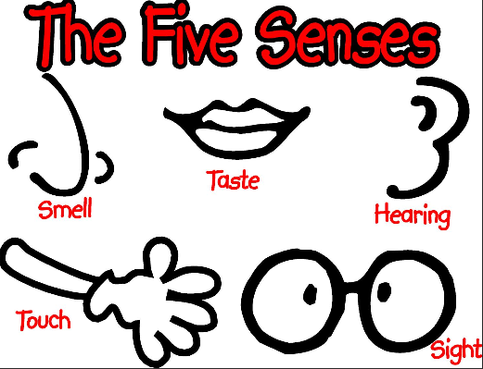

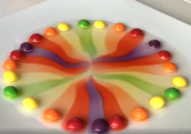
Observing changes over time Skittles in Water

