basement | 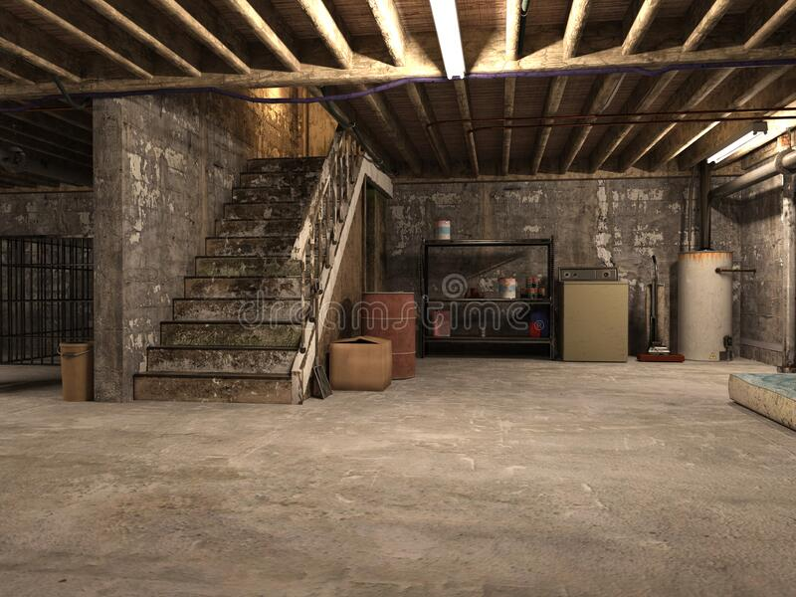 | The floor of a building, which is partly or entirely below ground level.
afraid |  | Worried that something unpleasant may happen.  Can you show me your afraid face?
creaky | 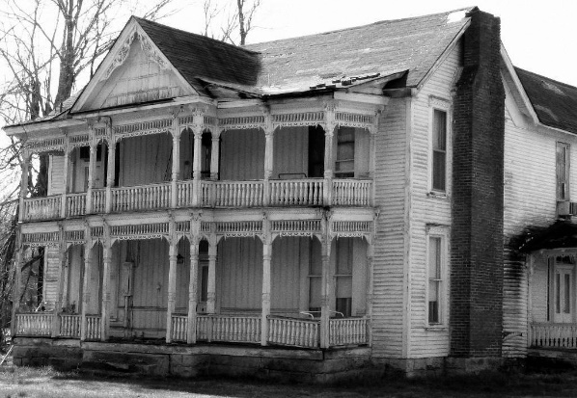 | To make a creaking sound when being moved.

