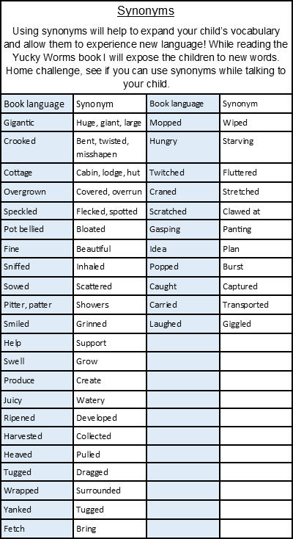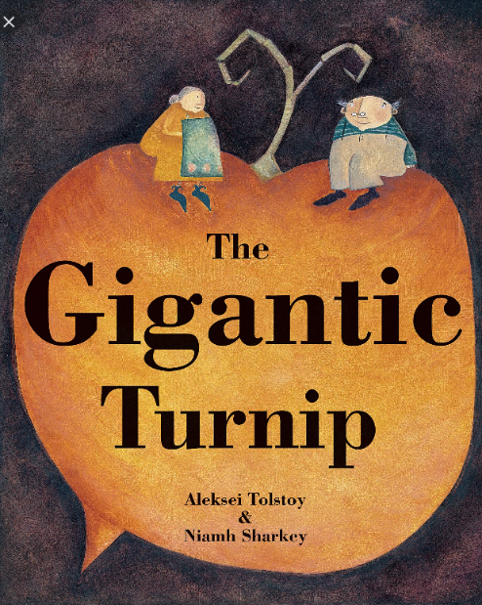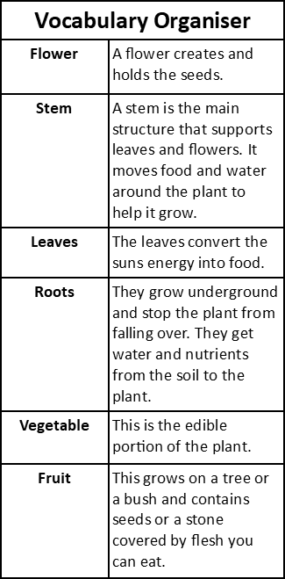

During this half term we will be spending 5 weeks finding out how we can help our environment. We will be looking closely at the plants that grow in our immediate environment like the garden or local green, the differences between vegetables and fruits, what plants need to grow, the different parts of a plant and the life cycle of a plant.