Dear parents/guardians,

Year 6 SATs – Important Information for Parents

What Are SATs?

SATs (Standard Assessment Tests) are taken at the end of Year 6 to assess your child’s progress in English and maths. The tests are marked externally, and results are available before your child finishes primary school in July.

SATs Test Dates

Monday, May 11th – English Grammar, Punctuation & Spelling
Tuesday, May 12th – English Reading
Wednesday, May 13th – Maths Paper 1 (Arithmetic) & Paper 2 (Reasoning)
Thursday, May 14th – Maths Paper 3 (Reasoning)

What’s in the Tests?

English Grammar, Punctuation & Spelling
45-minute grammar and punctuation paper
Type of questions include:
- short-answer questions
- Identify words (e.g., adjectives in a sentence)
- Correct or rewrite sentences

15-minute spelling test – 20 words.

English Reading
One-hour test with three passages of text which increase in length.
Types of questions include:
- Ordering events in a story.
- Finding and copying words.
- Short-answer and open-ended questions.
Children need strong reading stamina to successfully complete this paper, and we are incorporating strategies into our teaching to help them further develop this skill

Maths
Paper 1 (Arithmetic, 30 minutes) – Focuses on calculations, including long multiplication and division.
Paper 2 (Reasoning, 40 minutes) – Problem-solving and logical thinking.
Paper 3 (Reasoning, 40 minutes) – More problem-solving tasks.
Types of questions include:
- Multiple choice, true/false, completing charts.
- Explaining how they solved a problem.

How Can You Help Your Child?

- Practice spellings and times tables daily.
- Encourage reading for at least 20 minutes a day to build stamina.
- Use online resources like:
  - Times Table Rockstars
  - MathsBot
  - Spelling Shed
- Support with revision guides
- Ensure good sleeping habits

By helping your child prepare, you can boost their confidence and reduce stress before SATs.

Below are examples of questions the children will have in their tests.

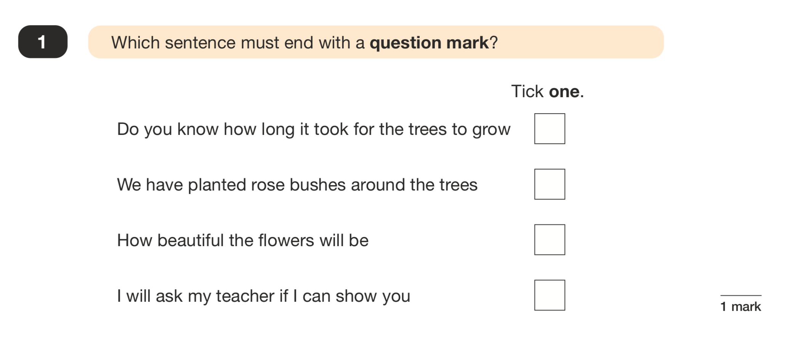
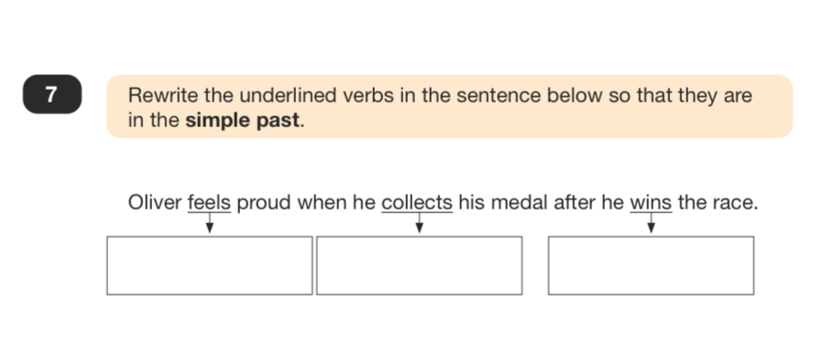
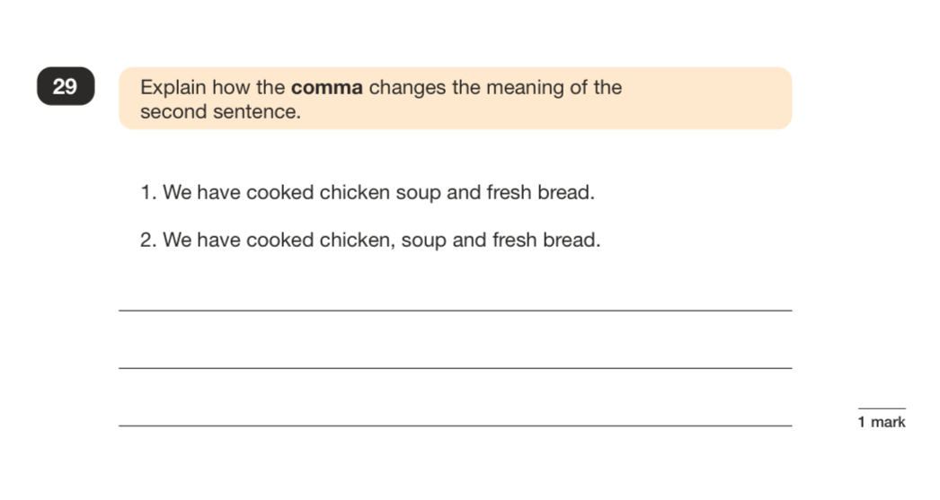

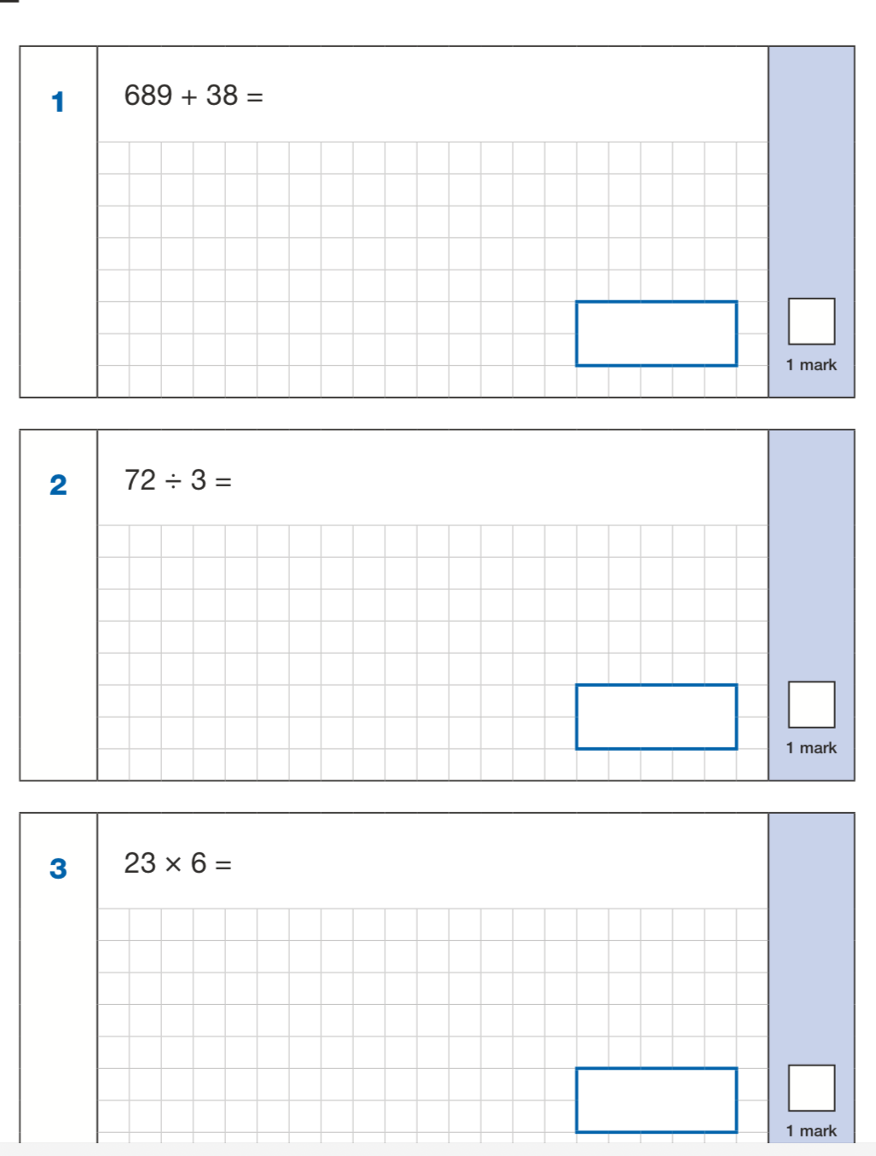
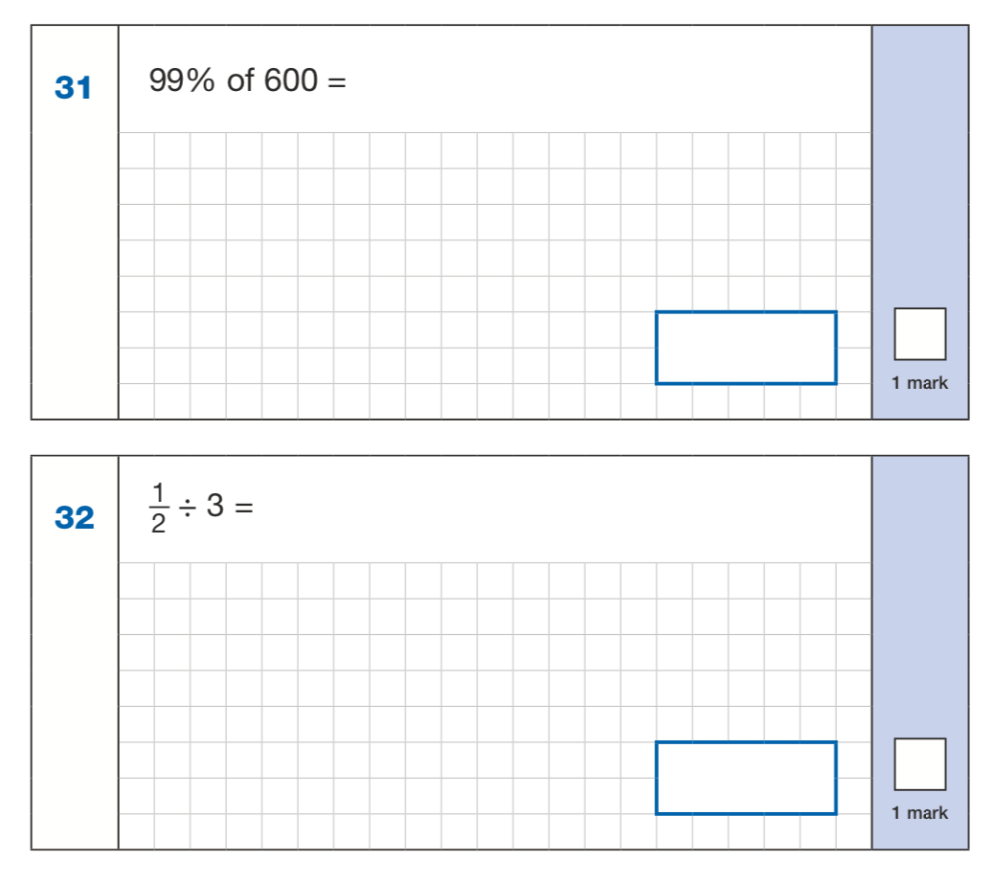
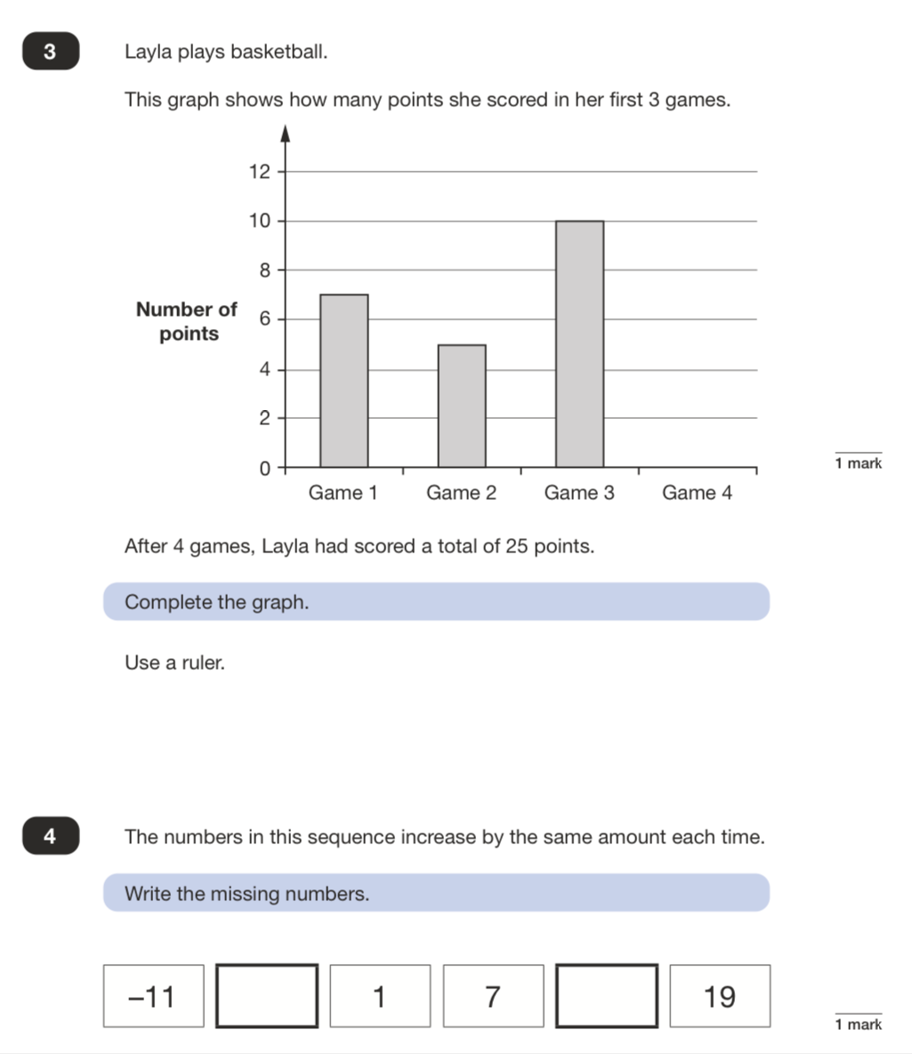
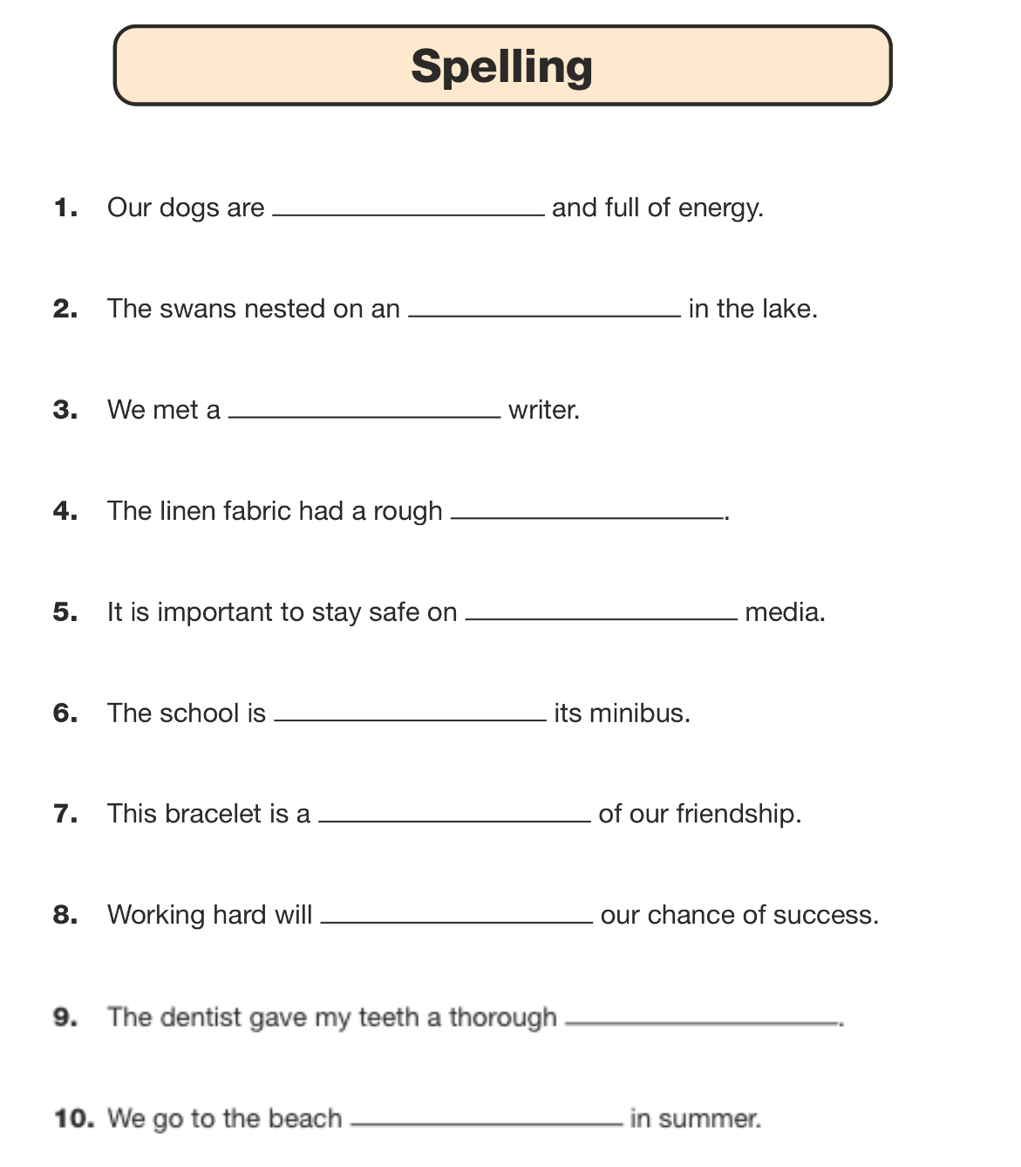
These are examples of:

First half of the spelling text
Questions from the arithmetic paper
Questions from the reasoning paper.

Below is a list of high frequency words that the children have learnt from year 3 – 6. Encourage your children to read them, practice spelling them and ensure they understand what they mean.

