Newsletter No. 08 13th November 2020

Dear Parents and Carers

Thank you for all your support with Children in Need today, the children have a raised awareness of this special cause and taken part in fun activities. There is still time to make your donation using the following link so if you have something to spare please remember it is for a very worthy cause, particulary during these difficult times https://app.parentpay.com/ParentPayShop/Foc/Default.aspx?shopid=1716.

Next Friday (20th November), we will be asking the children to come into school wearing odd socks to coincide with Anti-Bullying week. We are asking the children to wear odd socks as an opportunity to encourage our school community to express themselves and celebrate their individuality and what makes them all unique. We will be putting some of our learning on the school website in the ‘latest news’ section to share with you what we have been up to.

The staff have been reminiscing this week, can you believe that we have now been in our wonderful school building for four years this week! The time has flown by and it is hard to remember now life in the old school. We have shared lots of happy memories and look forward to making new ones with you all that will make up the future of Hawes Side!

Have a wonderful weekend and we will see you all on Monday,

Mrs Boothroyd

Flu Vaccinations – If you have completed and returned the flu vaccination form, we would like to advise you that the nursing team will be in school on the morning of Friday 20th November to carry out the vaccinations.

Primary School Reception Application – September 2021 – If your child was born between 1st September 2016 and 31st August 2017, you must apply for a Primary School Reception place for September 2021. Blackpool Council are encouraging parents to apply for a school place online at: www.blackpool.gov.uk/schooladmissions. The closing date for Primary School applications is 15th January 2021. Applications received after the closing date will be processed after all those which are received on time. If you apply late this may reduce your chances of an offer for one of your preferred schools. If you wish to receive a paper application and information booklet these are available from schoolaccess@blackpool.gov.uk or telephone 01253 476637. For more information, please see flyer at the bottom of this newsletter. PLEASE DO NOT LEAVE IT UNTIL THE LAST MINUTE TO APPLY.

School Meals –
Thank you for the great response! We already have parents logging on and booking meals for next week, which is fantastic.
If you have not yet had the chance to login we would be grateful if you could do so as soon as possible. Should you wish your child to have a school meal you will need to use this system to make their order and, if you pay for meals, set up your preferred payment method.
Further details are available on the academy website under Parents but as always, we are happy to help in school.
Thank you

Lockdown – Whilst we are in the National Lockdown we ask more than ever for your support in ensuring the safety of our community. Please continue to follow the one-way system, maintain social distancing and encourage cleanliness routines with your child.
We have updated our Risk Assessment and links to guidance on our academy website.
Your support is very much appreciated.

Please click here for the most up to date guidance from the government for parents and carers.

Pupil First Name | Class | Value recognised | Values Certificate Comment
Oscar | RA | Reflection | Oscar has begun to think about his actions and is beginning to always make the right choices. Amazing Oscar!
David | RA | Relationships | David is a caring and well mannered little boy. He is making clearly bonds with his friends and shows a nurturing side when they are hurt. Well done David!
Freddie F | Rh | Respect | Freddie is a kind and sensitive boy. He shows a great deal of concern and care for his friends in class. Well done Freddie F, you are wonderful asset to our class.
Olivia | RH | Responsibility | Livvy is always keen to do the right thing. She wants to make sure that things are done correctly and always follows the classroom rules. Well done Livvy.
Maddison | RS | Resilience | Maddison has worked really well learning her phonemes, blending sounds and segmenting. She has recently began to read our reading books, well done Maddison.
Alannis | RS | Resilience | Alannis has worked really well learning her phonemes and can blend sounds and segment letters to spell a word. She has recently began to read and is trying her best at all times, well done Alannis.
Max | 1A | Responsibility | For being a great friend to everyone. A great role model to others.
Ruben | 1H | Resilience | For taking his time to write and check sentences in English.
Dylan-James | 1H | Resilience | For taking his time to draw and colour a beautiful poppy.
Harley | 1S | Resilience | For his amazing efforts in both reading and writing in phonics! Keep it up Harley.
Hanna | 1S | Relationships | For inspiring others with her excellent attitude towards learning and always doing the right thing. Well done Hanna
Cory | 2A | Resilience | Cory has demonstrated resilience in his phonics and reading. He is always ready to have a go and doesn't give up.
Alesxis | 2A | Respect | Alexis has demonstrated respect for others, adults and children in the classroom. She is always ready to listen and learn, demonstrating fantastic active listening.
Mia | 2H | Respect | For always demonstrating respect to all those around her, and trying super hard with her reading at home.
Zachary | 2H | Resilience | For trying really hard with his reading and handwriting at home and in school, well done!
Jenson | 2S | Responsibility | Jenson always works hard to improve his learning. Notably this week he’s been a superb help with helping the rest of the class become more confident in singing the alphabet chant. He’s brought much enthusiasm and effort which has really motivated his peers to take part.
Martha | 2S | Reflection | Martha always takes pride in her work. She always strives to do her best, this week she has worked well to independently correct and edit her work to improve it further.
Charlie | 3A | Resilience | For being a role-model in resilience, trying his hardest with handwriting and demonstrating fantastic progress
Kaitlyn | 3A | Respect | For being a polite role-model to her class, always sharing her beautiful manners with her peers and teachers
Imogen | 3H | Resilience | For showing resilience when working out subtraction calculations in maths
Ronnie | 3H | Respect | For always being respectful towards others in class and putting 100% effort into his work
Andrew | 3S | Resilience | For showing tremendous perseverance in Mathematics to ensure he completed all tasks set.
Lillie | 3S | Relationships | For being a polite and well-mannered member of the class that continuously demonstrates a positive attitude towards her learning
Sian | 4A | Responsibility | Fantastic speech for her class representative.
Jayden | 4A | Resilience | Brilliant week challenging himself in Numeracy.
Adam | 4H | Resilience | For working hard in every subject and always trying his best
Burns | 4H | Respect | For always being a polite, respectful class member
Junior | 4S | Resilience | For fantastic resilience within his writing work. Keep it up Junior!
Lucus | 4S | Responsibility | For showing fantastic responsibility within our music lessons and being a super role model.
Liam | 5a | Resilience | For being resilient in English
Alyssia | 5a | Respect | For being a respectful member of class.
Amy | 5H | Responsibility | Amy always works hard in all subjects and takes great responsibility with her learning.
Oliver | 5H | Respect | Oliver is always respectful towards others. He is a kind, sensible and helpful member of the class.
Pheobie | 5S | Relationships | For being such a good, understanding and forgiving friend to all in the class.
Skye | 5S | Resilience | For working so hard at coming into school and being a good role model to others.
Kia-la | 6A | Responsibility | For being a super independent learner.
Harvey | 6A | Reflection | For great contributions in class discussions.
Tyler | 6H | Resilience | For working hard in maths on his fraction work
Sienna | 6H | Responsibility | For being a great role model in class and helping others.
Elysia | 6S | Responsibility | For acting on feedback and being responsible for her learning.
Spencer | 6S | Resilience | For being resilient in and out of school and being a good friend
Brigade Clothing – Parents Direct Delivery - We are delighted to inform you that parents can now order school jumpers/cardigans directly from Brigade. Please see below their instructions on how to order.

HOW TO USE THIS SERVICE INSTRUCTIONS:

- Log onto www.brigade.uk.com
- Click on the parents click to order button
- Enter your child’s school name
- Select the school from the drop down list provided
- Follow the online instructions to place your order

Free delivery on orders over £50.00 (parents clubbing orders together can take advantage of this)

£3.99 delivery fee applied for all orders under £50.00

IMPORTANT WASH CARE INSTRUCTIONS
Always refer to your garment care label to ensure that your uniform looks as good as new for as long as possible. We produce tough, hardwearing uniform; however it is important that you follow the care labels correctly to ensure you get the best out of your purchase.

Turn garments inside out to wash and dry
- Fasten any buttons before washing
- Do not overload machine
- Iron inside out on a cool setting to avoid heat damage, which can cause a shiny surface on fabrics (do not iron knitwear or cuffs and welts on sweatshirts)
- Bobbling/Pilling is caused by friction and excessive heat. It is also known within the British textile industry that fabric softeners are a major cause of bobbling/pilling of the fabric. Bobbling/pilling often disappears over time and is not a reflection on the quality of the garment.

HOW TO MEASURE YOUR CHILD
Measure the actual body measurements as this is far more accurate than measuring over clothes.
- CHEST: Measure around the chest at the fullest part, placing the tape close up under the arms.
- COLLAR: Measure around the base of the neck where the collar sits, inserting two fingers between the neck and tape to allow growth
- WAIST: Measure around the natural waistline.
- TROUSER LENGTH: Measure the inside leg from crotch to floor without shoes on.
- HIPS: Measure around your hips, 20cm (8") below your natural waistline.
- SKIRT LENGTH: Measure from the waist down to where you would want the hem
- DRESS & PINAFORE LENGTH: Measure from nape of neck to length required.

PRIMARY UNIFORM - SIZE COMPARISONS

Brigade Sweatshirts and Sweatshirt Cardigans/Polo Shirts/T-Shirts
Chest | 22” | 24” | 26” | 28” | 30/32” | 32” | 34”
Age | 2-3 | 3-4 | 5-6 | 7-8 | 9-11 | 10-11 | 12-13

TIES (For Primary and Senior Schools)
Tie Style/Size | 9" – Elastic | 12" – Clip on | 14" – Clip on | 16" – Clip on | 39" – Tie | 45" - Tie
School Age | Infant/Junior | Junior | Junior | Senior | Junior | Junior/Senior

Hawes Side Academy
Term Dates – 2020/2021

 | School Closes |  | School Opens
Autumn Terms 2020 starts |  |  | Wednesday | 2 September 2020
Inset Day | Thursday | 1 October 2020 | Monday | 5 October 2020
Autumn Half Term 2020 | Friday | 23 October 2020  (Foundation, Yrs 1 & 2 @ 3.00 pm)  (Yrs 3, 4, 5, & 6 @ 3.10 pm) | Monday | 2 November 2020
Christmas 2020 | Thursday | 17 December 2020  (Foundation, Yrs 1 & 2 @ 3.00 pm)  (Yrs 3, 4, 5, & 6 @ 3.10 pm) | Monday | 4 January 2021
Spring Half Term 2021 | Friday | 12 February 2021  (Foundation, Yrs 1 & 2 @ 3.00pm)  (Yrs 3, 4, 5, & 6 @ 3.10 pm) | Monday | 22 February 2021
Easter Break 2021 | Friday | 26 March 2021  (Foundation, Yrs 1 & 2 @ 3.00 pm)  (Yrs 3, 4, 5, & 6 @ 3.10 pm) | Wednesday | 7 April 2021
May Day 2021 | Friday | 30 April 2021  (Foundation, Yrs 1 & 2 @ 3.00 pm)  (Yrs 3, 4, 5, & 6 @ 3.10 pm) | Tuesday | 4 May 2021
Summer Half Term 2021 | Friday | 21 May 2021  (Foundation, Yrs 1 & 2 @ 3.00 pm)  (Yrs 3, 4, 5, & 6 @ 3.10 pm) | Monday | 7 June 2021
Summer 2021 | Tuesday | 20 July 2021  (Foundation, Yrs 1 & 2 @ 3.00 pm)  (Yrs 3, 4, 5, & 6 @ 3.10 pm)

Hawes Side Academy
Term Dates – 2021/2022

 | School Closes  (Foundation, Yrs 1, 2 & siblings @ 3.00 pm)  (Yrs 3, 4, 5, & 6 @ 3.10 pm) |  | School Opens  (Siblings @ 8:40am)  (Rest of school @ 8:50am)
Autumn Terms 2021 starts |  |  | Thursday | 2 September 2021
Inset Day (Friday 1 October) | Thursday | 30 September 2021 | Monday | 4 October 2021
Autumn Half Term 2021 | Friday | 22 October 2021 | Monday | 1 November 2021
Christmas 2021 | Friday | 17 December 2021 | Wednesday | 5 January 2022
Spring Half Term 2022 | Friday | 11 February 2022 | Monday | 21 February 2022
Easter Break 2022 | Friday | 1 April 2022 | Tuesday | 19 April 2022
May Day 2022 (Monday 2 May 2022) | Friday | 29 April 2022 | Tuesday | 3 May 2022
Summer Half Term 2022 | Friday | 27 May 2022 | Tuesday | 7 June 2022
Summer 2022 | Thursday | 21 July 2022

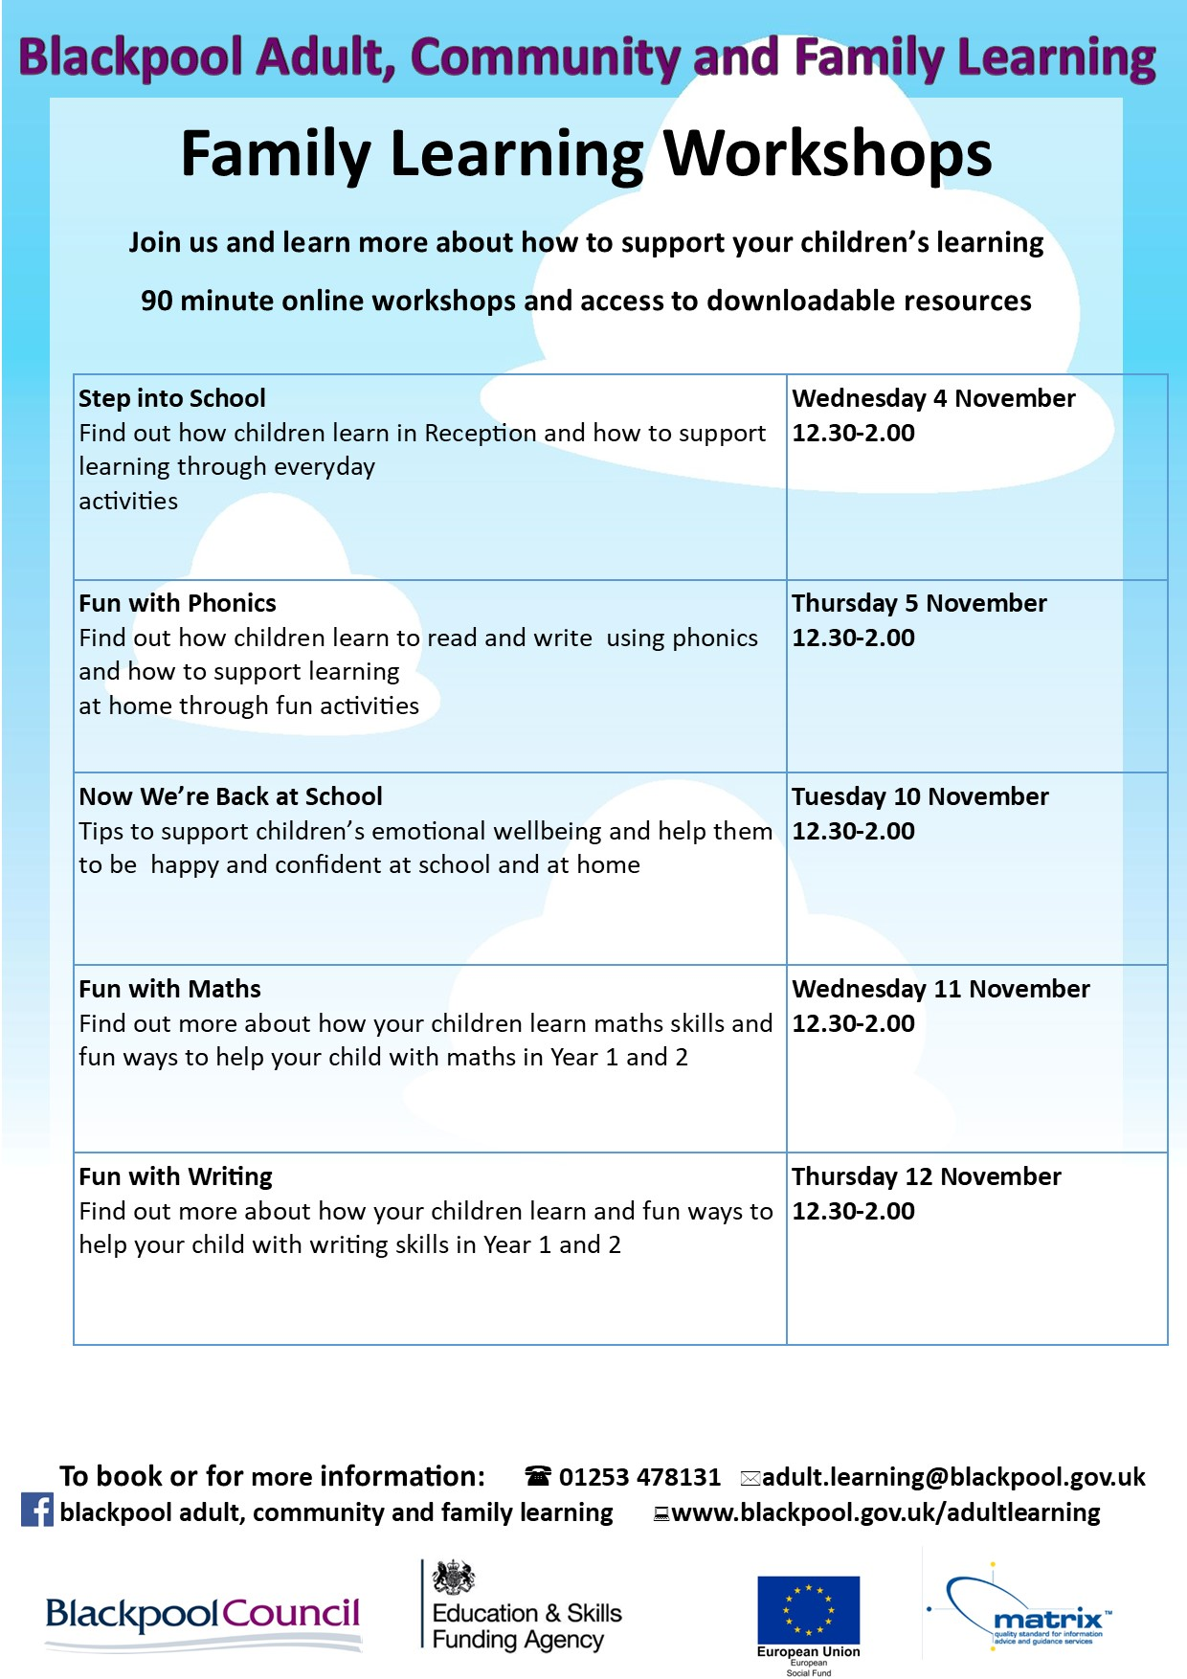

New Menu from Monday, 09 November 2020
Monday 09
Handmade Pizza Margherita (V)
Bread Roll (cheese or ham)
Carrot Sticks (picnic)
Easy Peeler
Shortbread (sultana)
Tuesday 10
Beefburger in a Bun
Baguette (choice of fillings) CPU/POD
Crumbed Vegetable Burger in a Bun (VG)
Cucumber Sticks (picnic)
Frubes Yogurt Tube
Vanilla Sponge (concept)
Wednesday 11
Cheese & Tomato melts
Wrap (choice of fillings) Cheese or Ham
Ham and Cheese Melts
Mixed Pepper Sticks (picnic)
Apple
Crispy Biscuits
Thursday 12
Pork Sausage Sandwich
Baguette (choice of fillings) CPU/POD
Vegetarian Sausage Sandwich
Carrot Sticks (picnic)
Frubes Yogurt Tube
Lemon Sponge (concept)
Friday 13
Fish Finger Wrap
Sandwich (Choice of Fillings) V0
Cucumber Sticks (picnic)
Banana

