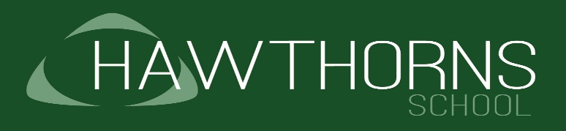
Sunnyside Moss Campus, Lumb Lane,
Audenshaw, Manchester M34 5SF
Tel: 0161 370 1312
Fax: 0161 301 5375
Email: admin@hawthorns.tameside.sch.uk
Website: www.hawthorns.tameside.sch.uk

Head of School: Mr Pierre Coiffait
Monday 16th March 2020
Dear Parents & Carers
As you’re probably aware, the government’s guidance on the coronavirus has changed from the ‘contain’ phase to one of ‘delaying’ the spread of the virus. We’re getting in touch to let you know what we’re doing in light of this, and what we expect from all of you, to help make sure our school community and our young people stay safe.

We’d like to reassure you that we’re taking all of the necessary steps to protect our community and are continuing to follow official guidance from the government and local authority. At this point in time we are aiming to keep the school day as near to normal as we possibly can.

What’s the current situation?

The school remains open – this is the current official guidance we’ve been given.

Most school functions continue to run as normal. We have cancelled all trips out of school, including to swimming, trampolining and soft play, to minimise children and staff exposure to other environments and people at the current time. Planned visits to church for Easter have also been stopped. All non-essential visitors to school have been cancelled for the foreseeable future.

After school clubs are still intending to operate at this point in time but these may change in line with guidance. Please check daily for updates.

Parent meetings this week have been postponed. Parents can opt to have a telephone discussion with the class teacher about their child’s progress if they choose – please call the school to arrange if you wish to take up this option. We will update parents of Year 2 children later this week regarding planned annual reviews.

Pupils and young people should attend school unless they feel unwell or have been advised to remain at home. Current government advice issued today (Monday) has been amended slightly; if your child has any of the following symptoms they should remain at home for 7 days:

- a new continuous cough and/or high temperature of 37.8 degrees
- If someone has these symptoms, however mild, they should stay at home and do not leave for 7 days from when their symptoms started.
- They do not need to call NHS 111 to go into self-isolation.

If your child is unwell, report this as you would normally by telephoning the absence line at the school.

What we’re doing to protect and support pupils and staff

- All essential visitors to school are being asked to follow good hand hygiene and hand gel has been made available at all reception desks.
- Hand gel is available across all sites and staff have been advised to follow good hand hygiene and to support our young people in doing the same.
- Young people are being encouraged to wash hands on a more regular basis.
- Posters have been displayed around the school to remind everyone about the importance of following the hygiene advice from government.
- All senior leaders across the trust are meeting on a regular basis to review and update contingency planning. Our school website will be updated daily in the afternoons and we will place all updates on this website with links to the updates on our social media platforms.

What we need you to do

If you’ve recently changed your contact details, please inform the school office as soon as possible to update the information.

Talk to your children about the coronavirus to reassure them. It’s a scary time and we should make sure children feel supported.

If we ask you to, come and collect your child straight away (we’ll contact you if they become ill with either a temperature or a new, continuous cough).

What happens if the school has to close?

While we hope this won’t happen, in the current circumstances it is possible that it will. If the school does close we will continue to provide updates and guidance on our website and social media pages. This will be the source of our information in the event of any closure period.

If you have any questions

Please contact the:

- school office, if you have any questions about our response to this issue
- NHS, if you want to know more about the symptoms of coronavirus - if you think you or your child may have the symptoms, use NHS 111 online if at all possible, before calling 111
- Department for Education’s coronavirus helpline: 0800 046 8687, if you have any questions about the government’s response to coronavirus in relation to schools
- government’s travel advice, if you want to know whether any upcoming trip or holiday you’re taking abroad should go ahead

It’s a tricky time and we know you’re worried about the impact this might have on your family and our community. It’s important we keep each other safe and talk about these events to help with any anxiety. Please be assured that the health and safety of your child is paramount in our thinking and any decisions that we make will be in their best interest.

Thank you for your continued support.

P.Coiffait

