Curriculum Intent, Impact & Implementation – Art
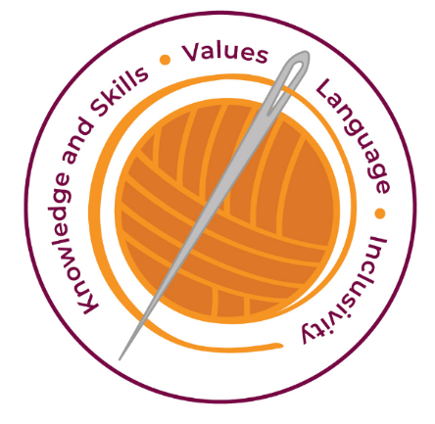

Our curriculum has four golden threads which are woven through all we do.

3R’s – Respect, Resilience and Responsilbity
Within these threads we have our 22 core values – understanding, unity and co-operation, freedom, appreciation and simplicity, hope, resilience, responsibility, thoughtfulness, tolerance, trust, friendship, perseverance, patience, peace, quality, love, humility, honesty, caring, happiness and courage.

Knowledge and Skills Intent & Implementation –  Our intention is to develop lifelong learners who have the skills knowledge, and curiosity needed to take full advantage of every opportunity in life. | - Our curriculum balances declarative knowledge with experiential knowledge, building self-knowledge and nurturing traits in learners which will hold them in good stead whichever direction their learning takes them.

Impact – All children are ready for the next part of their life whether that be the next year at primary or ready for their move to secondary and beyond. They understand the importance of learning and value all opportunities.
Values Intent & Implementation –  Our intention is that all children recognise and maintain a shared set of values, which will allow them to make a positive difference to themselves and others in a rapidly changing world. | - The pathways encourage as children work values such as unity, co-operation, friendship collaboratively and creatively.  - Children have a ‘Curiosity’ approach and show resilience to keep exploring and understand that all of their attempts are valid.  - The children respect the work of others and recognise that art is subjective – they are allowed to like or dislike an artist’s work but are respectful in their critique.

Impact - All children have a core set of values which underpin every decision they make. They understand the importance of values and how these make us feel personally and how showing values allows children and young people to live positively in modern Britian.
Language Intent & Implementation –  Our intention is that all children will acquire the language to allow them to express their thoughts, ideas and learning in a clear and coherent manner. | - The AccessArt Primary Art Curriculum is supported by a series of “Talking Points” carefully curated to introduce pupils to a wide variety of artists, designers and craftspeople from across the world.

Impact – All children have a language rich curriculum where they are encouraged to communicate effectively in full sentences. They are taught the skills to communicate efficiently within a vast range of situations and understand the need of listening attentively and responding appropriately to be a successful communicator.
Inclusivity Intent & Implementation –  Our intention is that no child is left behind. Every child, regardless of background, social, emotional, or educational need will achieve well and fulfil their potential. | - Each pathway tells a story / forms a journey, for every pupil. Each pathway follows a particular format which promotes excellent teaching & learning and reduces cognitive load.  - AccessArt is fully adaptable to include and accommodate all learners.

Impact – All children feel valued and consider themselves as equal while also developing a good understanding of the difference between equity and equality. Diversity is celebrated. Children are supported to show resilience and are proud of their achievements whatever their starting points.
The Foundation Stage.
We encourage creative work in our Foundation Stage. We relate the creative development of the children to the objectives set out in the Early Years Framework, which underpin the curriculum planning for children birth to five years. The children’s learning includes art, music, dance, role play and imaginative play. The range of experience encourages children to make connections between one area of learning and another and so extends their understanding. We provide a rich environment in which we encourage and value creativity. Children experience a wide range of activities that they respond to, using the various stages. We give them the opportunity to work alongside artists and other adults. The activities that they take part in are imaginative and enjoyable.

Key Document Details
Author: Lauren Hargreaves | Approver: Whole school
Owner: E Rushen-Gough | Version: 2.0
Date: September 2024 | Next Review: Sept 2025

