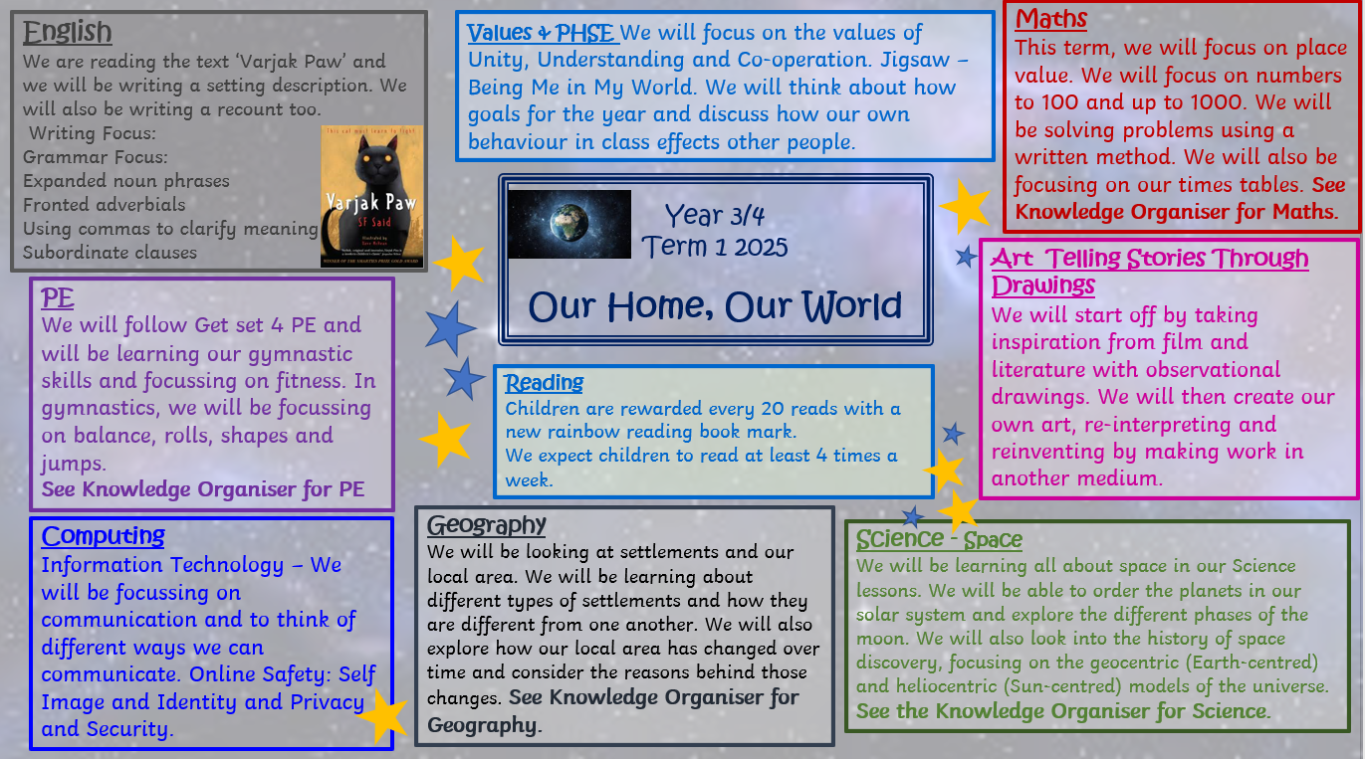

Our Home, Our World

|  |
| --- |
| Key Vocabulary |

|  |
| --- |
| Different Types of Settlement |

|  |  |
| --- | --- |
| most isolated house ... | A remote or isolated home is home that is not near any houses or settlements. These settlements typically have no facilities, and inhabitants must travel a set distance to access facilities. |
|  | A hamlet is a settlement that is smaller than a village or town. A hamlet does not have a central place of worship or central meeting places. Hamlets typically consist of only a handful of houses and little or no facilities. |
|  | A village is a settlement that is larger than a hamlet but smaller than a town. The population of villages generally ranges from a few hundred to a few thosand people. In the UK, hamlets earned the right to be called a village when they had their own church. |
|  | A town is settlement that is larger than a village but smaller than a city. The criteria to distinguish towns and cities varies from place to place. Most towns have a larger number of facilities, e.g. a train/bus station, a secondary school, places of worship and a commercial centre. |
|  | Cities are settlements that are large in size. Generally, cities have over 100,000 people and many cities have millions of people. Cities are local facilities hubs, with area facilities like hospitals and universities. |

|  |  |
| --- | --- |
| agriculture | The farming of crops or animals. |
| early settlers | The first people to settle in an area includung Romans, Vikings and Anglo-Saxons. |
| healthcare | Includes doctors, dentists, hospitals etc. |
| industrial | Businesses that provide products or services. |
| Retail | Shops selling products to people. |
| Settlement | A village, town or city where people live. |
| city | A large human settlement |
| Town | A built up area smaller than a city and bigger than a village |
| Village | A group of houses and buildingss in a rural area, smaller than a town |
| residential | Land used for housing. |
| OS Symbols | Symbols to label features on a map. |

|  |
| --- |
| Settlements in the UK |

|  |
| --- |
| Maps of Settlements |

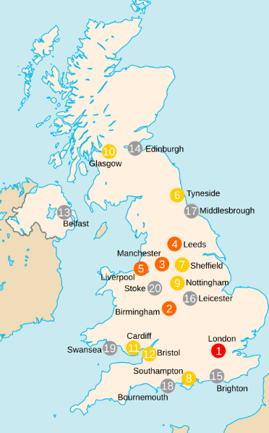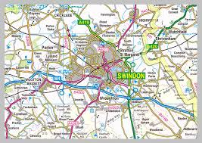

Fact: Settlements can be temporary like a refugee camp.

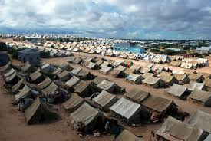

Mapmakers use colours, symbols, words and letters to

help people understand maps. The OS Symbols will help

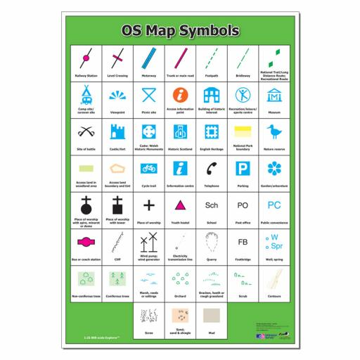Identify what is in each settlement.

The map above shows the 20 most populous cities in the UK (by the population of its total metropolitan area). London is by fat the largest and most populous city in the UK. As of 2023, there are 77 cities in the UK. About 82% of the British population lives in urbanised areas such as large towns and cities. This leaves only 18% of people who live rurally, in isolated homes, hamlets and rural villages. Some parts of the UK (e.g. the southeast of England) have many more settlements and people than others (e.g. northern Scotland).

|  |
| --- |
| How is Land Used in Settlements? |

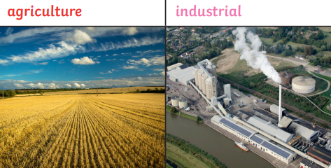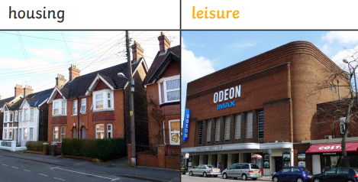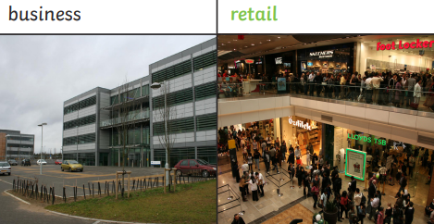

Earth and Space

|  |
| --- |
| The Eight Planets |

|  |
| --- |
| The Moon’s Phases |

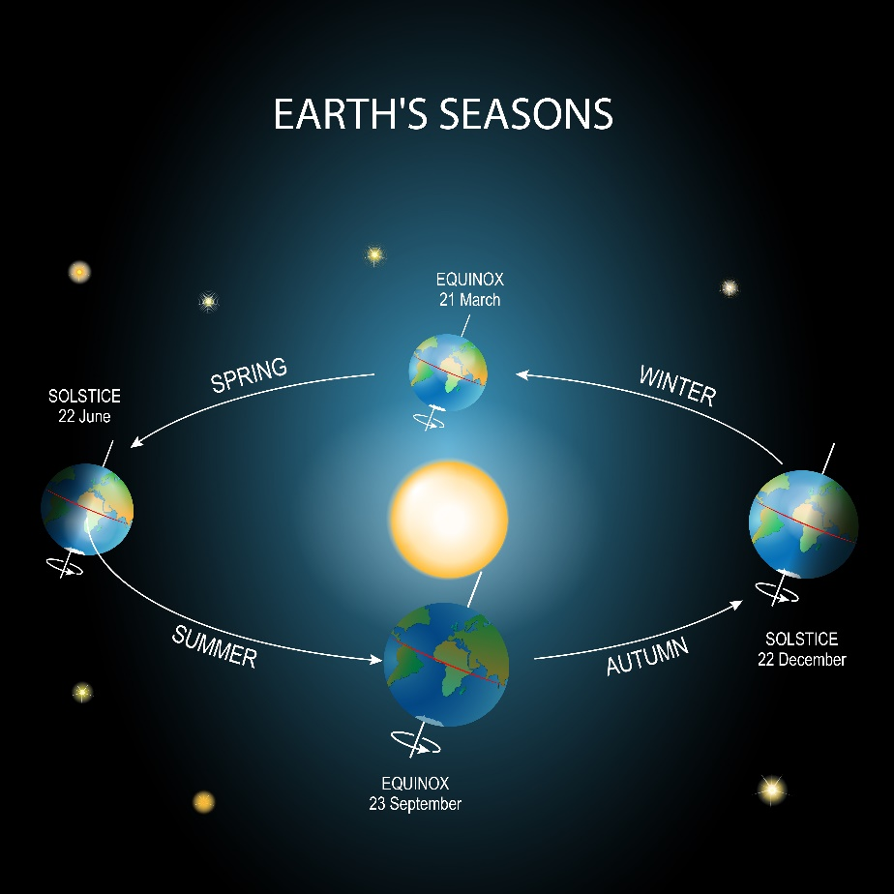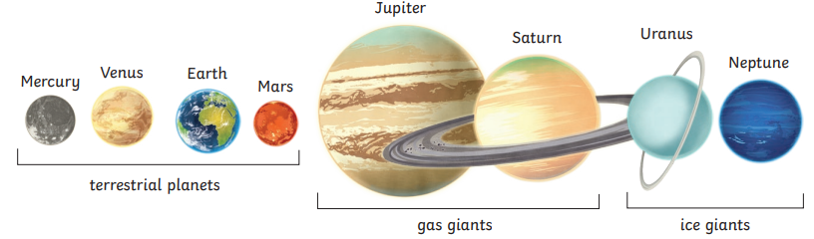

Copernicus developed the heliocentric theory that the Sun was at the centre of the solar system. The planets orbit the Sun in a circular pattern. Some made of rock and metal (the terrestrial planets) and some made of gas and ice (the gas and ice giants).

The Moon orbits Earth in an oval pattern whilst spinning on its axis. The Sun illuminates the Moon. The shadow of the Earth creates the Moon’s phases. The Moon orbits round Earth once approximately every 27 days. It takes the same amount of time to rotate on its axis. This means we always see the same side of the Moon.

|  |
| --- |
| Earth’s Movements |

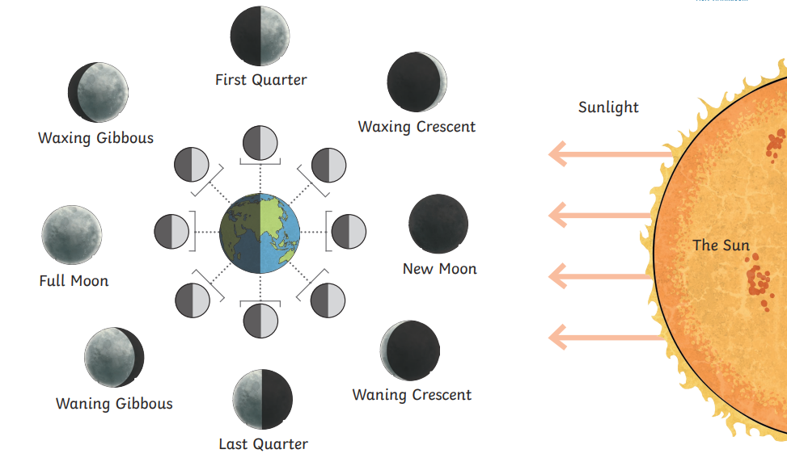

The Earth spins on its axis and completes a full rotation every 24 hours. The Earth is constantly rotating and orbiting the Sun – which takes 365 days, As the Earth rotates, it faces towards and away from the Sun. This creates the day and night cycle.

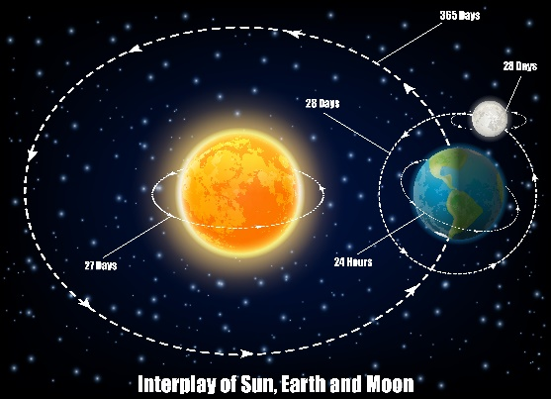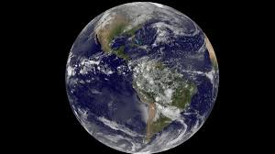

|  |
| --- |
| Key Vocabulary |

|  |
| --- |
| Seasons |

|  |  |
| --- | --- |
| heliocentric | The modern model of the solar system, which places the Sun at the centre. |
| geocentric | The old solar system model, which thought the Earth was at the centre. |
| solar system | The name of the Sun and all planets and objects that orbit it. |
| moon | A body which orbits a planet; also called a natural satellite. |
| orbit | The path of a celestial object around another, such as Moon around the Earth. |
| phase | The appearance of a Moon or planet, according to the amount of illumination. |
| waxing | The name given to Moon phases when the Moon is becoming brighter. |
| waning | The name given to Moon phases when the Moon is becoming darker. |
| axis | The (imaginary) line which a planet rotates around and tilts on. |
| terrestrial planet | The name given to the four inner rocky planets – Mercury, Venus, Earth and Mars. |
| planet | A planet is a large, spherical celestial body that orbits a star. |
| gas giants | The name given to the four outer planets – Jupiter, Saturn, Uranus and Neptune. |
| satellite | A satellite is a natural or human-made object or body that orbits a larger object such as a planet or a star. |
| celestial body | A celestial body is a natural object outside Earth’s atmosphere, such as planets, the Sun and the Moon. |

Each year, many places on Earth experience four seasons, each lasting for three months. These are spring, summer, autumn and winter.

The seasons are due to Earth’s tilt as it orbits round the Sun. Earth is tilted at an angle of about 24 degrees. This means that, at different times throughout the year, parts of Earth are either tilted towards or tilted away from the Sun, which changes temperatures and weather conditions.

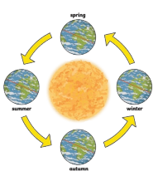

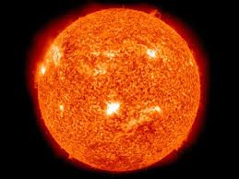

|  |
| --- |
| The Sun |

The Sun is a burning ball of gas which appears to move across the sky during the day. However, this movement is actually due to the Earth’s orbit around the Sun.

