Child Friendly Behaviour and Anti Bullying Policy – 2024/ 2025

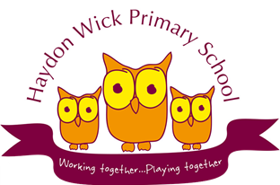

Produced by School council

Haydon Wick Primary School

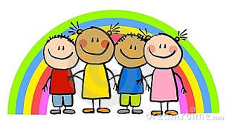

**Our School: What we want it to be like:**

Our school is special and we want it to be a place where everyone feels happy and is friendly and gets on with each other. We want children to mix with each other and co-operate with patience and kindness, treating each other with respect. Our 22 values and our British values are important to remember and to show them to each other.

**How we should behave and why:**

We should behave in a respectful way that makes all children and adults in our school feel safe. This means we should be kind and friendly to everyone. We should listen carefully to each other and follow instructions.

**What happens if we behave appropriately?**

Each term the house with the most values points has an extra playtime. We also get stickers and postcards sent home. In Friday assembly, we celebrate hard work, achievements and those who have shown the value of the month. Golden tickets are awarded for the Golden table on Friday lunchtimes. Each class has a reward system that means if we behave well there is an end of term treat.

**What happens if we do not behave appropriately?**

We are given a warning, which gives us a chance to make the right choice. If we make a wrong choice, a member of staff will talk to us about our choices. If we continue to make the wrong choices, we might have to leave the classroom, miss playtimes and see Mrs Gale. If our choices continue to be wrong, our parents will be informed. If it is serious inappropriate behaviour, we might be sent home.

We will have a chance to discuss our behaviour and make steps to put it right.

**What we promise to do:**

We will try our hardest to follow the values and rules of school and be positive towards others.

**Are our behaviour rules for everyone?**

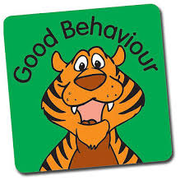We expect everyone at Haydon Wick to respect our rules. Some children find it hard to follow the rules and we help those children in different ways so they can earn rewards too.

**Are our behaviour rules for all times?**

We should behave well at all times when we are wearing Haydon Wick’s school uniform, class times, assemblies, playtimes, walking to and from school, on school trips, after school clubs, and with visitors so that people outside and inside school can see we make the right choices and do our best.

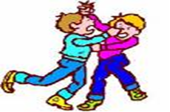**What is Bullying?**

In our school, a bully is someone who hurts someone more than once, by using behaviour which is meant to hurt, frighten or upset another person.

**Bullying can be…**

**Emotional:** Hurting people’s feelings, leaving you out.

**Physical:** Punching, kicking, spitting hitting, pushing.

**Verbal:** Being teased, name-calling.

**Racist:** Graffiti, calling you racist names.

**Cyber:** saying unkind things by text, e-mail and/or social media. This is really bad because the unkind things can stay there.

**When is it bullying?**

****Several

Times

On

Purpose

**We promise to always treat bullying seriously.**

**What should I do if I see someone else is being bullied?**

* Don’t walk away and ignore the bullying Don’t be a bystander
* Let someone know what is happening, tell a trusted friend or adult
* Tell the bully to stop if it is safe to do so.
* Don’t stay silent or the bullying will keep happening

**The Head, the Governors, the staff and the School council will work together to:**

* Make our school a place where everyone can feel safe and happy. That means no bullying allowed.
* We will help everyone to get on with each other and we believe that everyone has the right to be who they are.

**Who can I tell?**

A friend, Mum/Dad, Teachers, School Council, lunch time Staff, any other adult in school, Mrs Palmer, Mrs Gale, another trusted family member

If you are being bullied:

**Start Telling Other People!**

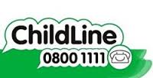You can talk to someone outside of school by calling Child Line on 0800 1111. It’s free and confidential.

**If you are bullied-**

**DO:-**

* Ask them to STOP if you can.
* Use eye contact and tell them to go away.
* Ignore them.
* Walk away.
* Use the worry box if you are too scared to speak openly about it.
* Talk to a School council member
* TELL SOMEONE, you trust

**DON’T:-**

* Do what they say.
* Get angry or look upset.
* Hit them or retaliate in any other way.
* Think it is your fault.
* Hide it.

