Curriculum Intent, Impact & Implementation – Computing
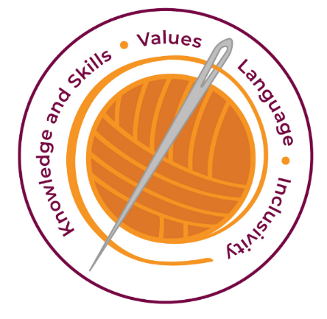

Our curriculum has four golden threads which are woven through all we do.

3R’s – Respect, Resilience and Responsilbity
Within these threads we have our 22 core values – understanding, unity and co-operation, freedom, appreciation and simplicity, hope, resilience, responsibility, thoughtfulness, tolerance, trust, friendship, perseverance, patience, peace, quality, love, humility, honesty, caring, happiness and courage.
Knowledge and Skills Intent & Implementation –  Our intention is to develop lifelong learners who have the skills knowledge, and curiosity needed to take full advantage of every opportunity in life. | - Online Safety should form a part of every Computing lesson, and should be referenced in other relevant learning opportunities.  - Opportunities for technology as a tool to support learning and teaching in all areas are identified in curriculum planning.  - Planning for Computing is implemented which meets the requirements of the National Curriculum Programme of Study for Computing and the Early Years Foundation Stage  - Use computational thinking and creativity, so that they leave primary school as knowledgeable and flexible learners.

Impact – All children are ready for the next part of their life whether that be the next year at primary or ready for their move to secondary and beyond. They understand the importance of learning and value all opportunities.
Values Intent & Implementation –  Our intention is that all children recognise and maintain a shared set of values, which will allow them to make a positive difference to themselves and others in a rapidly changing world. | - Opportunities are taken whenever possible to reinforce messages of a healthy life style.  - Clear rules for Online Safety reviewed with each class at the beginning of every year. Parents and pupils should sign an acceptable user policy together when a pupil first starts at the school.

Impact - All children have a core set of values which underpin every decision they make. They understand the importance of values and how these make us feel personally and how showing values allows children and young people to live positively in modern Britian.
Language Intent & Implementation –  Our intention is that all children will acquire the language to allow them to express their thoughts, ideas and learning in a clear and coherent manner. | - Opportunities for communication and collaboration develop understanding of the purposes for using technology and these are used to bring together home and school learning experiences.  - Become digitally literate – able to use, express themselves and develop ideas through information and communication technology.

Impact – All children have a language rich curriculum where they are encouraged to communicate effectively in full sentences. They are taught the skills to communicate efficiently within a vast range of situations and understand the need of listening attentively and responding appropriately to be a successful communicator.
Inclusivity Intent & Implementation –  Our intention is that no child is left behind. Every child, regardless of background, social, emotional, or educational need will achieve well and fulfil their potential. | - The school maintains its policy of equal opportunities as appropriate for Computing. λ Computers and related technology are made available to all pupils regardless of gender, race or abilities.  - The class teacher differentiates work by task, resource or support, to ensure the individual needs of more able and SEN pupils are met.  - The school is aware that not all pupils have the same access to resources at home and this is considered by staff in the planning and delivery of the curriculum.

Impact – All children feel valued and consider themselves as equal while also developing a good understanding of the difference between equity and equality. Diversity is celebrated. Children are supported to show resilience and are proud of their achievements whatever their starting points.
The Foundation Stage.
Pupils build confidence to use technology purposefully to support their learning to reach their Early Learning Goals as appropriate. Pupils in Foundation Stage class will have experiences using technology indoors, outdoors and through role play in both child-initiated and teacher-directed time. The Foundation Stage teacher will plan for the opportunity to use technology in a range of contexts.

Key Document Details
Author: M.Cowley | Approver: Whole school
Owner: E Rushen-Gough | Version: 2.0
Date: September 2024 | Next Review: Sept 2025

