Curriculum Intent, Impact & Implementation – DT
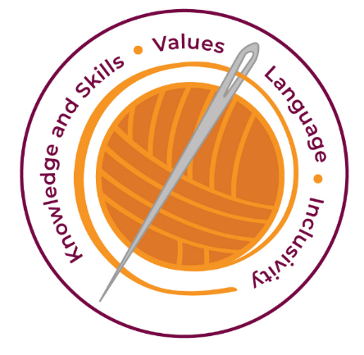

Our curriculum has four golden threads which are woven through all we do.

3R’s – Respect, Resilience and Responsilbity
Within these threads we have our 22 core values – understanding, unity and co-operation, freedom, appreciation and simplicity, hope, resilience, responsibility, thoughtfulness, tolerance, trust, friendship, perseverance, patience, peace, quality, love, humility, honesty, caring, happiness and courage.

Knowledge and Skills Intent & Implementation –  Our intention is to develop lifelong learners who have the skills knowledge, and curiosity needed to take full advantage of every opportunity in life. | - Children gain a knowledge and understanding of materials, components, controls and structures.  - Children use focused practical tasks to develop skills, techniques and knowledge particularly those related to tools and materials  - Children draw upon knowledge and skills from other curriculum areas, particularly mathematics, science and art.

Impact – All children are ready for the next part of their life whether that be the next year at primary or ready for their move to secondary and beyond. They understand the importance of learning and value all opportunities.
Values Intent & Implementation –  Our intention is that all children recognise and maintain a shared set of values, which will allow them to make a positive difference to themselves and others in a rapidly changing world. | - The pathways encourage as children work values such as unity, co-operation, friendship collaboratively and creatively.  - Children have a ‘Curiosity’ approach and show resilience to keep exploring and understand that all of their attempts are valid.

Impact - All children have a core set of values which underpin every decision they make. They understand the importance of values and how these make us feel personally and how showing values allows children and young people to live positively in modern Britain.
Language Intent & Implementation –  Our intention is that all children will acquire the language to allow them to express their thoughts, ideas and learning in a clear and coherent manner. | - Children will be encouraged to generate ideas through group discussions either led by the teacher or between the children  - To maintain safety children will follow clear instructions.  - Children will develop specialist vocabulary linked to the area of the curriculum. This will allow them to express their thoughts and ideas with clarity.

Impact – All children have a language rich curriculum where they are encouraged to communicate effectively in full sentences. They are taught the skills to communicate efficiently within a vast range of situations and understand the need of listening attentively and responding appropriately to be a successful communicator.
Inclusivity Intent & Implementation –  Our intention is that no child is left behind. Every child, regardless of background, social, emotional, or educational need will achieve well and fulfil their potential. | Those children who are recognised as having special educational needs will follow similar programmes of study as their peers. However, the work, if necessary will be differentiated to meet individual children’s needs

Impact – All children feel valued and consider themselves as equal while also developing a good understanding of the difference between equity and equality. Diversity is celebrated. Children are supported to show resilience and are proud of their achievements whatever their starting points.

The Foundation Stage.
The emphasis for our foundation stage children is for them to be encouraged to examine and talk about everyday objects and give possible reasons for why things are made the way they are. They will refine their fine motor skills, for example, using a range of small tools. They will also learn to create with materials by exploring a range of techniques and tools, and experimenting with texture, form and function.

Key Document Details
Author: M.Hambidge | Approver: Whole School
Owner: E Rushen-Gough | Version: 2.0
Date: September 2024 | Next Review: Sept 2025

