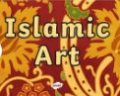  Research Islamic art – create your own piece in a medium of your choice. | 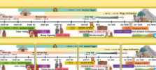  Research and create a timeline of significant events from the early Islamic civilisation. | 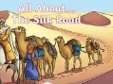  Find out about the silk road. What is it? Why is it significant? Create a PowerPoint explaining what you have found out.
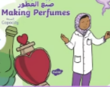  Find out how to make your own perfume. Create it, design the packaging and write an advert for it. | 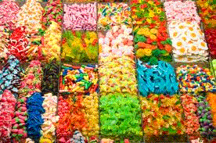  Pick and mix homework  Term 4 | 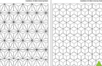  Use tessellation to create a geometric pattern
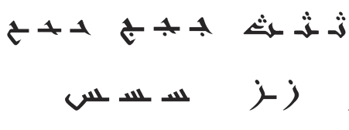  Learn some Arabic – write or record what you have learned. | 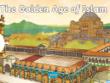  Find out about the importance of Baghdad to the early Islamic civilisation – create a fact file about it. | 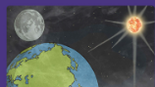  Explore Islamic creation stories – create a mini book of some of the stories.

