Curriculum Intent, Impact & Implementation – Geography
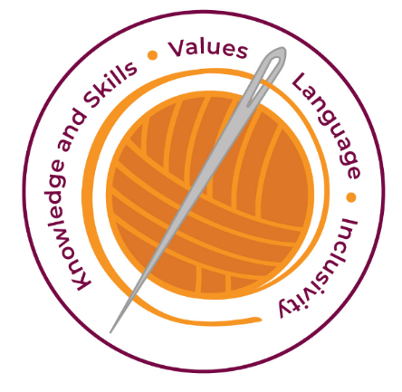

Our curriculum has four golden threads which are woven through all we do.
3R’s – Respect, Resilience and Responsilbity
Within these threads we have our 22 core values – understanding, unity and co-operation, freedom, appreciation and simplicity, hope, resilience, responsibility, thoughtfulness, tolerance, trust, friendship, perseverance, patience, peace, quality, love, humility, honesty, caring, happiness and courage.
Knowledge and Skills Intent & Implementation –  Our intention is to develop lifelong learners who have the skills knowledge, and curiosity needed to take full advantage of every opportunity in life. | - Helps them with real life bigger picture to give them skills and understanding to take them on their journey to next year and beyond.  - Have an excellent knowledge of where places are and what they are like.  - Have an extensive base of geographical knowledge and vocabulary.  - Have a real sense of curiosity to find out about the world and the people who live there.

Impact – All children are ready for the next part of their life whether that be the next year at primary or ready for their move to secondary and beyond. They understand the importance of learning and value all opportunities.
Values Intent & Implementation –  Our intention is that all children recognise and maintain a shared set of values, which will allow them to make a positive difference to themselves and others in a rapidly changing world. | - Partner talk helps develop our values (unity, co-operation, friendship)  - Be fluent in complex, geographical enquiry and the ability to apply questioning skills and use effective analytical and presentational techniques.  - The children will be inquisitive and ask questions about the world around them.  - The children will see themselves as global citizens, showing empathy, tolerance and understanding  - To inspire in children a curiosity and fascination about the world and people within it; to promote the children’s interest and understanding of diverse places, people, resources and natural and human environments, together with a deep understanding of the Earth’s key physical and human processes.

Impact - All children have a core set of values which underpin every decision they make. They understand the importance of values and how these make us feel personally and how showing values allows children and young people to live positively in modern Britian.
Language Intent & Implementation –  Our intention is that all children will acquire the language to allow them to express their thoughts, ideas and learning in a clear and coherent manner. | - We use Widgets to support the children’s recall of key language  - The children are encouraged to express well-balanced opinions, rooted in very good knowledge and understanding about current and contemporary issues in society and the environment.

Impact – All children have a language rich curriculum where they are encouraged to communicate effectively in full sentences. They are taught the skills to communicate efficiently within a vast range of situations and understand the need of listening attentively and responding appropriately to be a successful communicator.
Inclusivity Intent & Implementation –  Our intention is that no child is left behind. Every child, regardless of background, social, emotional, or educational need will achieve well and fulfil their potential. | - We create a positive and supportive environment.  - Everyone is included and this promotes unity.  - Responding to individuals needs of all our diverse learners develops understanding, tolerance and thoughtfulness

Impact – All children feel valued and consider themselves as equal while also developing a good understanding of the difference between equity and equality. Diversity is celebrated. Children are supported to show resilience and are proud of their achievements whatever their starting points.
The Foundation Stage.
Understanding the world involves guiding children to make sense of their physical world and their
community. The frequency and range of children’s personal experiences increases their knowledge and sense of the world around them –from visiting parks, libraries and museums to meeting important members of society such as police officers, nurses and firefighters.
In addition, listening to a broad selection of stories, non-fiction, rhymes and poems will foster their understanding of our culturally, socially, technologically and ecologically diverse world. As well as
building important knowledge, this extends their familiarity with words that support understanding
across domains. Enriching and widening children’s vocabulary will support later reading.
comprehension

Key Document Details
Author: S.Osborne | Approver: Whole School
Owner: E Rushen-Gough | Version: 2.0
Date: September 2025 | Next Review: Sept 2025

