Otters and Badgers Class

Pick and Mix Homework

Term 3

Remember you don’t need to do all 7!

Maths

Can you create a worksheet that focuses on adding 4-digit numbers together?

If you want a challenge, put it into code!

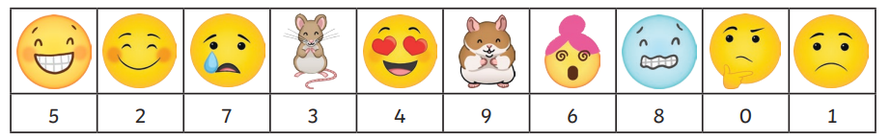

In PSHE, our focus is Dreams and Goals. Considering what you might want your future job to be, write yourself a CV letter, explaining why you would be a good candidate for your dream job!

In geography, our topic will be magnificent mountains. Can you make a poster showing the different elements that a mountain is made up of?

In Science, we are studying electricity. Can you draw three different electrical circuits that contain different components, using the correct circuit symbols?

Art – can you create a mountain in art form?

It could be a drawing, a sculpture, a digital painting, anything you can think off!! Be creative!!

Essential Homework

Read for 10 minutes

Learn and practise your spellings on Purple Mash.

Pracitse your times tables and use maths rockstars!

English –

We will be looking at creating and re telling stories this term. Can you take one of your favourite story and re tell it in your own words?

**All work to be returned by the last week of term.**