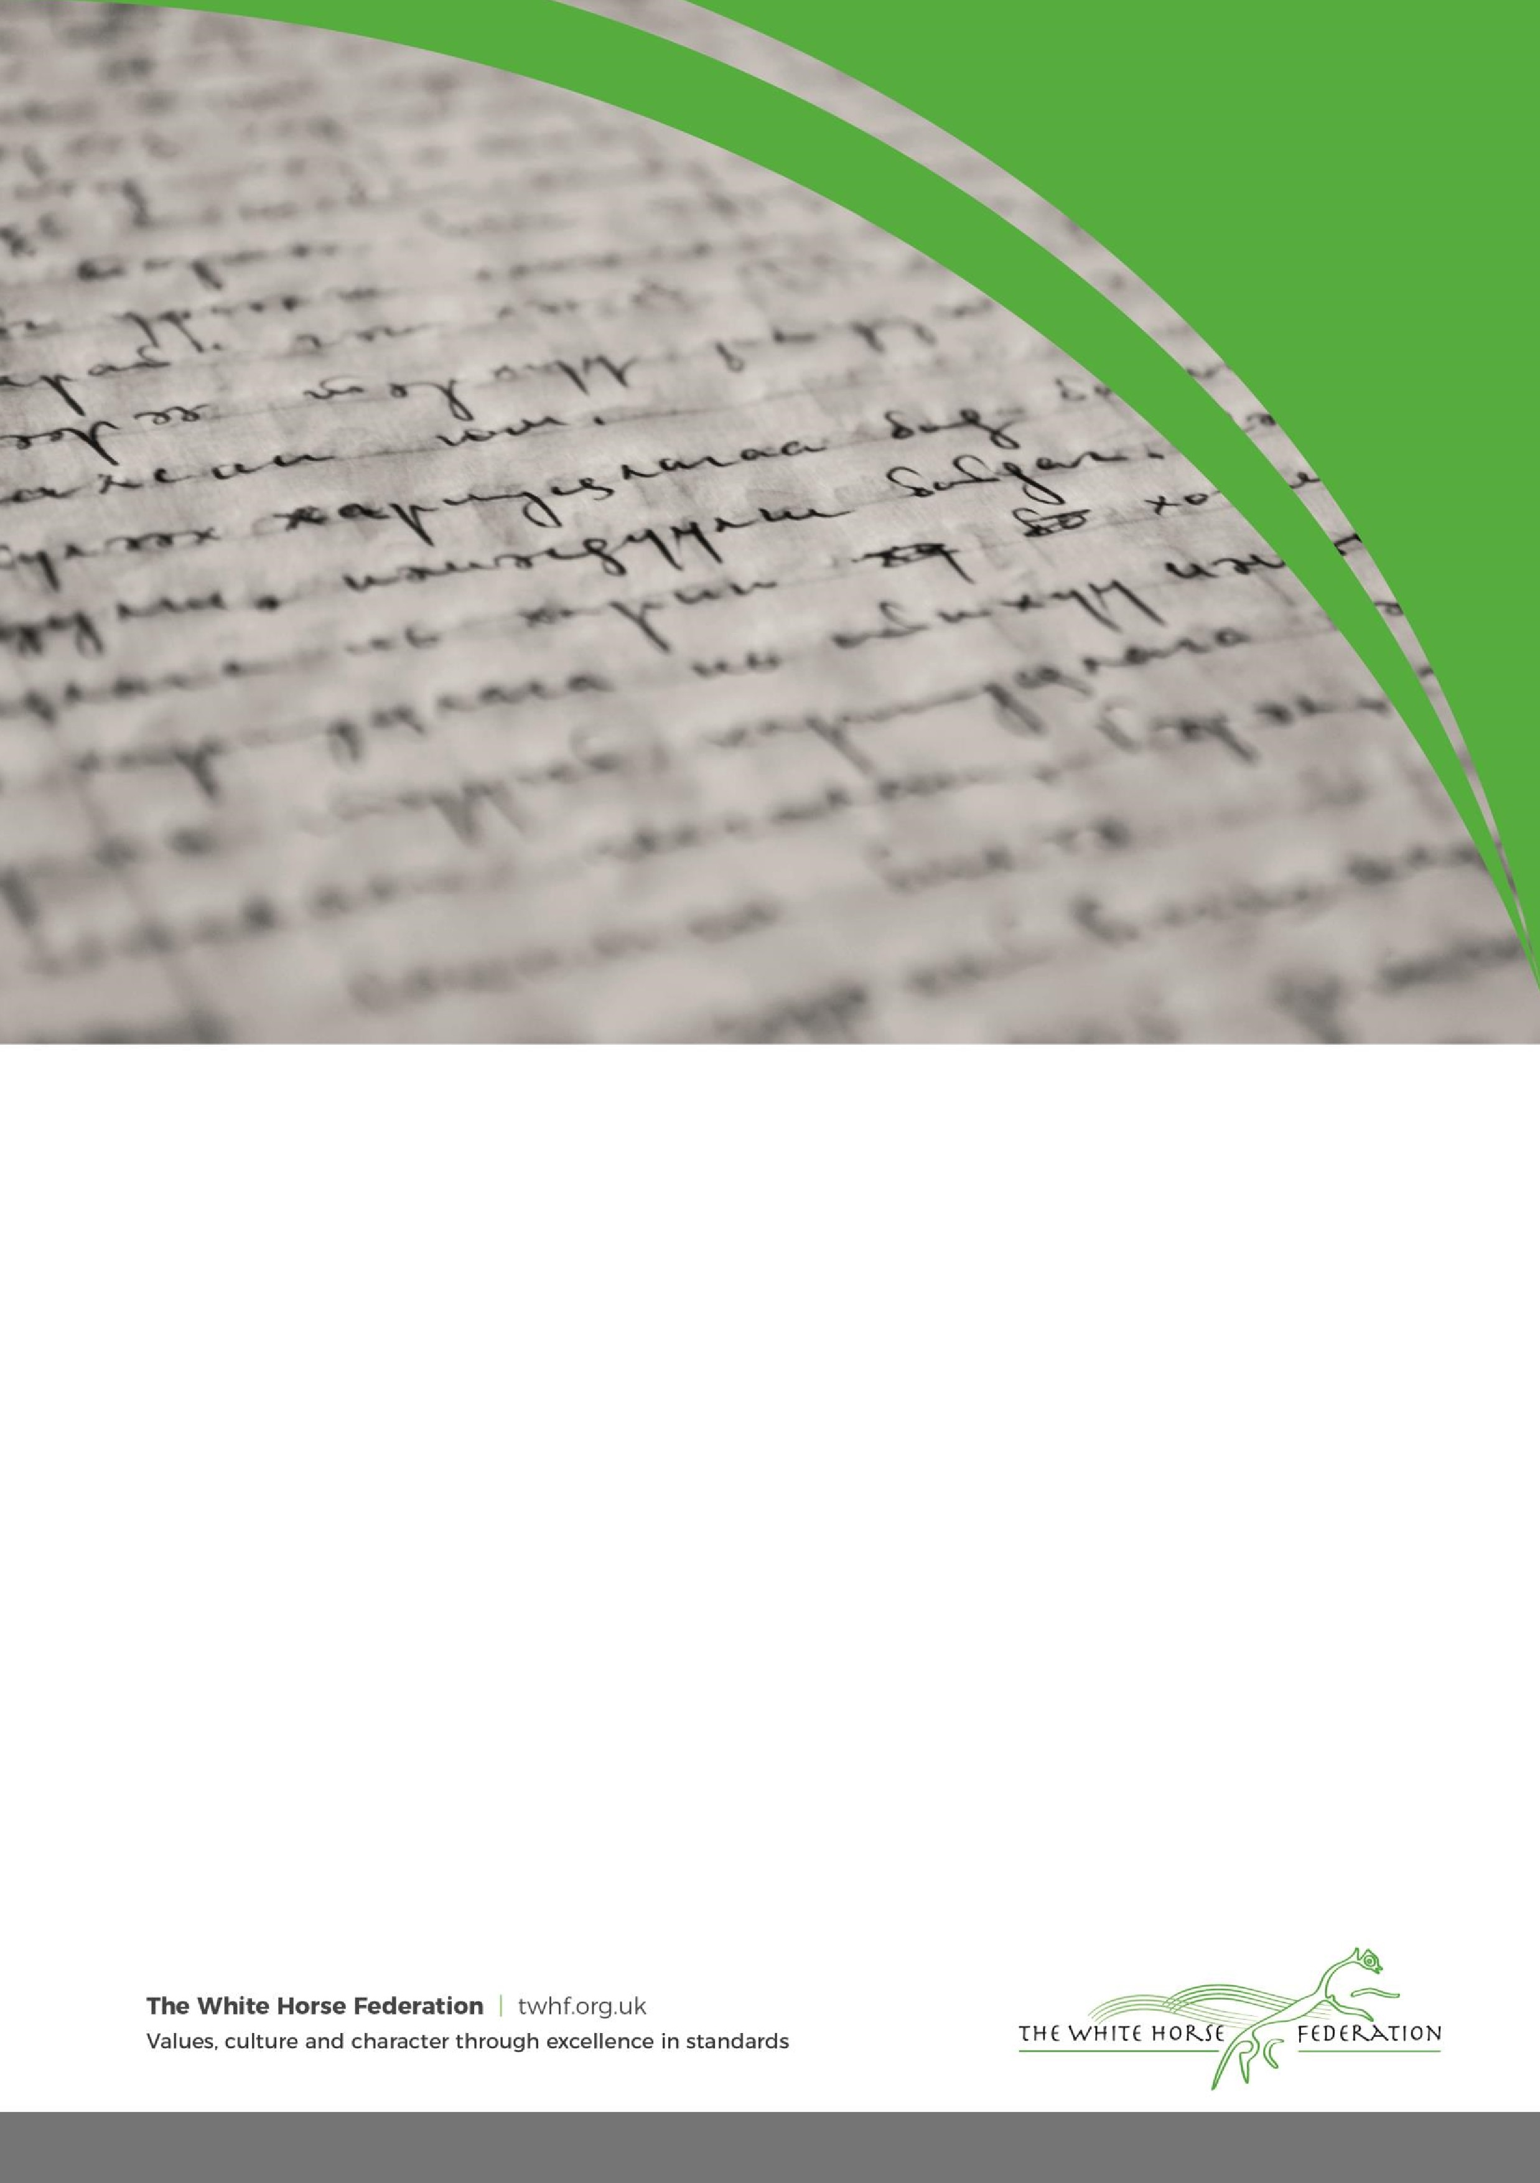

School Name:

Haydon Wick Primary School

Version No:

6

Ratified date:

September 2023

Author:

Chris Neal

Interim review date:

N/A

Owner:

Chris Neal

Next review date

September 2024

Approved by:

Governors

Anti
-
Bullying
Policy

The aim of this policy is to ensure that pupils learn in a supportive, caring and safe environment without fear of being bullied. Only when all issues of bullying are addressed will pupils be able to fully benefit from the opportunities available at school.

Bullying is anti-social behaviour and affects everyone; it is unacceptable and will not be tolerated. Bullying is defined as deliberately hurtful behaviour, repeated regularly over a period of time, where it is difficult for those being bullied to defend themselves.

Bullying can be:
- Emotional being unfriendly, excluding, tormenting (e.g. hiding books, threatening gestures)
- Physical pushing, kicking, hitting, punching or any use of violence
- Racist racial taunts, graffiti, gestures
- Sexual unwanted physical contact or sexually abusive comments
- Homophobic because of, or focusing on the issue of sexuality
- Verbal name-calling, sarcasm, spreading rumours, teasing
- Cyber - all areas of internet, such as email & internet chat room misuse
- Mobile threats by text messaging & calls
- Misuse of associated technology, i.e. camera & video facilities

Child On Child Abuse
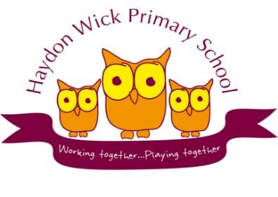
We recognise that children are capable of abusing other children. This can happen both inside and outside of school and online. A child may not find it easy to report child on child abuse and we recognise that they might show signs or act in ways that they hope an adult will notice, including a change in behaviour. Even if there are no reported cases of child on child abuse, we recognise that abuse may still be taking place but not being reported. We understand that the pupil who is perpetrating the abuse may also be at risk of harm and we will make every effort to ensure that the perpetrator is supported appropriately.
The school has a number of school rules, but the primary aim of our policies is not a system to enforce rules. It is a means of promoting good relationships, so that people can work together with the common purpose of helping everyone to learn. Our policies support the school community in aiming to allow everyone to work together in an effective and considerate way. However it manifests itself, bullying will not be tolerated at Haydon Wick Primary School.

Aims
This policy is designed to ensure that as a school we are alert to signs of bullying and act promptly and firmly against it.
- To promote a secure and happy environment free from threat, harassment and any type of bullying behaviour.
- To take positive action to prevent bullying from occurring through a clear school policy on Personal and Social Development.
- To show commitment to overcoming bullying by practising zero tolerance.
- To inform pupils and parents of the school’s expectations and to foster a productive partnership, which helps maintain a bully-free environment.

- To make children aware of their right to be safe and their responsibilities to ensure others feel safe.
- To make staff aware of their role in fostering the knowledge and attitudes which will be required to achieve the above aims.

Whole School and Individual Staff Responsibilities
- Never ignore suspected bullying.
- Don‘t make premature assumptions.
- Listen carefully to all accounts and investigate as fully as possible.
- Adopt a problem-solving approach which moves pupils on from justifying themselves.
- Complete the school pro-forma for recording bullying incidents on our CPOMS system and always report to the Principal.
- Follow-up repeatedly, checking bullying has not resumed.
- Use of a range of teaching and learning styles and strategies which challenge bullying.
- Use interventions which are least intrusive and most effective.

Support for Parents
When parents raise a concern that their child is being bullied it is essential that this concern is taken seriously and not dismissed without further enquiries being made.
The bullying incident report can be used as a focus of the discussion with a parent so that there is a clear record of the concern and of immediate action to be taken by school staff.

Procedures and Recording
Recording incidents is vital as it allows school staff to identify patterns of behaviour, as often what is perceived initially to be a trivial incident, may be part of a number of incidents which are serious for the individual child.
The following steps will be taken when dealing with any incident:
All reported incidents will be investigated as soon as possible by the member of staff who has been approached or witnessed the incident.
- Listen to the child reporting the incident and make sure that they feel that their concerns are being taken seriously.
- Record the incident on CPOMS.
- Check through to establish if there are any previous incidents involving the same children.
- If you feel that this is one of a number of incidents, or particularly severe, refer immediately to a member of the SLT.
- If the incident is ‘minor’ and does not merit a referral, please make sure you deal with the incident effectively and in line with the positive behaviour policy.

Children must feel that their complaint has been dealt with properly. If you are unsure what to do, please seek advice.
- Once an incident has been recorded and reported to the SLT, a thorough investigation of the incident involving all parties will be undertaken and recorded in writing in the action section on CPOMS.
- The Principal should always be made aware of any incidents which have been dealt with by other members of the SLT.
- After the investigation has taken place, a decision should be made as to whether a case of persistent bullying is taking place. If this is the case, the parents of the perpetrator will be invited to discuss the situation with the Principal or Assistant Principal as appropriate.

- Parents of the bullied child must be kept informed of the whole process and it is vital that they feel satisfied with the way the incident has been dealt with.
- If an allegation of bullying is made by a parent, full written details should be taken and referred to the Principal or Assistant Principal.

Support
Pupils who have been bullied will be supported by:
- Being offered an immediate opportunity to discuss the experience with a member of staff.
- Reassuring the pupil.
- Offering continuous support.
- Restoring self-esteem and confidence.

Pupils who have bullied will be helped by:
- Discussing what happened.
- Discovering why the pupil became involved.
- Establishing the wrong-doing and need to change.
- Informing parents or guardians to help change the attitude of the pupil.
- Within the curriculum the school will raise the awareness of the nature of bullying through inclusion in PSHE, assemblies and subject areas, as appropriate, in an attempt to eradicate such behaviour.

Incidents of bullying outside the school’s premises
Although schools are not directly responsible for bullying off the school premises, we would still encourage victims “not to suffer in silence”. Actions the school could take, if deemed appropriate, include:
- Talking to the local police about the problems within the community.
- Talking to the schools if appropriate whose pupils are involved in bullying off the premises.

Bullying can also take place via text messages, online and other means of ‘cyber communication’. This often happens out of school hours, but has implications for the parties involved when they are in school. We would always talk to pupils and parents about the issues and take their concerns seriously.

Adult Bullying
From time to time, adults behave inappropriately towards each other. If any parent feels that they are being treated inappropriately within our school community they must report this to the Principal immediately.
On occasions, when a parent suspects another child of inappropriate behaviour towards their own child, they try to take matters into their own hands. This can result in:
- Parents approaching other parents in groups
- Inappropriate verbal exchanges in front of pupils
- A breakdown in communication
If children are experiencing problems with other children, parents must not try to ta

Incidents of Online Bullying

Aim

Haydon Wick Primary
S
chool are committed to act on any Incident of
online bullying

and reserve
the right to act upon these as per section 89 clause 5 of the Education and Inspections Act 2006.
This means that the school reserves the right to deal with any bullying incident that pertains to the
school “to such extent as is

reasonable”, whether it is on the school p
remises or in the online
world.

Definition

As there is no legal definition of bullying, for the purposes of this policy the school will use the
following summary
:

“The repeated use of electronic
communication in any form, on any platform, which
would cause harm or distress to another person.”

Children’s rights

Article 19 of the UNCRC: Children should be protected from being hurt or mistreated, in body or
mind. Haydon Wick Primary

School

is a righ
ts respecting school.

Stat
ement of intent

The school will deal with any incidents on an individual case by case basis, using a set of sanctions
that are proportionate to any behaviours demonstrated. The

school will take into account:

•

The context

•

The
intention

•

The impact

of any incident before determining the response and actions to be taken. The school will allow a
degree of flexibility in the application of actions e.g. a series of low level incidents would likely to
be treated differentially from pe
rsistent and more serious incidents.

Procedure

All incidents of online bullying should be logged and recorded
on the schools CPOMS system
to
identify any patterns of behaviour, in order to allow issues to be dealt with p
roactively and
proportionately.

Any incident should be reported to the Principal of the school.

A record of the incident
on
CPOMS will

then
be
monitored by the E
-
safety co
-
ordinator of t
he school.

The Principal will consider the context, intention and impact of the inci
dent, in order to determine
the
level of sanction put in place.

Parents and carers from both parties must be informed and advised
of any action that takes place.

The Principal wi
ll

decide on a sanction which is proportionate to the incident.

Monitoring, Evaluation and Review
of this policy will take place annually as part

of the
Safeguarding programme.

