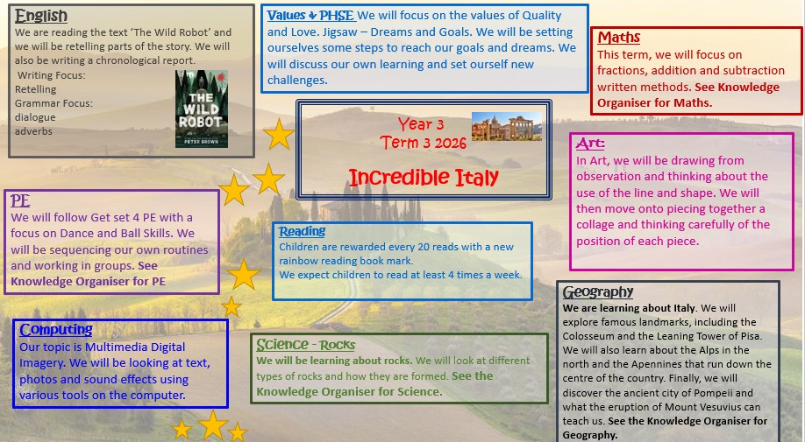

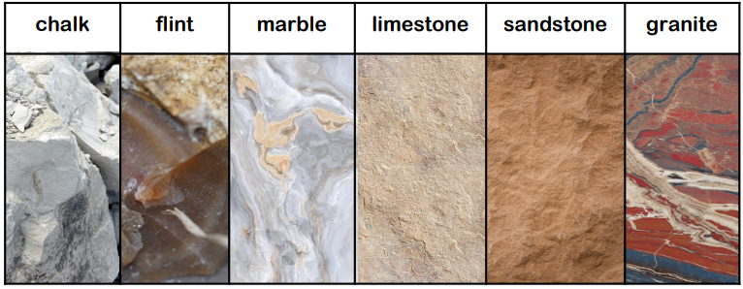
Rocks

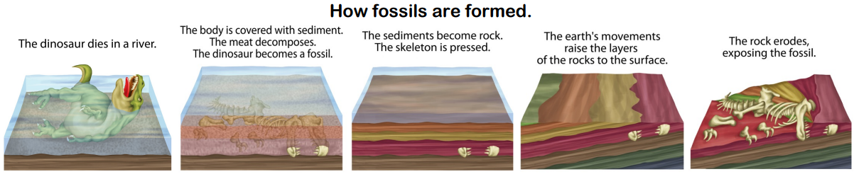

Igneous Rock
Metamorphic Rock
Sedimentary Rock

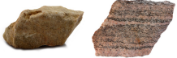
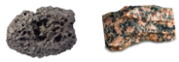
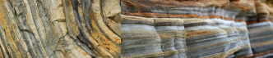

These rocks form under the sea. Rocks are broken into small pieces by wind and water (erosion). They settle as mud, sand, minerals and even remains of living things. Over time layers build up and the pressure turns this sediment into rock.
Far underground the temperature is so hot, rock melts into a liquid (molten rock). When the liquid is underground, it is called magma and it can cool to form igneous rock.
Metamorphic rocks are formed under the surface of the earth from the change (metamorphosis) that occurs under the intense heat and pressure (squeezing).

Vocabulary

igneous rocks | rocks created from solidified lava
intrusive igneous rock | rock that has been formed under the Earth’s surface over a long period of time
extrusive igneous rock | rock that has been formed from molten lava and either cooled quickly or slowly
magma | hot liquid rock below the surface of the Earth.  When a volcano erupts it can be seen, and is called lava
sedimentary rock | rocks that are made from layers of sediment that has been subjected to heat and pressure
metamorphic rock | rocks that have changed from igneous or sedimentary through heat and pressure
weathering | the wearing away of rocks which are broken down into smaller pieces
Acid rain | rain which has been made too acidic by air pollution
erosion | the wearing away of rocks by wind or water
fossil | the imprint of a prehistoric plant or animal embedded in rock
decompose | the process where dead animals and plants break down into smaller parts
fragments | small pieces
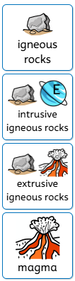

What is soil made from?



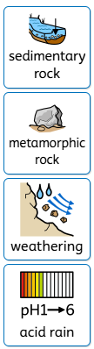
AIR – Oxygen, carbon dioxide, nitrogen
ORGANIC MATTER – Living and dead plants and animals.
WATER – Air and water fill the gaps between particles of soil.
MINERALS – Broken down rock.

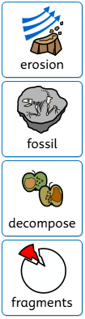

Incredible Italy
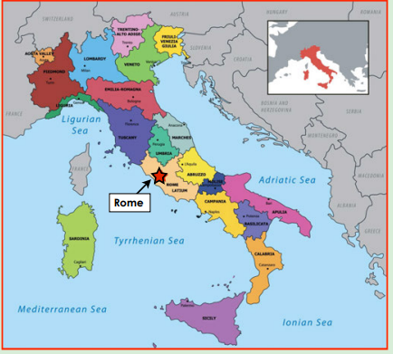
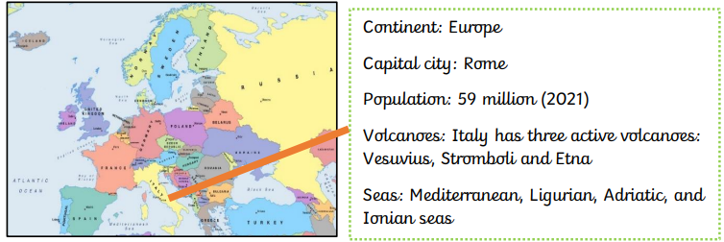

The capital city of Italy is Rome.

Physical Features

Human Features

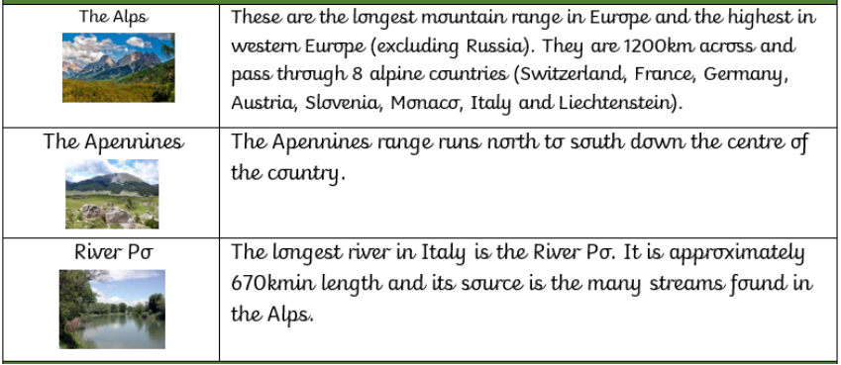
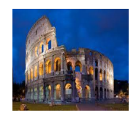
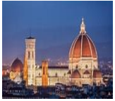
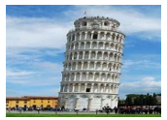
Cathedral of Santa Maria
Leaning Tower of Pisa
Colosseum
The Colosseum in Rome, built in 70 A.D., as one of many built throughout Italy during the time of the Romans. This huge amphitheatre could hold 50,000 spectators and was often the scene of chariot races, gladiator and animal battles along with executions.

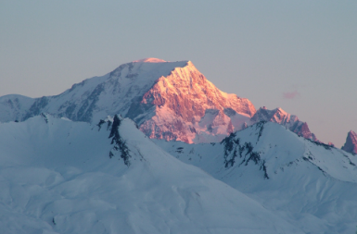
Mont Blanc is the highest mountain in the Alps.

Key Vocabulary
Pompeii

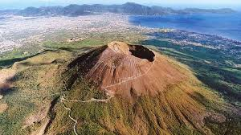
Mountains | A very high area of land with steep ides.
Volcano | A moutain from which hot melted rock, gas, steam and ash from inside the Earth sometimes burst.
Amphitheatre | Brick built oval stadium – Roman architecture.
Peninsula | A piece of land which is almost completely surrounded by water.
Borders | Political factors and physical (e.g rivers, ountains and seas) affect where borders between countries are set.
Roundhouse | A circular dwellling.
Landmark | A key feature or building that is easily seen and important to the area.
Human feature | Something man-made such as a landmark, road, factory or airport.
Physical feature | Something natural as mountains, deserts, jungles or rivers.
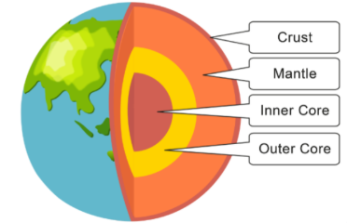

The city of Pompeii was a major resort city during the times of Ancient Rome. However, in 79 AD, disaster struck the city when it was buried under 20 feet of ash and debris from the eruption of the nearby volcano, Mount Vesuvius. The city of Pompeii was a popular vacation destination for the Romans. It is estimated that between 10,000 and 20,000 people lived in the city. Many wealthy Romans had summer homes in Pompeii and would live there during the hot summer months.

