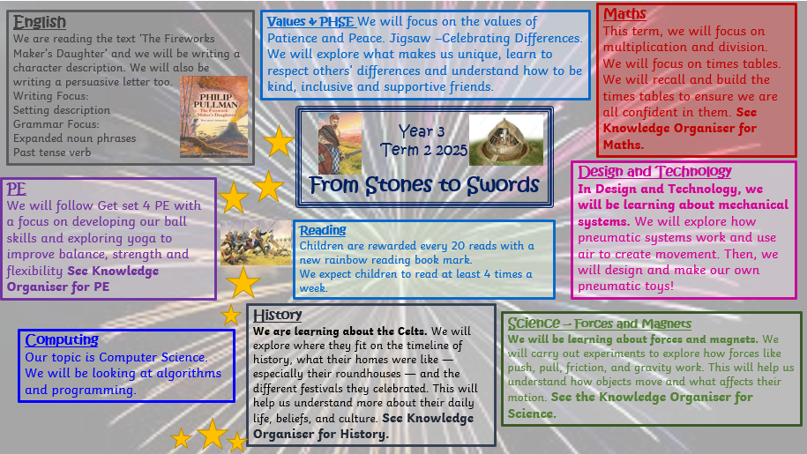

From Stones to Swords – Celtic Britain

Timeline
The Iron Age in Britain started around 800 BC. It followed the Bronze Age after iron began to be used for making weapons and tools – it was stronger than bronze an easier to work with. The Iron age continued in Britain about 800 years until the Romans invaded in AD 43.

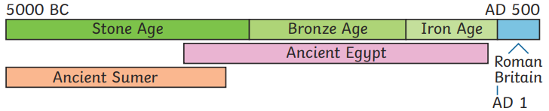

Warriors
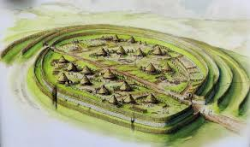

Hillforts

Celtic warriors would have usually fought with a long sword or shield and an oval, wooden shield. They often went into battle wearing blue warpaint.

The Iron Age people lived in farming communities in hillforts. These hillforts allowed hundreds of people to live together in a village where they could live off the land.
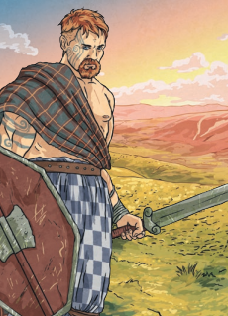

Clothing

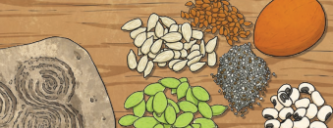
Men wore a T-shapes tunic made from wool or linen with trousers and a belt. Women wore floor length skirts or dresses with a cloak pinned with a brooch.
Woollen clothes would have been dyed with natural colours from berries and plants. Celts often wore jewellery made from bronze, silver, gold and tin. Checked and striped patterns were often worn.

Crops such as barley, oats and wheat were grown. Cows, pigs, goats and sheep were farmed for milk, meat and wool. Dee, wild boar and fish were hunted. Berries, nuts and plants were gathered.
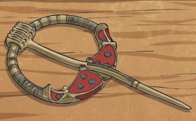

Key Vocabulary
Roundhouses

Prehistoric | A time before historical records began.
Celts | The name given to people who lived in Europe during the Iron Age.
Hillfort | A defended settlement built on hilltops.
Wattle and daub | A mixture of animal dung, clay and straw.
Bronze | A type of metal made from copper and tin to make it harder and more durable.
Roundhouse | A circular dwellling.
Invader | Invaders enter a country by force with the intention of conquering it. Invaders may take land.
Settlement | A place which hs typically been uninhabited, where people establish community.
Roundhouses were typical Iron Age circular houses. Some were very large, often housing lots of people living together. They had a timber frame, wattle and daub walls and a thatched roof. There would be a fire in the centre for cooking, light and warmth. Beds were made from hay or feather mattresses and animal skin or woollen blankets.

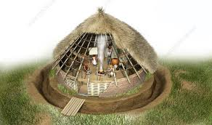

Religion
Iron Age Celts believed in over 400 gods or goddesses that they thought lived in rivers, woodlands, lakes and other natural places.
Druids were priests and religious leaders. They carried out religious rituals and were the only people who could communicate with the gods.
During religious festivals and rituals, sacrifices of food, precious objects and even humans were given to the gods in the hope that this would keep them happy.
Druids also had other important roles such as those similar to doctors (using plants for medicine), judges (sorting out disagreements within the tribes) and using nature to predict the future.

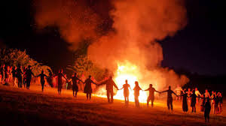

Forces and Magnets
Is it magnetic?
Magnetic Poles
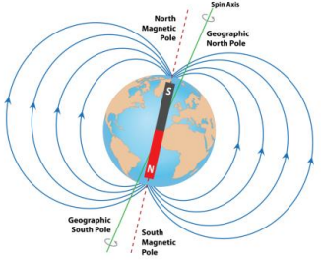
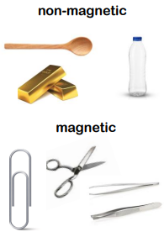
The ends of a magnet are called poles. One end is called the north pole and the other end is called the south pole. Opposite poles attract; similar poles repel. If you place two magnets so the south pole of one faces the north pole of the other, the magnets will move towards each other. This is called attraction. If you place the magnets so that two of the same poles face each other, the magnets will move away from each other. They are repelling each other.

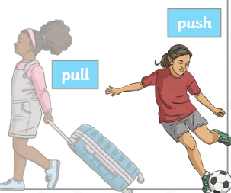
Scientists
Forces
Forces can be categorised into pushes or pulls.

Sir Isaac Newton | William Gilbert

Forces act in opposite directions to each other.
When an object moves across a surface, friction acts as an opposite force. Friction is a force that holds back the motion of an object.
Some surfaces create more friction than others, meaning that objects move across them more slowly.
On a ramp, the force that causes the object to move downwards is gravity.
Objects move differently depending on the surface of the object itself and the surface of the ramp

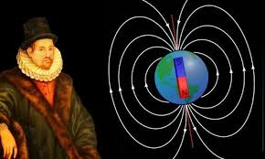
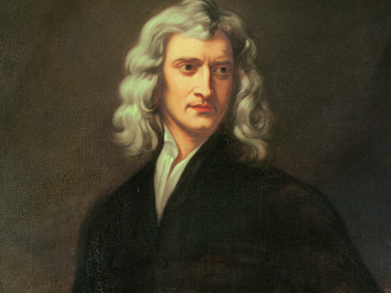

Newton theorised that a force must pull objects downwards after observing an apple fall from a tree. This sparked curiosity about why objects fall downwards rather than sideways or upwards.
A doctor to Queen Elizabeth I, Gilbert's work was crucial in explaining magnetism. He theorized that the Earth itself is a giant magnet with a metallic core and described the concept of the magnetic field.

