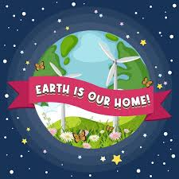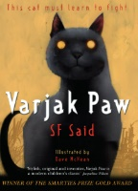

**Year 3 – Hedgehogs Class**

**Term 1 2025/26**

**Our Home, Our World**

Computing

We will be learning how to use the internet safely and find information to answer a range of different questions. We will learn how to determine which information is the most accurate to use.

Reading

Children are rewarded every 20 reads with a new rainbow reading book mark.

We listen to children read 1:1 or in a group setting during daily Guided Reading sessions.

Science

Our topic this term is ‘Light’. We will be learning about light sources and how shadows are formed.

PE

Children will get the opportunity to learn and develop skills in Gymnastics and Fitness this term.

PSHE

We will focus on the values of Friendship and Perseverance.

Jigsaw – Being Me in My World. We will think about our goals for the year and discuss how our own behaviour in class can affect other people.

Maths

We will focus on place value and 3-digit numbers. We will be solving problems using a written method.

Geography

We will be looking at settlements and our local area. We will be learning about different types of settlements and how they are different from one another. We will also explore how our local area has changed over time and consider the reasons behind those changes.

Art

Telling Stories Through Drawings

We will start off by taking inspiration from film and literature with observational drawings. We will then create our own art, reinterpreting and reinventing by making work in another medium.

English

We are reading the text ‘Varjak Paw’ and will be writing a setting description. We will also be writing a recount too.

Writing focus – grammar:

Expanded noun phrases

Fronted adverbials

Using commas

Subordination

