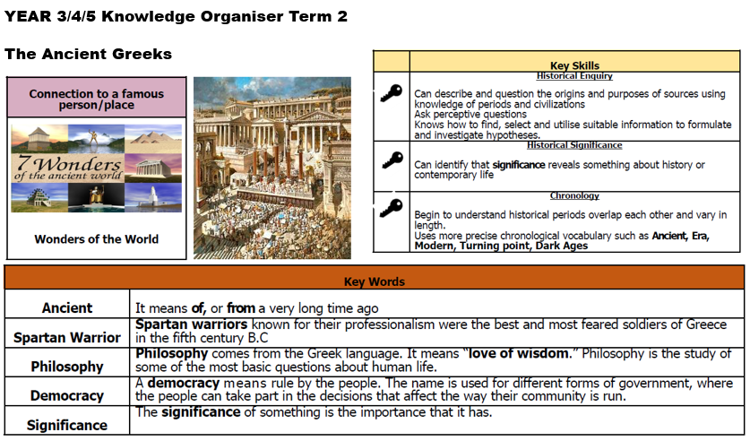

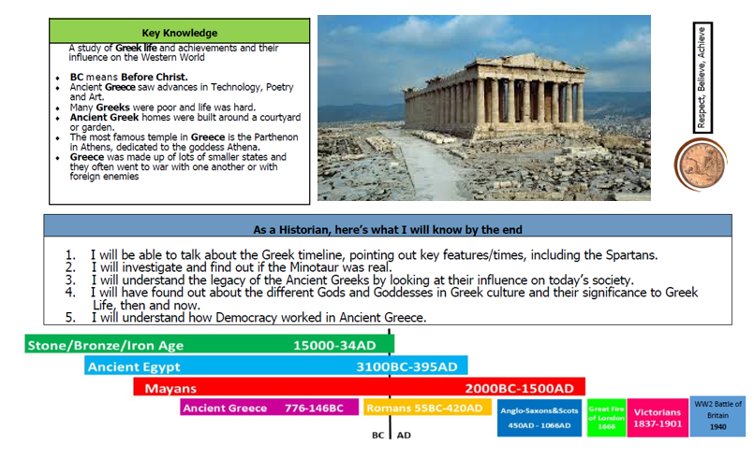

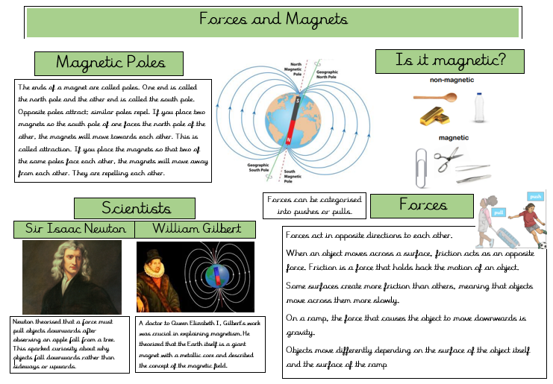

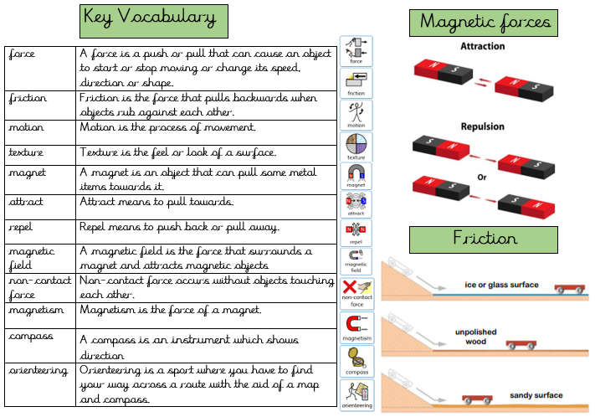

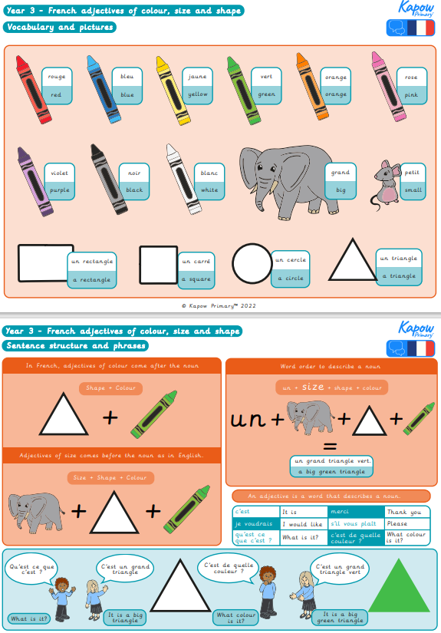

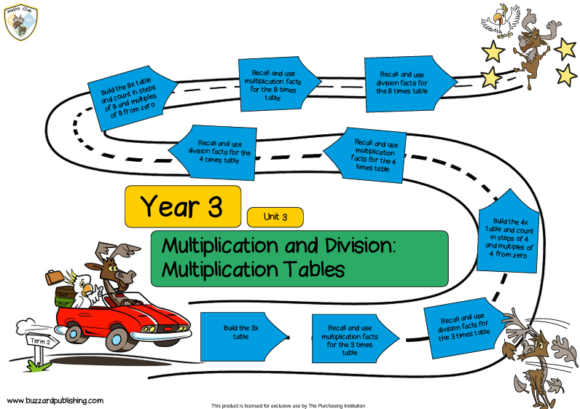

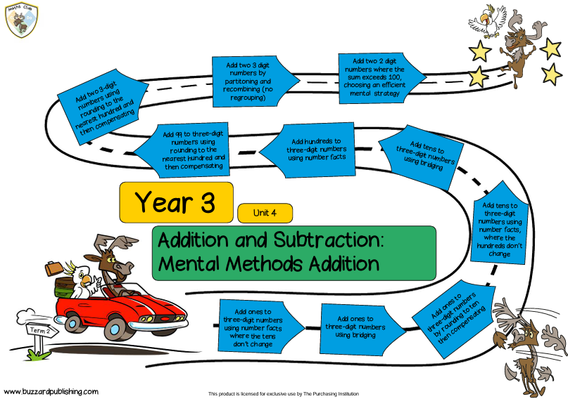

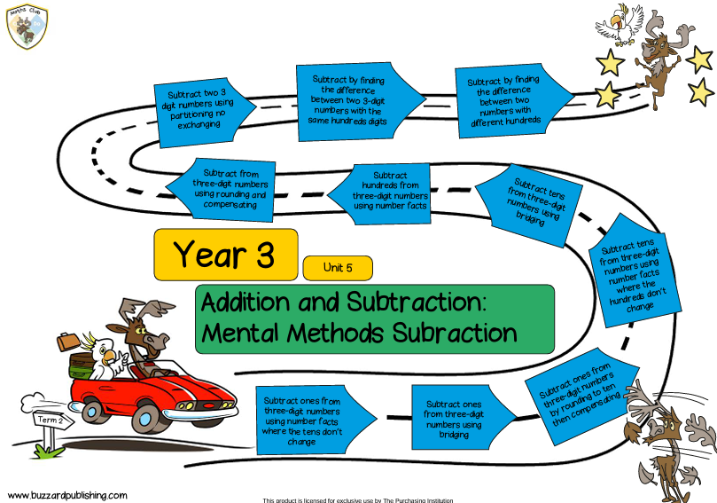

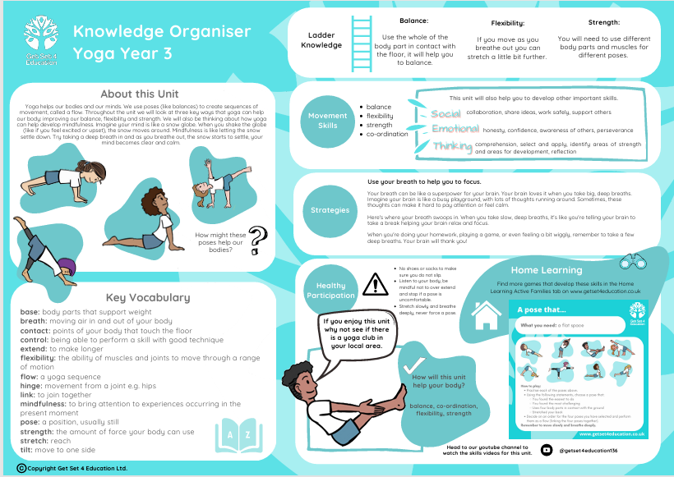

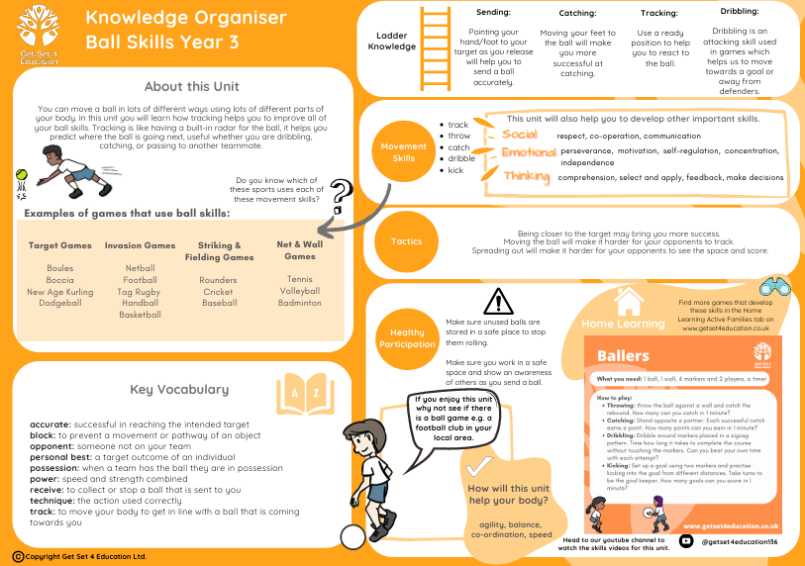
Y3 PSHE Jigsaw Knowledge Organiser Celebrating Difference
Puzzle Outcomes
- I understand that everybody’s family is different and important to them and appreciate my own family/ people who care for me.
- I understand that differences and conflicts sometimes happen among family members.
- I know how to calm myself down and can use the ‘Solve it together’ technique.
- I know what it means to be a witness to bullying.
- I know some ways of helping to make someone who is bullied feel better.
- I know that witnesses can make the situation better or worse by what they do.
- I can problem-solve a bullying situation with others.
- I recognise that some words are used in hurtful ways and will try not to use hurtful words.
- I can tell you about a time when my words affected someone’s feelings and what the consequences were.
- I can give and receive compliments and know how this feels.
Our Values of the term: Patience and Peace

Celebrating Difference at Haydon Wick Primary School
As good citizens of Haydon Wick Primary School, we understand that everybody is unique and we should respect and celebrate everyone’s differences.
Anti-bullying week: Power for Good
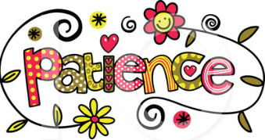

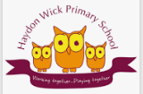

Key Vocabulary
Family | A family is two or more people who are connected by biology, adoption, marriage, or strong emotional bonds.
Conflict | A serious disagreement or argument.
Solution | The act or process of solving a problem or question.
Bullying | unwanted, aggressive behaviour that involves a real or perceived power imbalance.
Bystander | Someone who happens to be present when something takes place but does not take part in it.
Witness | A person who sees or hears something that happened.
Gay | Sexual or romantic attraction to people of the same sex.
Consequences | something that happens as a result of behaving in a particular way.

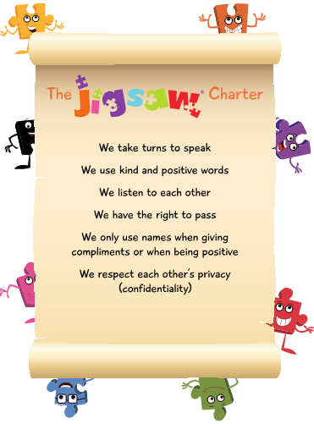

Weekly Celebrations
Week 1: Accept that everyone is different
Week 2: Include others when working and playing.
Week 3: Know how to help when someone is being bullied.
Week 4: Try to solve problems.
Week 5: Use kind words.
Week 6: Know how to give and receive compliments.

