+

Can you create a poster about Italy? You may want to focus on a particular city or landmark. You can present this on paper, create a model or even create it on the computer.
Can you create a collage of animals from your local area? Go for a walk in the woods or your local area and look to see what animals you can see. Then, using a variety of materials, create a collage.
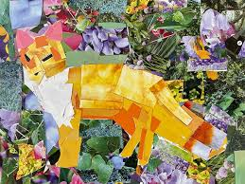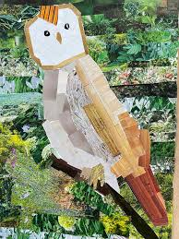
In English, we are reading the book, ‘The Wild Robot’.
Write a short paragraph of what tool Roz could make to survive on the island. You may want to draw a diagram to go with this.

In PE, we will be dancing. Make up your own routine and think about jumps, steps, arm movements or even pretend you’re an animal or a character. Upload your dance onto Class Dojo.

In Science, we are going to be learning about Rocks.
Can you create a poster showing different types of rocks? You can write about each type and draw some examples.

Hedgehogs Class
Pick and Mix Homework
Term 3
Remember you MUST do at least one of the activities.

Essential Homework To be done EVERY DAY!
Read for 10 minutes
Learn and practise your spellings.
Pracitse your times tables on TTRS.
Computing - You will need to log on to Purple Mash & look for the 2dos. This term, it is based on a couple of maths activities based on multiplication.

Imagine you are Roz, the robot living on the island. Write about one full day in Roz’s life. Think about the following: What do you do when you wake up? What sounds and sights do you notice on the island? How do you find food or help your animal friends? How do you keep safe at night?

All work to be returned by 12th February 2026

