+
In English, we are reading the book, ‘The Song of a Dolphin Boy.’
Write a non-chronological report about dolphins. Some of the headings could be:
Where do they live? or Diet or Behaviour
Can you create a collage of your favourite meal or picnic? You could use magazines, printed images, coloured paper, natural items like rice or pasta. Remember to label each food item.

Can you paint or draw the landscape of the River Cole in Coleshill? The river flows through countryside near Swindon before joining the River Thames. You may want to include trees and plants on the riverbank or wildlife that live nearby. Research first so you are able to see what it looks like.

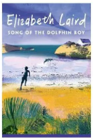

In Science, we are going to be learning about Animals, including Humans.
Can you create a food groups poster? Label each food group and include examples.
Can you create your own multiplication questions and answer them using the formal method? Example: 24 x 6 =
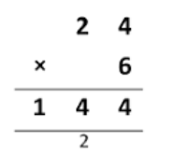

Hedgehogs Class
Pick and Mix Homework
Term 5
Remember you MUST do at least one of the activities

Essential Homework To be done EVERY DAY!
Read for 10 minutes.
Learn and practise your home spellings and Purple Mash spellings.
Practise your times tables on TTRS.
Computing - You will need to log on to Purple Mash & look for the 2Dos. This term, it is based on a couple of science activities for our topic ‘Animals, including humans’.

Can you carry out a personal fitness challenge? You could measure:
How fast you can run 50 metres, how many star jumps you can do in 1 minute or how far you can jump. Record them and add them to Class Dojo.

All work to be returned by Friday 15th May 2026

