Curriculum Intent, Impact & Implementation – History
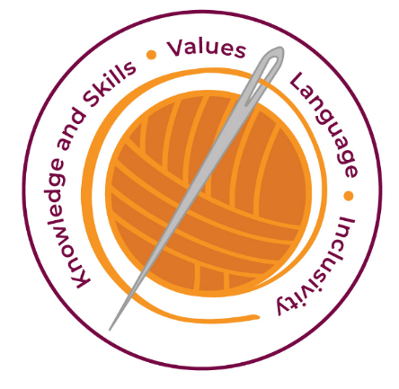

Our curriculum has four golden threads which are woven through all we do.
3R’s – Respect, Resilience and Responsilbity
Within these threads we have our 22 core values – understanding, unity and co-operation, freedom, appreciation and simplicity, hope, resilience, responsibility, thoughtfulness, tolerance, trust, friendship, perseverance, patience, peace, quality, love, humility, honesty, caring, happiness and courage.

Knowledge and Skills Intent & Implementation –  Our intention is to develop lifelong learners who have the skills knowledge, and curiosity needed to take full advantage of every opportunity in life. | - A secure knowledge and understanding of people, events and contexts from the historical periods covered.  - The ability to think critically about history and communicate confidently in styles appropriate to a range of audiences.  - The ability to consistently support, evaluate and challenge their own and others’ views using detailed, appropriate and accurate historical evidence derived from a range of sources.  - The ability to think, reflect, debate, discuss and evaluate the past, forming and refining questions and lines of enquiry.

Impact – All children are ready for the next part of their life whether that be the next year at primary or ready for their move to secondary and beyond. They understand the importance of learning and value all opportunities.
Values Intent & Implementation –  Our intention is that all children recognise and maintain a shared set of values, which will allow them to make a positive difference to themselves and others in a rapidly changing world. | - A passion for history and an enthusiastic engagement in learning, which develops their sense of curiosity about the past and their understanding of how and why people interpret the past in different ways.  - A respect for historical evidence and the ability to make robust and critical use of it to support their explanations and judgements.  - A desire to embrace challenging activities, including opportunities to undertake high-quality research across a range of history topics.  - What they learn through history can influence their decisions about personal choices, attitudes and values.  - To stimulate the children’s curiosity in order for them to develop their knowledge, skills and understanding.

Impact - All children have a core set of values which underpin every decision they make. They understand the importance of values and how these make us feel personally and how showing values allows children and young people to live positively in modern Britian.
Language Intent & Implementation –  Our intention is that all children will acquire the language to allow them to express their thoughts, ideas and learning in a clear and coherent manner. | - We use Widgets to support the children’s recall of key language  - The children are encouraged to express well-balanced opinions, rooted in very good knowledge and understanding about current and historical issues in society.

Impact – All children have a language rich curriculum where they are encouraged to communicate effectively in full sentences. They are taught the skills to communicate efficiently within a vast range of situations and understand the need of listening attentively and responding appropriately to be a successful communicator
Inclusivity Intent & Implementation –  Our intention is that no child is left behind. Every child, regardless of background, social, emotional, or educational need will achieve well and fulfil their potential. | - We create a positive and supportive environment.  - Everyone is included and this promotes unity.  - Responding to individuals needs of all our diverse learners develops understanding, tolerance and thoughtfulness

Impact – All children feel valued and consider themselves as equal while also developing a good understanding of the difference between equity and equality. Diversity is celebrated. Children are supported to show resilience and are proud of their achievements whatever their starting points.
The Foundation Stage.
The Early Years Foundation Stage Curriculum supports children’s understanding of History through the planning and teaching of ‘Understanding the World’. This aspect is about how children find out about past and present events in their own lives, their families and other people they know. Children are encouraged to develop a sense of change over time and are given opportunities to differentiate between past and present by observing routines throughout the day, growing plans, observing the passing of seasons and time and looking at photographs of their life and of others.

Key Document Details
Author: S Osborne | Approver: Whole School
Owner: E Rushen-Gough | Version: 2.0
Date: September 2024 | Next Review: Sept 2025

