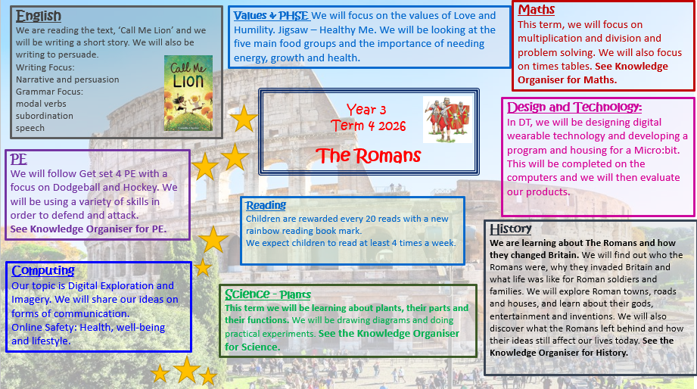

The Romans

Timeline
The first Romans lived in Italy nearly 3000 years ago. They founded the city of Rome in 753 BC and, over the centuries, conquered many lands to create a huge empire.

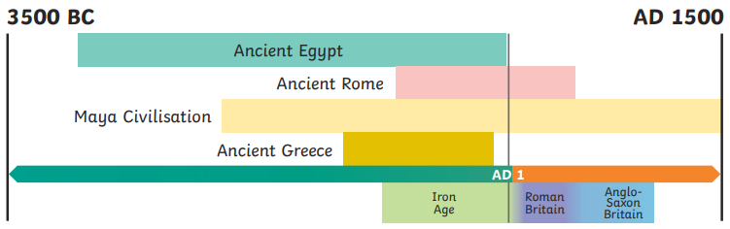
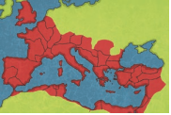

Roman Villas

Emperor Claudius
Wealthy Romans and some Celts built large homes in the countryside called villas. The land attached to these homes was used for farming as agriculture was an important business for the Romans. Countryside villa complexes, included a main house, bath house, workshops and gardens.

In AD 43, Emperor Claudius launched a third attack on Britain. He sent a powerful and well-organised army of around 40,000 men (that landed in southern England) to conquer the Celtic tribes. This time, much of Britain (or Britannia as the Romans called it) did become another province of Rome.

The Colosseum
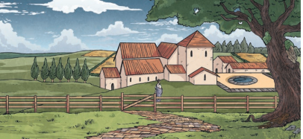

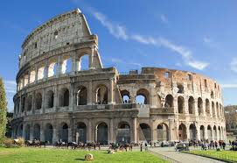
The Colosseum is in Rome. This is the most famous, surviving Roman amphitheatre.
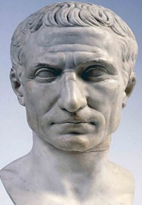
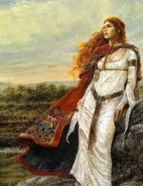
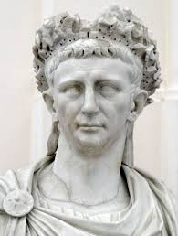
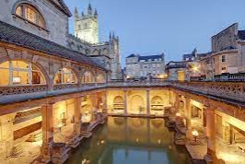

Emperor Claudius
Julius Caesar
Boudicca

Key Vocabulary
Hadrian’s Wall in AD 122

tribe | A group of people who share the same culture and values.
Roman Empire | The name used for the land that was controlled by the Romans, including large parts of Europe plus parts of North Africa and West Asia.
empire | A group of countries controlled by one ruler or government.
emperor | The ruler of an empire.
conquest | Taking control of a place by fore, often with an army.
citizen | A person with all the rights and protections of a nation or land. In the Roman Empire, only citizens were able to vote.
Celts | People living in Britain tribes, including the Iceni, Brigantes and Catuvellauni.

In AD 122, Emperor Hadrian gave an order to build a wall in the north of the country. Roman legions had tried to conquer Caledonia (Scotland), but the Picts would not give up their lands and they also raided land that the Romans controlled. Hadrian’s Wall took around six years to build and it was 73 miles long. Around 15,000 troops lived at Hadrian’s Wall so they could defend this northern border of the Roman Empire.

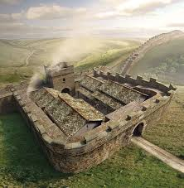

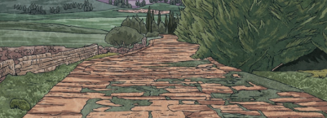

Roman Roads and Towns
The Roman army are famous for building long, straight roads. Special engineers planned these roads and they criss-crossed the whole Roman Empire. They boosted trade, communication with the emperor and helped the legions to keep control of all the different provinces.
The Romans built new towns all over Britain. Each one had a marketplace, town hall, shops, temples and homes; large towns had an amphitheatre. Bath houses were elaborately designed and were popular places to relax and meet friends.

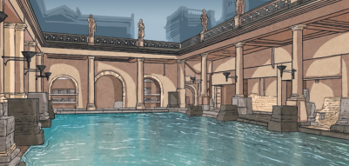

Plants
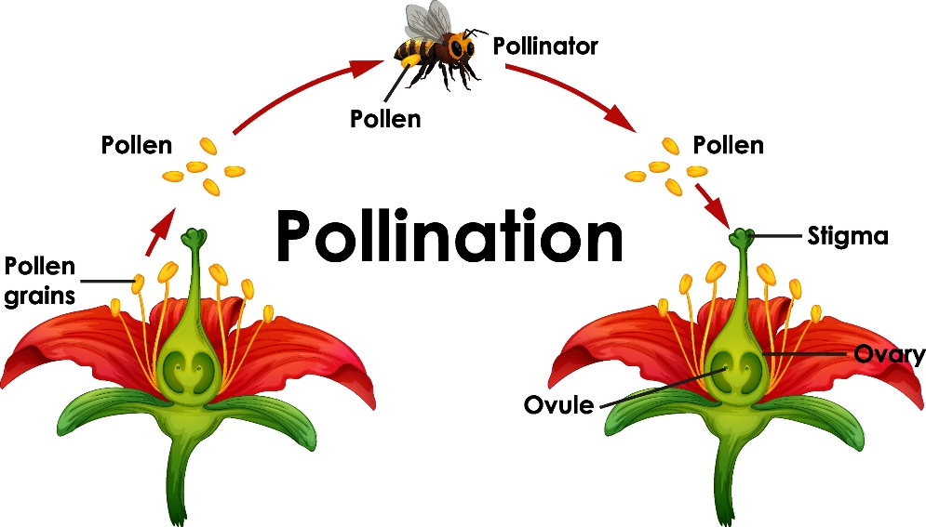
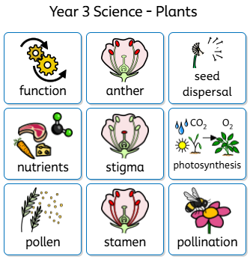

Pollination

Parts of a plant

- The roots of a plant absorb water from the soil and anchor it.
- The stem transports water to the leaves.
- The leaves make food for the plant through photosynthesis
- The flower is where the plant reproduces through the processes of pollination, fertilization, seed formation and dispersal.

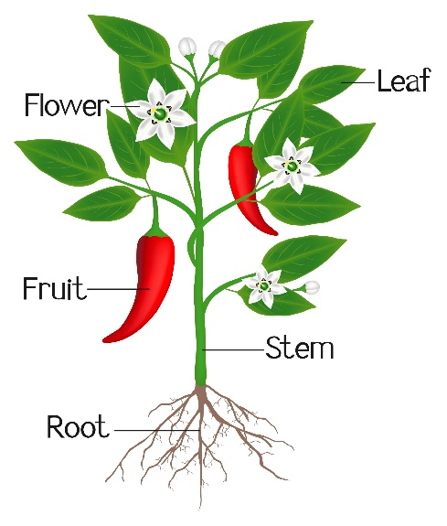

Parts of a flower

Vocabulary

function | a job that part of a living thing has to keep it alive
nutrients | a substance that is needed for healthy growth, development and functioning
photosynthesis | the process in which green plants use sunlight, water and carbon dioxide to make their own food
stamen | the male part of the flower
anther | the top of the stamen that produces the pollen
stigma | the female part of a plant that is sticky to collect pollen
pollen | a fine powder produced by certain plants for the pollination process
pollination | the process by which pollen is moved from the male to the female part of a flower
seed dispersal | the scattering or spreading of seeds
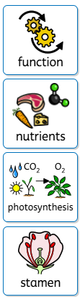
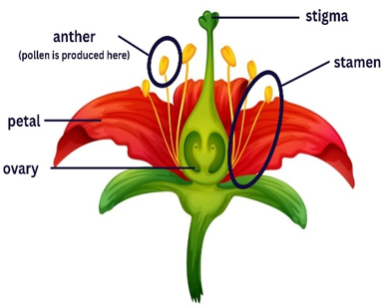

Seed dispersal
