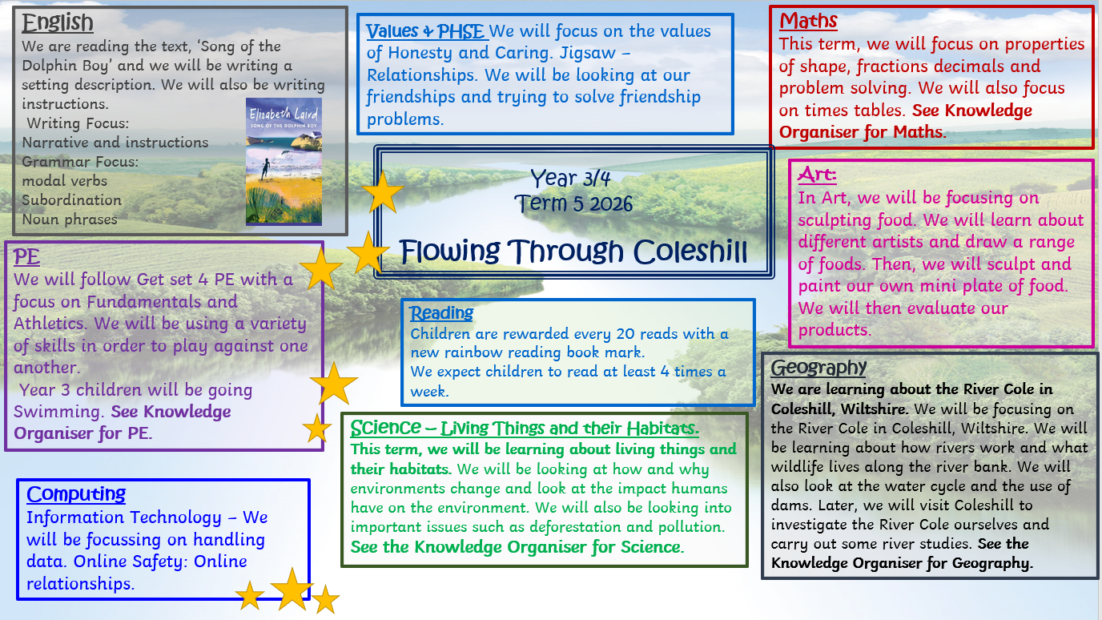

Year 4/5

Flowing Through Coleshill
The Water Cycle
How Do We Use Rivers?

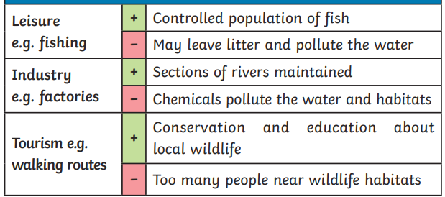
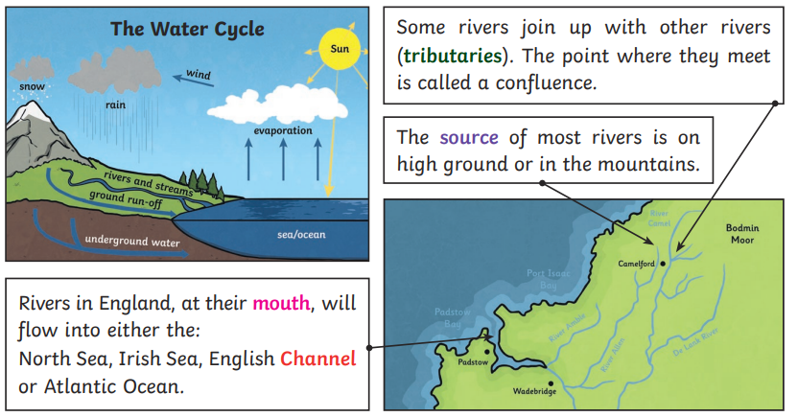

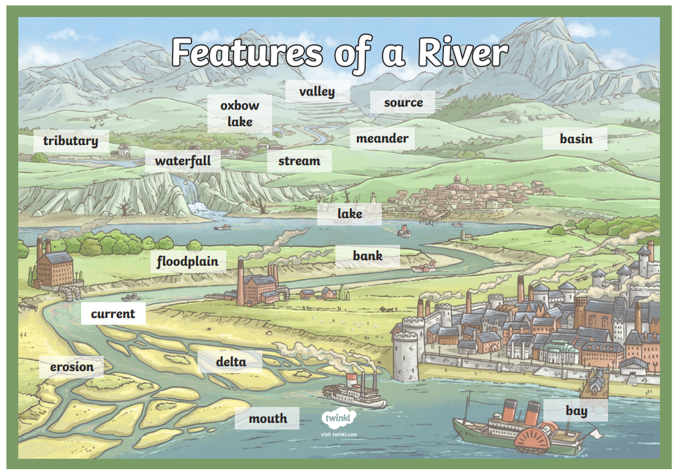
Dams

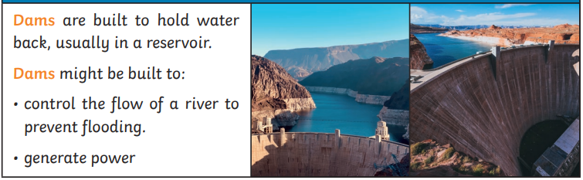

Coleshill
Key Vocabulary

Channel | The course in the ground that a river or water flows through.
Dam | A barrier built to hold back water.
Erosion | Rocks and other river materials ae picked up by the water and moved to another place along the river.
Valley | A long ditch in the earth’s surface between ranges of hills or mountains.
Mouth | The point where a river ends, typically where it meets the sea.
Flooding | When a river overflows its banks.
Drainage | How water flows away from an area through rivers and streams.
Coleshill is a small village near Swindon in the English countryside. It is known for its historic buildings, quiet rural setting, and farmland owned by the National Trust. The village has a long history and is a peaceful place with traditional English character.

River Cole is a small river that flows through the countryside near Swindon. It runs through villages such as Coleshill and continues north towards Oxfordshire. The river supports local wildlife and is surrounded by fields, meadows, and walking paths. It is an important natural feature of the local landscape.

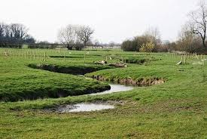
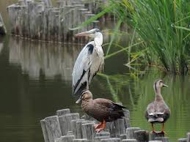

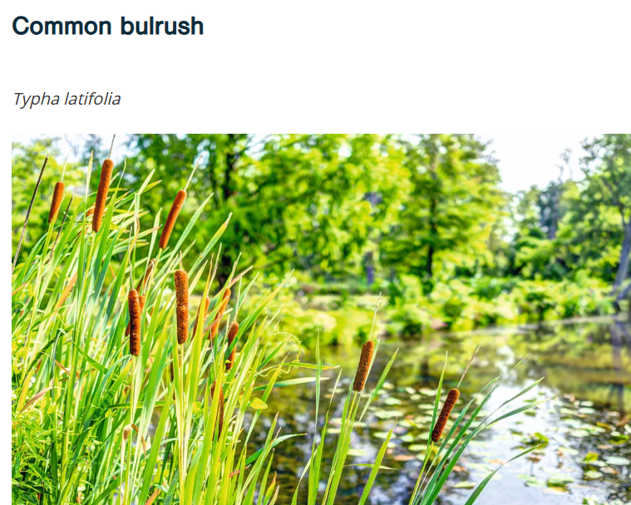
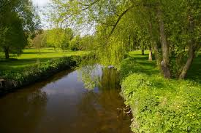

Living Things and Their Habitats
Why Environments Change

How Environments Change

NATURAL CHANGES – different seasons can change habitats. Greenhouse gases cause climate change and climate change has caused our planet to get a lot warmer over a very short period of time. This has caused more extreme weather events like hurricanes, floods and droughts. It has also caused the extinction of many living things.
HUMAN CHANGES – How humans live and what they do can impact habitats both negatively and positively.
Negative ways:
• Deforestation - cutting down trees for a range of reasons
• Littering – dropping rubbish or leaving large objects lying in the environment
• Pollution – introducing harmful substances into the environment.
• Air pollution from cars, e.g., carbon monoxide, and the burning of fossil fuels.
• Water pollution through industrial waste and farm fertilisers that can pollute rivers and streams.
• Rubbish—Plastic and household waste ends up on the streets, in the sea or in rubbish dumps, destroying habitats and wildlife.
Positive ways:
• Protecting endangered species via conservation projects
• Cleaning bodies of water
• Recycling
• Creating nature reserves

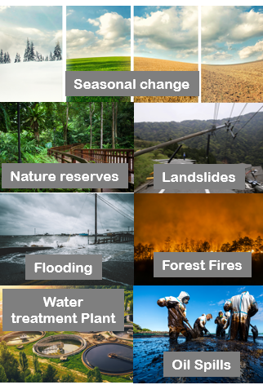

The water people use in their homes comes from nature and must be cleaned up to be returned to nature so it can be used again. This is an important part of our water cycle.

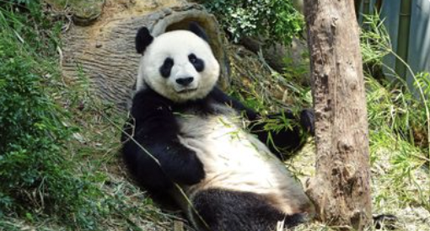

Key Vocabulary
Vertebrate or invertebrate?

migrate | To move from one area to another.
monsoon | Rainy season
deforestation | The cutting down of forests, including rainforests.
emissions | The production or discharge of something, especailly gas or raditation.
drought | To mix with a liquid and become part of a liquid.
freshwater | Water that does not contain salt.
camouflage | A way of blending or hiding in your surroundings.
adapted | Changed to suit an environment.
