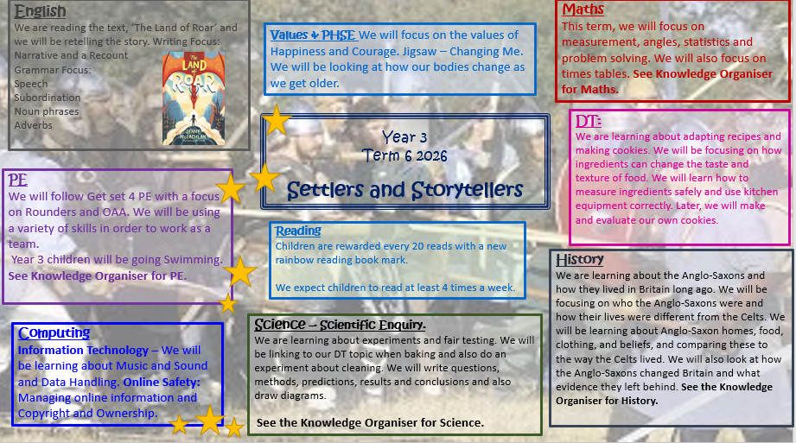

Scientific Enquiry
Asking questions and writing predictions
The Scientific Method

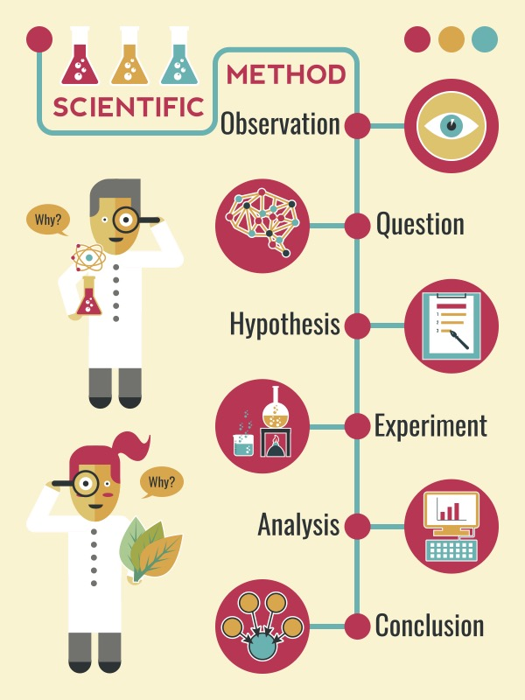
A good scientific question asks what happens when something is changed, or how it compares to something else. This means it can be tested.
A good scientific prediction says what you think will happen, and why you think that based on what you already know about the investigation.

Writing a conclusion

Writing a method and completing a practical test
- First, say what you have found out.
- Next, give evidence for the experiment that proves what you have found out.
- Then, explain your evidence (results) using scientific knowledge.
- Finally, say if your prediction was correct.
If you can, write further questions you could investigate.

Keep everything the same, apart from the independent variable.
Use a table to organise and record the results.
Use numbers and time words to organise the steps.
The independent variable is the only thing that is changed in the experiment.

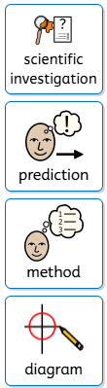
Vocabulary
scientific investigation | finding answers to questions using research methods
prediction | explaining what you think might happen
method | instructions for carrying out an experiment
diagram | a drawing or plan that shows the parts of something or how the parts work together
equipment | the objects needed to complete a method
fair test | where one variable is changed and all other elements are kept the same
variables | something that is changed in an experiment
results | information from a scientific test, such as the temperature of something
conclusion | the end result or outcome

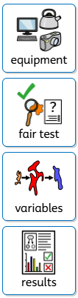

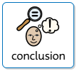

Settlers and Storytellers

Timeline
Living in Anglo-Saxon Britain

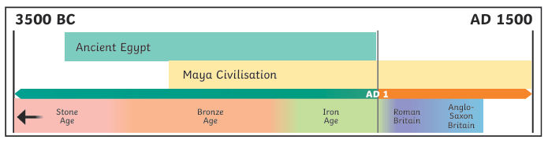
The Romans preferred living in towns but the Anglo-Saxons preferred to live in small villages. Anglo-Saxon influence can be seen in place names in Britain today. Wessex was a place named after the West Saxons who settled there. Sussex was named after the South Saxons. The kingdom of Mercia (which means border people) was named Mercia because it had so many borders with other kingdoms.

The Romans Leave Britain

Anglo-Saxon Paganism

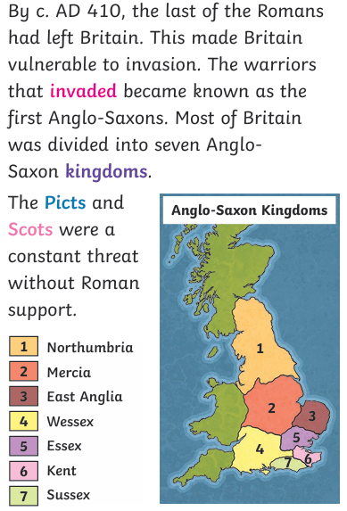

The religion of the early Anglo-Saxons was Paganism. They worshipped many gods. Festivals and sacrifices were made to the gods and goddesses. Pagans also believed in good and bad omens, lucky charms, spells and magic. They would perform many rituals that they believed would protect them in this life and the next.
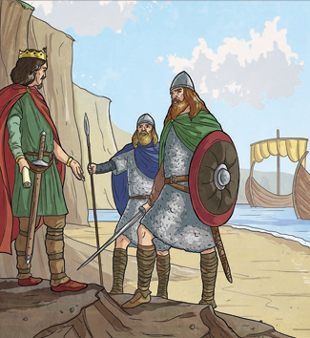

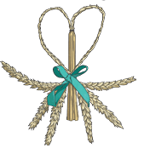

Key Vocabulary
The Anglo-Saxons and Christianity

angles | Tribes from an area today known as modern day Denmark that settled in Britain from around AD 450. They were one of the tribes that became known as the first Anglo-Saxons.
Saxons | A tribe from the north coast of Europe, especially Germany, that settled in Britain from around AD 450. They were one of the tribes that became known as the first Anglo-Saxons.
picts | Tribes originally from Scotland who were often feared.
invaders | People who enter an area and take control of it by force.
kingdom | An area ruled by a king or queen.
pagan | Someone who follows the Paganism religion and worships many gods and goddesses.
Christianity | A religion based on the teachings of Jesus Christ.

At the end of this period, Christianity became the main religion in Britain. In AD 597, a Roman monk called Augustine was sent to tell the Anglo Saxons about Christianity. King Ethelbert of Kent was the first to be converted and was baptised along with 10,000 of his people. Over the next 100 years, the rest of the kingdoms converted to Christianity too.

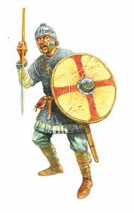
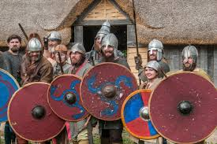

Christian Place of Worship
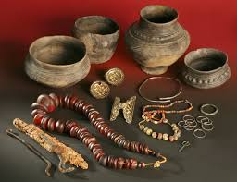

Many Christian places of worship were built at this time. Canterbury Cathedral was founded by Augustine. It was rebuilt from AD 1070 after a fire. A monastery was built on the island of Lindisfarne. This Holy Island was very influential and the monks here were successful at spreading Christianity across the north of England.

