Knowledge Organiser – Amazing Authors in Time
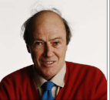
Overview
Roald Dahl (1916 – 1990) was a British children’s writer, poet and fighter pilot.

His books have sold more than 250 million copies worldwide and is often know as the ‘greatest children’s story teller of the 20th Century.’ Amongst his famous children’s stories are Charlie and the Chocolate Factry, George’s Marvellous Medicine, Matilda, Fantastic Mr Fox and The BFG.

His books often contain dark and villainous characters but teach the importance of being kind-hearted.

Dahl was born in Wales to Norwegian immigrant parents and fought in the RAF during World War 2.
Answers to Important Questions and Key Vocabulary
What did Dahl write about? |  | Most of Dahl’s stories feature mean, old characters – the enemies of children.  In Dahl’s stories, people who are kind, warm-hearted and often win through. | Key Vocabulary  Writer  Fighter Pilot  Norweigian  Clerk  Published  World War 2  Experiences  Metaphors  Rhyme  Illustrator  Alliteration
Was Dahl popular during his life? | 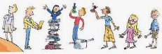 | Yes. Dahl’s books sold many millions of copies around the world when he was still alive. Many have been made into movies in recent years and so they have become even more popular.
What are Dahl’s most famous stories? | 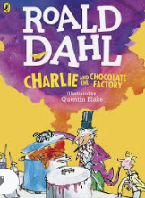  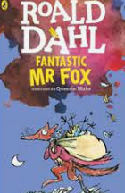 | Perhaps Dahl’s most famous story is Charlie and the Chocolate Factory. It is the story of a very poor, young boy, Charlie, who wins an opportunity to visit the remarkable factory of the greatest chocolate – maker in the world – Willy Wonka.  Fantastic Mr Fox is another of his famous tales. It tells the story of a very clever fox who steals food from three mean, old farmers – Boggis, Bunce and Bean.

Times in His Life
Early Life  Dahl was born on 13th September 1916 in Llandaff, Cardiff. He was names after Roald Amunden.  Both his sister and his father died when he was young. His mother chose to stay in the UK so he could go to UK schools.  He went to Repton School, one of the best schools in the UK. | Fighting in World War II  In 1939, Dahl quit his job as a clerk for the Shell Oil company to serve in the RAF during World War II.  At one point, he crash-landed his plane in north Africa, and was left with a fractured skull. He began to write about his experiences.
Children’s Writing Career
Hi first children’s book was written in 1943, called The Gremlins. He sent a copy to Eleanor Roosevelt, the wife of the American President, who read it to her children.

He drew on experiences of his time as a young trouble – maker, some of the mean people that he had met throughout his life, and his love of sweets and chocolate!

