Curriculum Intent, Impact & Implementation – MFL
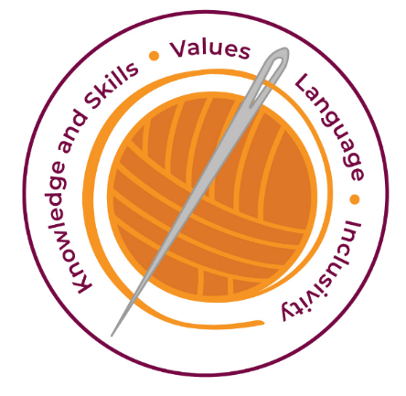

Our curriculum has four golden threads which are woven through all we do.

3R’s – Respect, Resilience and Responsilbity
Within these threads we have our 22 core values – understanding, unity and co-operation, freedom, appreciation and simplicity, hope, resilience, responsibility, thoughtfulness, tolerance, trust, friendship, perseverance, patience, peace, quality, love, humility, honesty, caring, happiness and courage.

Knowledge and Skills Intent & Implementation  Our intention is to develop lifelong learners who have the skills knowledge, and curiosity needed to take full advantage of every opportunity in life. | - We aim to develop children’s experience of language acquisition and encourage curiosity about languages.  - To develop their understanding of what they hear and read and have an ability to express themselves in speech and writing.  - The Kapow scheme of work which has been implemented aligns well with the requirements of the National Curriculum  - The Kapow French scheme of work is designed with six strands that run throughout. These are:  - Speaking and pronunciation  - Listening  - Reading and writing  - Grammar  - Intercultural understanding  - Language detective skills

Impact – All children are ready for the next part of their life whether that be the next year at primary or ready for their move to secondary and beyond. They understand the importance of learning and value all opportunities.
Values Intent & Implementation  Our intention is that all children recognise and maintain a shared set of values, which will allow them to make a positive difference to themselves and others in a rapidly changing world. | - Kapow encourage children work values such as unity, co-operation, friendship collaboratively and creatively.  - Children have a ‘Curiosity’ approach and show resilience to keep exploring and understand that all of their attempts are valid.  - The children respect the work of others and recognise that learning a language and speaking in front of others can be challenging.

Impact - All children have a core set of values which underpin every decision they make. They understand the importance of values and how these make us feel personally and how showing values allows children and young people to live positively in modern Britain.
Language Intent & Implementation  Our intention is that all children will acquire the language to allow them to express their thoughts, ideas and learning in a clear and coherent manner. | - The Kapow Curriculum is supported by a series of “Expert Teacher media clips” to ensure pupils are exposed to high quality models.  - The scheme provides balanced opportunities for communication in both spoken and written French, although in Year 3 the focus is on developing oral skills, before incorporating written French in Year 4 and beyond.  - The Kapow Primary scheme is a spiral curriculum, with key skills and vocabulary revisited repeatedly with increasing complexity, Page 4 of 5 allowing pupils to revise and build on their previous learning

Impact – All children have a language rich curriculum where they are encouraged to communicate effectively in full sentences. They are taught the skills to communicate efficiently within a vast range of situations and understand the need of listening attentively and responding appropriately to be a successful communicator.
- Extend their knowledge of how language works and explore differences between French and English
- Speak and read aloud with confidence and accuracy in pronunciation

Inclusivity Intent & Implementation  Our intention is that no child is left behind. Every child, regardless of background, social, emotional, or educational need will achieve well and fulfil their potential. | - Learning objectives appropriate to the child will be selected.  - Teachers will respond to pupil’s diverse learning needs  - Modify the curriculum to remove barriers so all pupils can access the same learning objectives.

Impact – All children feel valued and consider themselves as equal while also developing a good understanding of the difference between equity and equality. Diversity is celebrated. Children are supported to show resilience and are proud of their achievements whatever their starting points.

Key Document Details
Author: O Cresswell | Approver: Whole School
Owner: E Rushen-Gough | Version: 2.0
Update Date: September 2024 | Next Review: Sept 2025

