PSHE

Our topic is ‘Relationships’. We are specifically looking at what is considered a ‘healthy’ amount of time to spend online and how to stay safe online.

Make a poster including how to stay safe when online and outline the importance of having other hobbies e.g playing outside with friends and sports (so we don’t spend too much time online!)

Computing

Our topic is using search engines – can you make a list of questions for a family member or friend to answer using a search engine?

Maths

In Maths this term we are looking at a range of topics including fractions. Can you make a diagram depicting different fraction values? For example, using pizza and cake to show different values – the more imaginative the better!

Otters and Badgers

Pick n Mix Homework

Term 5

**All children must complete at least one task (we encourage other ideas too).**

**Due in by Friday 23rd May.**

Geography

Our topic is ‘Exploring Eastern Europe’. Create a fact file about a country in eastern Europe. Include the country’s flag, capital city, climate and any other interesting information that you find!

Science

Our topic is ‘states of matter’.

Can you draw a diagram showing the behaviour of particles in each state of matter? You could even video yourself pretending to be a particle in each state!

English

We are looking at the book ‘Wisp’. It is all about memories and having hope for the future. Write a paragraph about your favourite memory/a time when you felt really happy. You can add pictures and drawings too!

Art

Our topic is ‘Sculpture, Structure, Inventiveness & Determination’.

Can you create a sculpture? Use any materials and create any object!

Essential Homework

Read for 10 minutes every night.

Practise your spellings on Purple Mash and complete the weekly quiz.

Use TTRS (Times Tables Rock Stars).

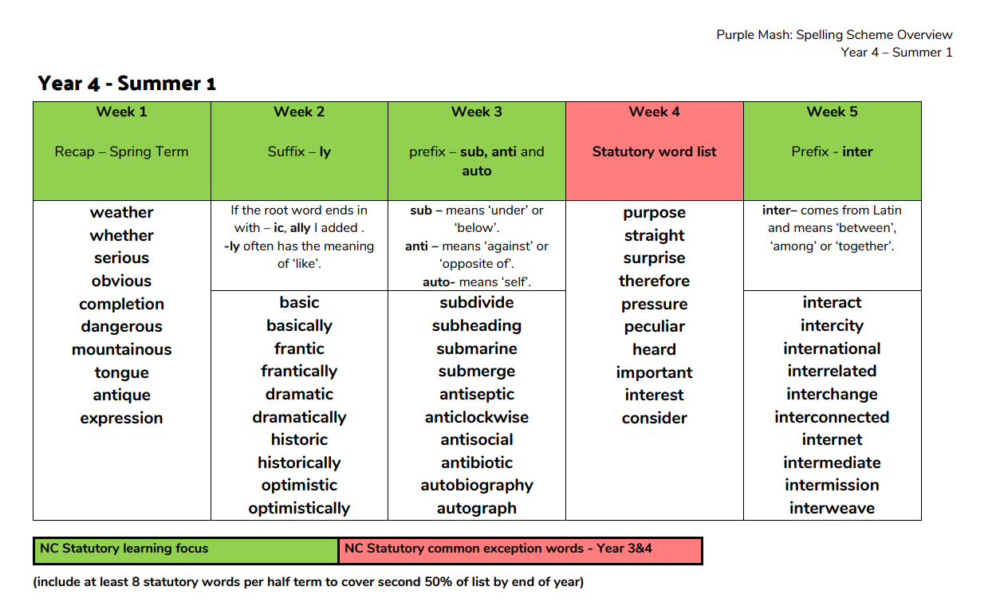

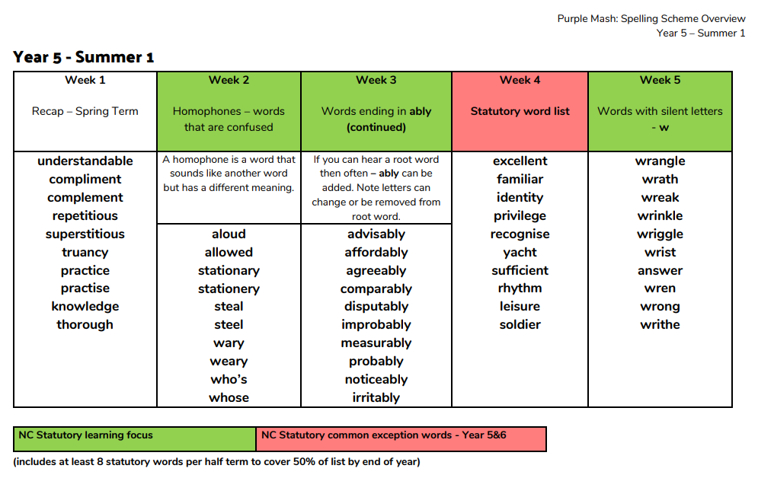

Spelling group

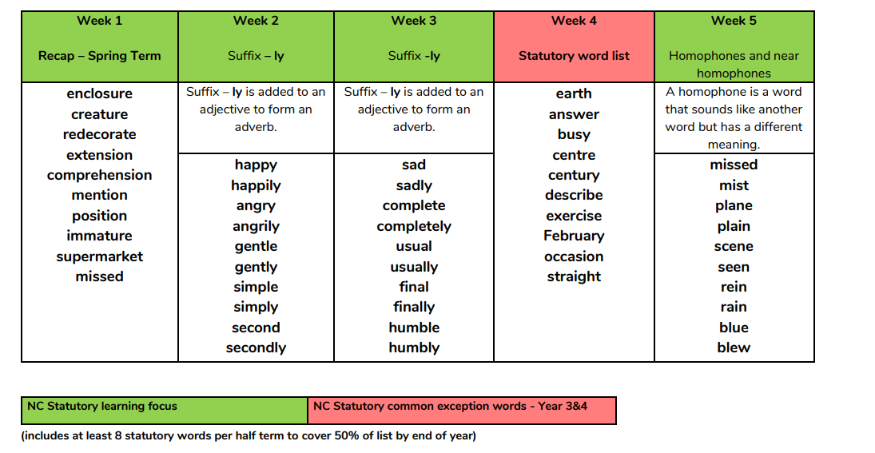

ZS

