Curriculum Intent, Impact & Implementation – PE
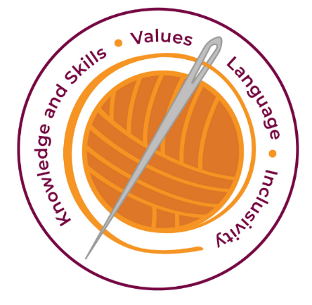

Our curriculum has four golden threads which are woven through all we do.

3R’s – Respect, Resilience and Responsilbity
Within these threads we have our 22 core values – understanding, unity and co-operation, freedom, appreciation and simplicity, hope, resilience, responsibility, thoughtfulness, tolerance, trust, friendship, perseverance, patience, peace, quality, love, humility, honesty, caring, happiness and courage.

Knowledge and Skills Intent & Implementation–  Our intention is to develop lifelong learners who have the skills knowledge, and curiosity needed to take full advantage of every opportunity in life. | - Develop and explore physical skills with increasing control and co-ordination.  - Develop the way they perform skills and apply rules and conventions for different activities.  - To provide children with opportunities to enjoy and succeed in the subject as well as being stimulated and challenged.  - Physical education is taught as a separate subject throughout the school. We use a variety of teaching and learning styles in PE lessons. Our principal aim is to develop the children’s knowledge, skills and understanding and we do this through a mixture of whole-class teaching and individual/group activities.

Impact – All children are ready for the next part of their life whether that be the next year at primary or ready for their move to secondary and beyond. They understand the importance of learning and value all opportunities.
Values Intent & Implementation –  Our intention is that all children recognise and maintain a shared set of values, which will allow them to make a positive difference to themselves and others in a rapidly changing world. | - Work and play with others in a range of group situations  - Develop positive attitudes towards health, hygiene, and fitness  - Develop personal characteristics like initiative, self-reliance, and self-discipline.

Impact - All children have a core set of values which underpin every decision they make. They understand the importance of values and how these make us feel personally and how showing values allows children and young people to live positively in modern Britian.
Language Intent & Implementation –  Our intention is that all children will acquire the language to allow them to express their thoughts, ideas and learning in a clear and coherent manner. | - Develop communication skills, encouraging the correct use of terminology.

Impact – All children have a language rich curriculum where they are encouraged to communicate effectively in full sentences. They are taught the skills to communicate efficiently within a vast range of situations and understand the need of listening attentively and responding appropriately to be a successful communicator.
Inclusivity Intent & Implementation –  Our intention is that no child is left behind. Every child, regardless of background, social, emotional, or educational need will achieve well and fulfil their potential. | - Setting common tasks that are open-ended and can have a variety of results  - Setting tasks of increasing difficulty, where not all children complete all tasks  - Providing a range of challenge through the provision of different resources, e.g. different gymnastics equipment  - Children with special educational needs including those deemed to be gifted and talented would be included in any physical education lesson. If a programme needs to be adapted then the teacher in charge will do this in consultation with the coordinator and SENCO (if applicable).

Impact – All children feel valued and consider themselves as equal while also developing a good understanding of the difference between equity and equality. Diversity is celebrated. Children are supported to show resilience and are proud of their achievements whatever their starting points.
The Foundation Stage.
As the reception year is part of the Foundation Stage of the National Curriculum, we relate the physical development of the children to the objectives set out in the Early Learning Goals, which underpin the curriculum planning for children aged three to five years of age. We encourage the children to develop confidence and control of the way they move, and the way they handle tools and equipment. We give all children the opportunity to undertake activities that offer appropriate physical challenge, both indoors and outdoors, using a wide range of resources to support specific skills. Balance ability lessons are also taught to the children and delivered by a member from Life Cycle UK.

Key Document Details
Author: B.Phillips | Approver: Whole School
Owner: E Rushen-Gough | Version: 2.0
Date: September 2024 | Next Review: Sept 2025

