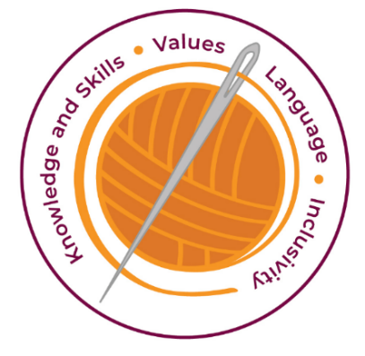
Curriculum Intent, Impact & Implementation - PSHE
Our curriculum has four golden threads which are woven through all we do.
3R’s – Respect, Resilience and Responsilbity
Within these threads we have our 22 core values – understanding, unity and co-operation, freedom, appreciation and simplicity, hope, resilience, responsibility, thoughtfulness, tolerance, trust, friendship, perseverance, patience, peace, quality, love, humility, honesty, caring, happiness and courage.

Knowledge and Skills Intent & Implementation –  Our intention is to develop lifelong learners who have the skills knowledge, and curiosity needed to take full advantage of every opportunity in life. | - All pupils have access to high quality teaching of PSHE.  - We endeavour to prepare pupils at our school for the opportunities, responsibilities and experiences of later life.  - To have a good understanding of how to stay safe, healthy and develop good, respectful relationships.  - To understand what it means to be a positive member of a diverse, multicultural society.  - The acquisition of knowledge and skills which will enable children to prepare them to be a global citizen now and in their future roles within a global community.  - We use flexible groups to develop children’s collaboration and co-operation.
Values Intent & Implementation –  Our intention is that all children recognise and maintain a shared set of values, which will allow them to make a positive difference to themselves and others in a rapidly changing world. | - As a values-based school, we aim to develop the whole child intellectually, morally, socially and spiritually in order to nurture rounded individuals with a strong sense of moral understanding and responsibility.  - Our Anti-Bullying and Rights Respecting council actively promote the school values such as respect, responsibility and kindness.  - Each month a value is introduced in assemblies and discussed with the children.  - Hot chocolate awards promote our school values and reward those who display them in or outside school.  - We teach the children about the importance of the British Values (Mutual Respect, Rule of Law, Democracy, Tolerance of different faiths and beliefs and Individual Liberty).  - Partner talk and group discussions help develop our values unity, co-operation, and friendship.
Language Intent & Implementation –  Our intention is that all children will acquire the language to allow them to express their thoughts, ideas and learning in a clear and coherent manner. | - Through high quality teaching, the language required to express their thoughts is taught and modelled.  - The children are encouraged to use the language taught in class and group discussions to express their own opinions.  - The relevant vocabulary is introduced and explained in each Jigsaw PSHE lesson.  - The language taught in each Jigsaw puzzle piece is consolidated and extended each year to ensure progression.
Inclusivity Intent & Implementation –  Our intention is that no child is left behind. Every child, regardless of background, social, emotional, or educational need will achieve well and fulfil their potential. | - PSHE lessons are accessible to all children in the school.  - We encourage the exploration of and respect for values held by different cultures and groups within our local community.  - We learn about ‘Celebrating Difference’ to appreciate our diversity.  - Everyone is included and aware of the UNCRC rights of the child.  - Responding to the individual needs of all our diverse learners develops understanding, tolerance and thoughtfulness.
The Foundation Stage.
In the Foundation Stage, PSHE and citizenship is taught as an integral part of topic work and is embedded throughout the curriculum. The objectives taught are the Personal, Social and Emotional Development statements from Early Years foundation stage statutory framework. Reception also uses the Jigsaw Scheme of Work materials

Key Document Details
Author: E Rushen-Gough | Approver: Whole School
Owner: E Rushen-Gough | Version: 2.0
Date: September 2024 | Next Review: Sept 2025

