Curriculum Intent, Impact & Implementation – RE
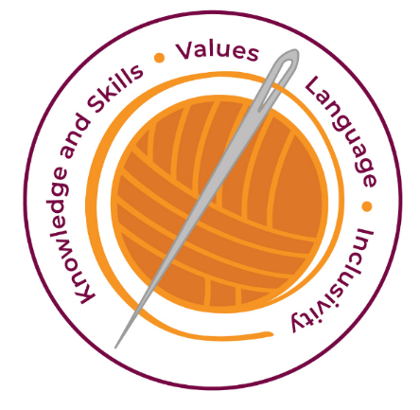

Our curriculum has four golden threads which are woven through all we do.

3R’s – Respect, Resilience and Responsilbity
Within these threads we have our 22 core values – understanding, unity and co-operation, freedom, appreciation and simplicity, hope, resilience, responsibility, thoughtfulness, tolerance, trust, friendship, perseverance, patience, peace, quality, love, humility, honesty, caring, happiness and courage.

Knowledge and Skills Intent & Implementation –  Our intention is to develop lifelong learners who have the skills knowledge, and curiosity needed to take full advantage of every opportunity in life. | - Our curriculum aims to teach children the key skills they need to be tolerant and respectful of other religions  - We offer children the opportunity to understand and appreciate religious traditions and diverse views. The children can reflect upon, discuss, and debate different ideas, whilst developing their own freedom and personal beliefs  - Their learning helps with understanding real life/the bigger picture to take them on the journey through school and in life

Impact – All children are ready for the next part of their life whether that be the next year at primary or ready for their move to secondary and beyond. They understand the importance of learning and value all opportunities.
Values Intent & Implementation –  Our intention is that all children recognise and maintain a shared set of values, which will allow them to make a positive difference to themselves and others in a rapidly changing world. | - Our whole school values support our aim to respect and appreciate all views and faiths  - We aim to inspire wonder and thoughtfulness, whilst celebrating children’s growing sense of self, their own community, and their place within it  - The children can develop their confidence and celebrate their community, enhancing their spiritual, moral, social, and cultural understanding  - The children will see themselves as global citizens, showing empathy, courage and responsibility

Impact - All children have a core set of values which underpin every decision they make. They understand the importance of values and how these make us feel personally and how showing values allows children and young people to live positively in modern Britian.
Language Intent & Implementation –  Our intention is that all children will acquire the language to allow them to express their thoughts, ideas and learning in a clear and coherent manner. | - The children are encouraged to express well-balanced opinions - developing oracy allows conversation and children can take more responsibility for their own learning  - The children will be inquisitive and ask questions - partner talk helps develop unity, co-operation, and friendship

Impact – All children have a language rich curriculum where they are encouraged to communicate effectively in full sentences. They are taught the skills to communicate efficiently within a vast range of situations and understand the need of listening attentively and responding appropriately to be a successful communicator
Inclusivity Intent & Implementation –Our intention is that no child is left behind. Every child, regardless of background, social, emotional, or educational need will achieve well and fulfil their potential. | - Every child has the freedom to access the key concepts underpinning religions and beliefs, whether they are of that tradition, or not  - We create a positive and supportive environment where everyone is included, promoting unity and love  - Equity and responding to individuals needs of all our diverse learners develops understanding, tolerance and thoughtfulness

Impact – All children feel valued and consider themselves as equal while also developing a good understanding of the difference between equity and equality. Diversity is celebrated. Children are supported to show resilience and are proud of their achievements whatever their starting points.

The Foundation Stage
By providing our youngest children with appropriate opportunities to find out and learn about the beliefs people hold and develop a range of skills, we give them a good foundation on which to
continue to develop their learning or RE as well as other subject areas. Relevant experience will include:
Listening and responding to stories, songs and poems about different beliefs.
Taking part in role play.
Talking and asking questions to develop their understanding of different viewpoints
and to make distinctions in their observations.
The RE teaching throughout the schools aims to build on these early experiences.

Key Document Details
Author: K.Powell | Approver: Whole School
Owner: E Rushen-Gough | Version: 2.0
Date: September 2024 | Next Review: Sept 2025

