Curriculum Intent, Impact & Implementation – Reading
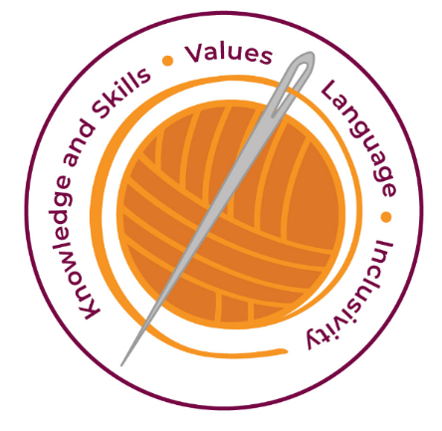

Our curriculum has four golden threads which are woven through all we do.

3R’s – Respect, Resilience and Responsilbity
Within these threads we have our 22 core values – understanding, unity and co-operation, freedom, appreciation and simplicity, hope, resilience, responsibility, thoughtfulness, tolerance, trust, friendship, perseverance, patience, peace, quality, love, humility, honesty, caring, happiness and courage.

Knowledge and Skills Intent & Implementation –  Our intention is to develop lifelong learners who have the skills knowledge, and curiosity needed to take full advantage of every opportunity in life. | - At Haydon Wick Primary School, we believe that for all our children to become fluent readers and writers. Reading is the "Gateway to Learning" and therefore all pupils need to be able to read well to access the full curriculum.  - As part of our ENRich curriculum, developing the basic mechanics of reading is at its core. It is engineered so that word reading and language comprehension is taught discretely.  - We have a strong focus on the development of language skills for our children because we know that speaking and listening are crucial skills for reading and writing in all subjects.  - We continue to use the Little Wandle programme for children who need continued exposure to phonics.  - Pupils are exposed to daily explicit word reading teaching and have opportunity for high-quality book talk.

Impact – All children are ready for the next part of their life whether that be the next year at primary or ready for their move to secondary and beyond. They understand the importance of learning and value all opportunities.
Values Intent & Implementation –  Our intention is that all children recognise and maintain a shared set of values, which will allow them to make a positive difference to themselves and others in a rapidly changing world. | - Children are encouraged to work with values such as unity, co-operation, friendship collaboratively and creatively.  - Children have a ‘Curiosity’ approach and show resilience to keep exploring and understand that all of their attempts are valid.

Impact - All children have a core set of values which underpin every decision they make. They understand the importance of values and how these make us feel personally and how showing values allows children and young people to live positively in modern Britian.
Language Intent & Implementation –  Our intention is that all children will acquire the language to allow them to express their thoughts, ideas and learning in a clear and coherent manner. | - To further develop RICH knowledge and skills, pupils are exposed to daily language comprehension teaching.  - As pupils move away from the SSP programme (in Year 2 and KS2), daily whole class lessons will be delivered.  - Centred around high-quality extracts and texts (with aspirational vocabulary), pupils will be explicitly taught language comprehension skills and strategies, enabling them to first understand and then explore the level of text they are required to read for their age.

Impact – All children have a language rich curriculum where they are encouraged to communicate effectively in full sentences. They are taught the skills to communicate efficiently within a vast range of situations and understand the need of listening attentively and responding appropriately to be a successful communicator.
Inclusivity Intent & Implementation –  Our intention is that no child is left behind. Every child, regardless of background, social, emotional, or educational need will achieve well and fulfil their potential. | - When pupils move through the school, daily whole class lessons will ensure pupils' reading accuracy; automaticity (speed) and prosody keeps pace with the level of text required for their age.  - To support pupils who fall behind, additional "accelerated" catch up interventions will be put in place.  - To further develop RICH knowledge and skills, pupils will also be exposed to daily language comprehension teaching.

Impact – All children feel valued and consider themselves as equal while also developing a good understanding of the difference between equity and equality. Diversity is celebrated. Children are supported to show resilience and are proud of their achievements whatever their starting points.

Key Document Details
Author: A Neal. | Approver: Whole School
Owner: E Rushen-Gough | Version: 2.0
Date: September 2024 | Next Review: Sept 2025

