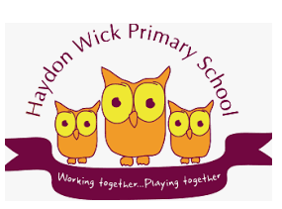

Haydon Wick Primary School
Reading Progression

Foreword
The over-arching aim of teaching reading is to support children in becoming fluent and motivated life-long readers. These age-related expectations (AREs) are intended to support teachers in making decisions about where pupils are in relation to national expectations. They have been organised into six strands: - oral - organisation and research - range - response - grammar (language, style and impact) - word reading The AREs have been thoroughly cross-referenced against the National Curriculum objectives, the National Curriculum non-statutory guidance, the six strands above and the parallel Writing AREs.

Oral 1: (reference Range)
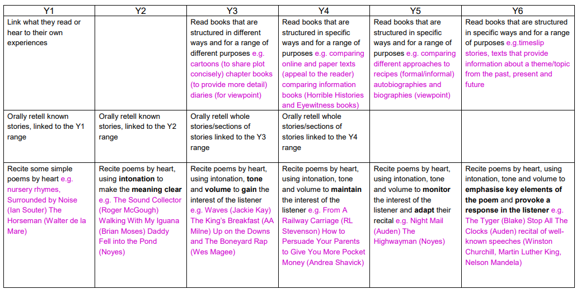

Oral 2: (reference Range)
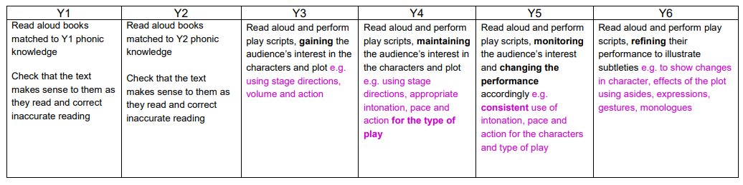

Organisation and Research: 1
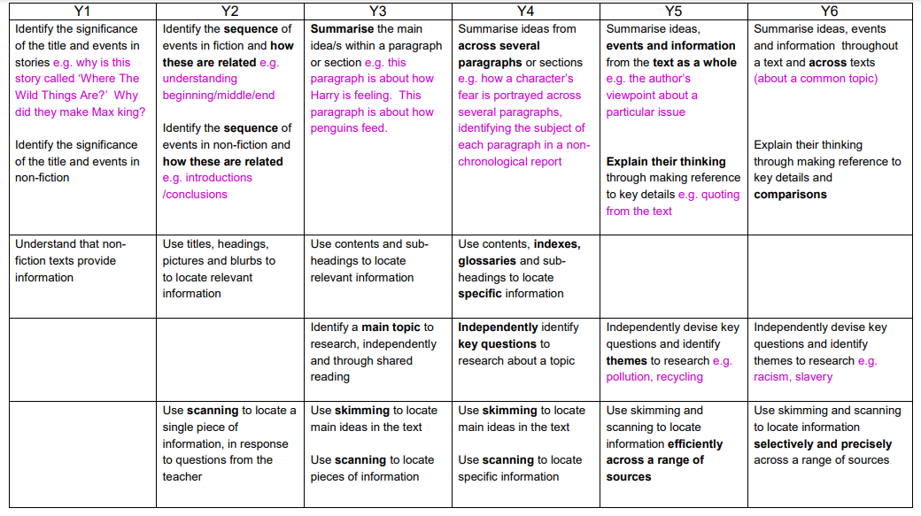

Organisation and Research: 2
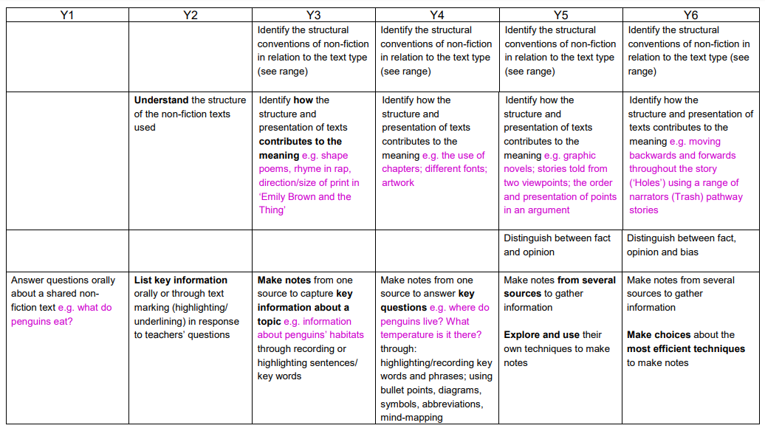

Organisation and Research: 3
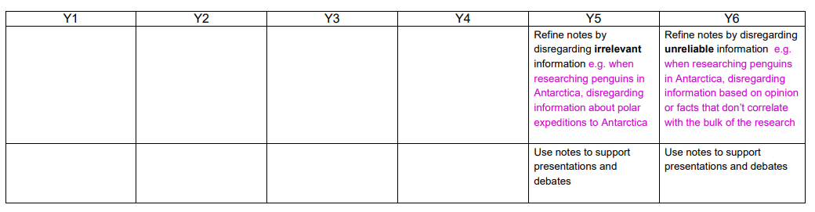

Response: 1
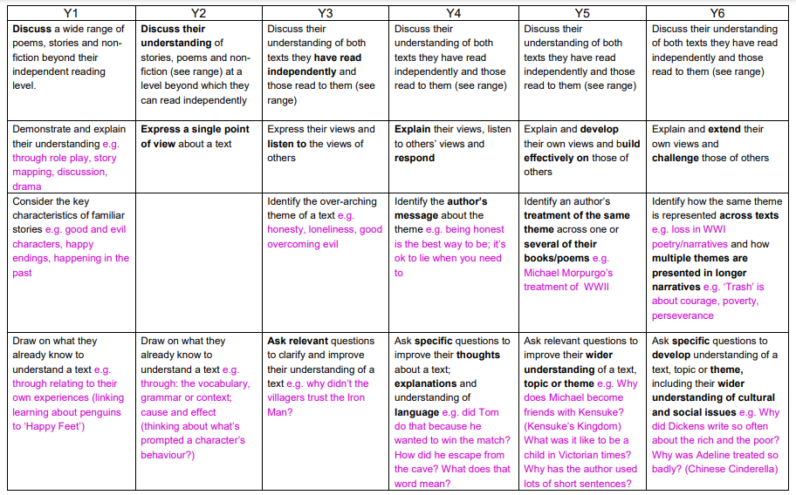

Response: 2
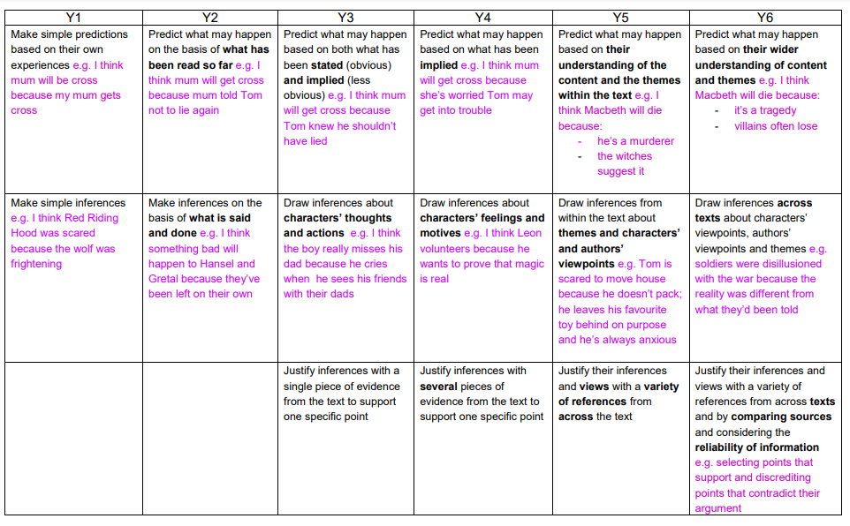

Grammar (Language, Style and Impact)
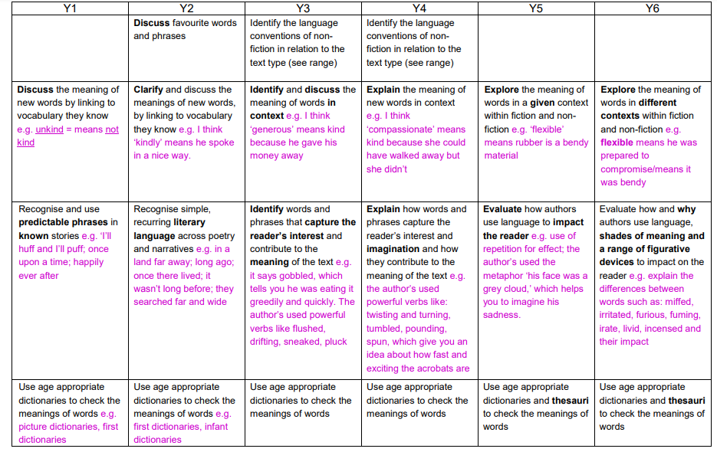
Word Reading
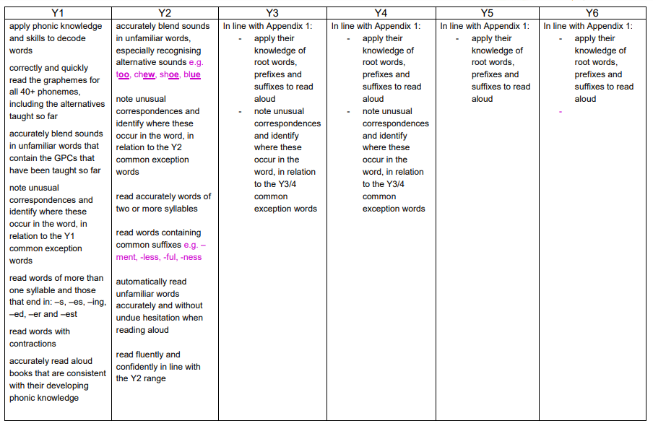

Range
In all year groups, pupils should be able to read texts that are in line with the word reading expectations for their year group. They should also be exposed to texts beyond the level at which they can read independently, through listening to texts read aloud and through shared reading. In both cases, pupils should read texts that range not only in their content but also in the way they are structured. As their skills develop, pupils should be able to select and refine their choice of texts for a range of purposes.
Please see the accompanying document, which exemplifies what is constituted by ‘a wide range of texts’ for each year group.

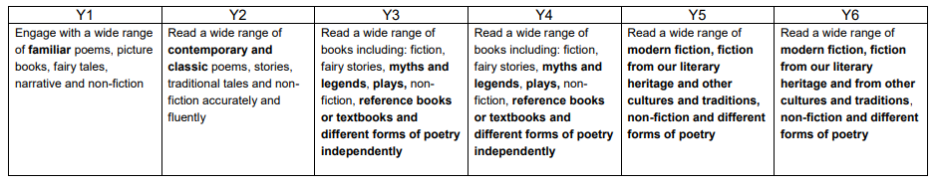

Reading Assessment: Year 1
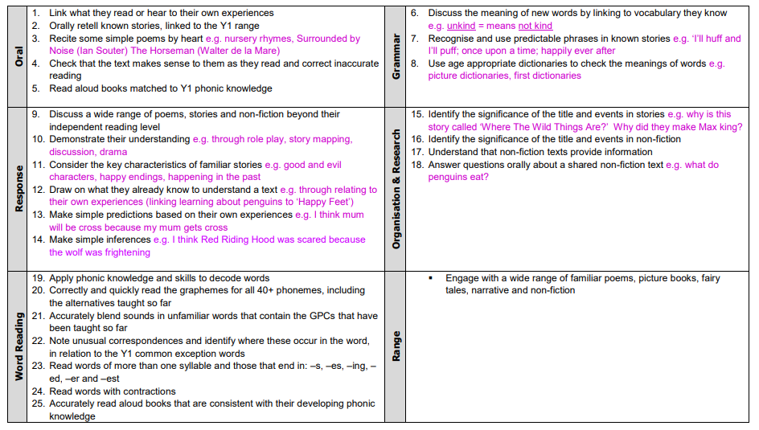

Reading Assessment: Year 2
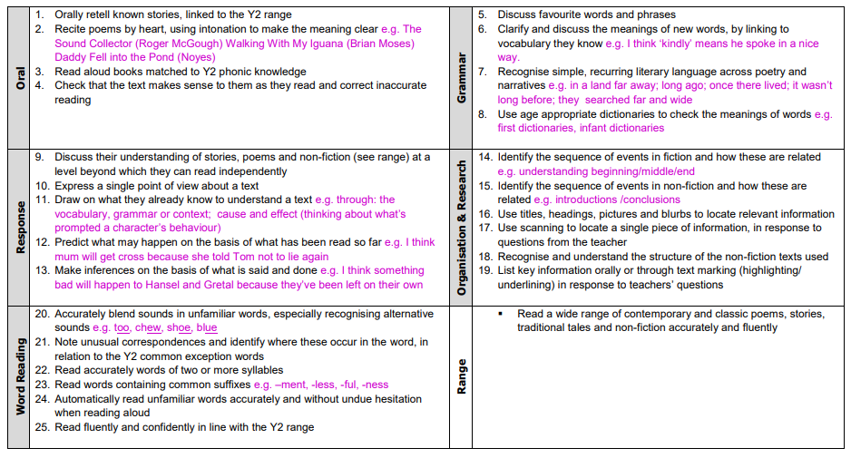

Reading Assessment: Year 3
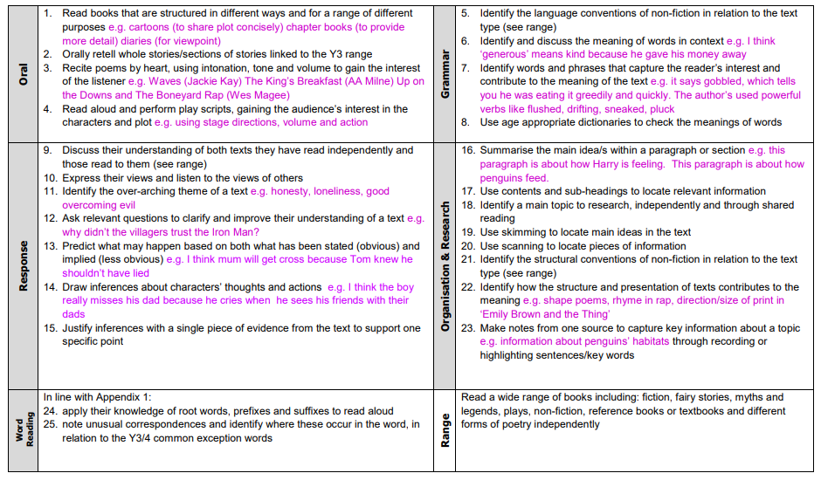

Reading Assessment: Year 4
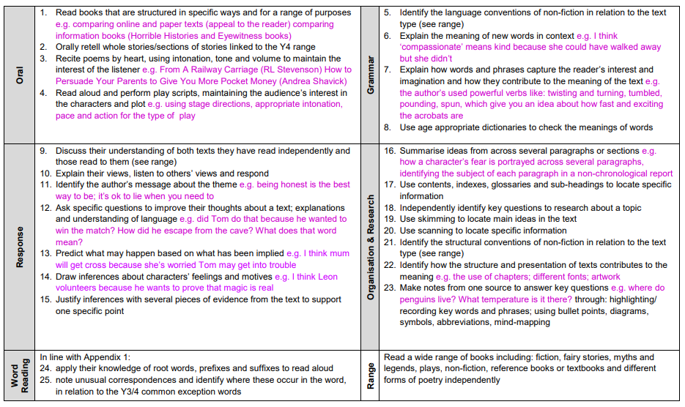

Reading Assessment: Year 5
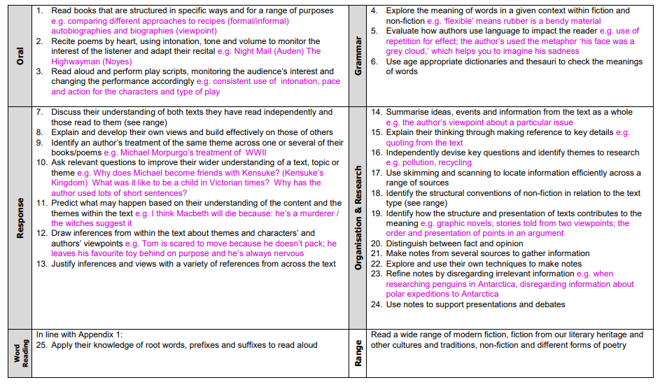

Reading Assessment: Year 6
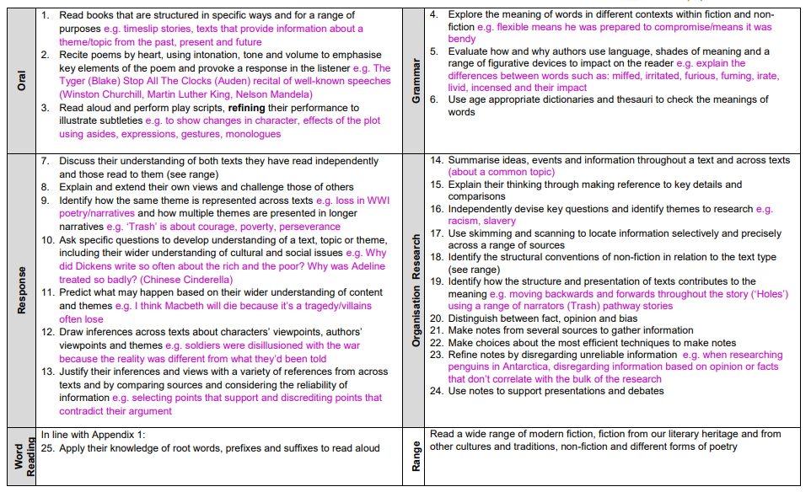

Reading Range
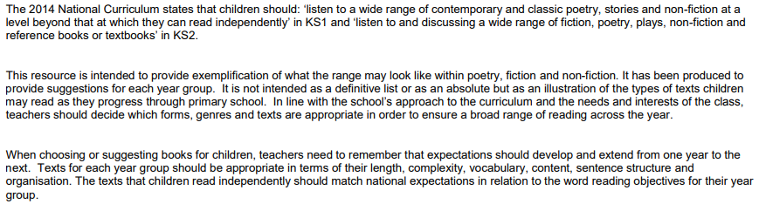

Poetry Range
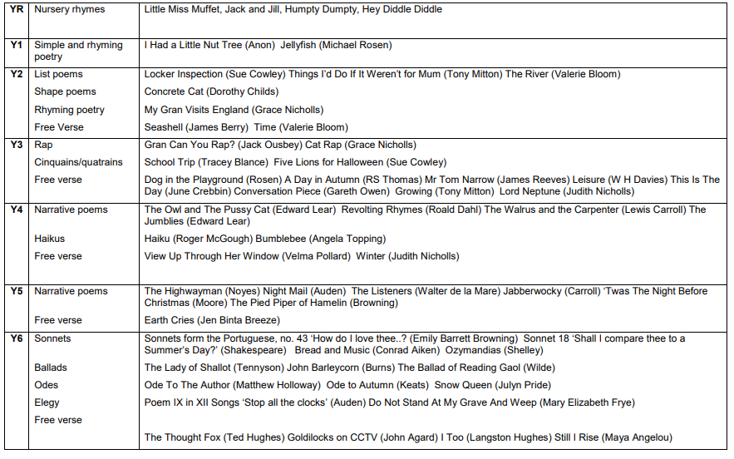

Narrative Range
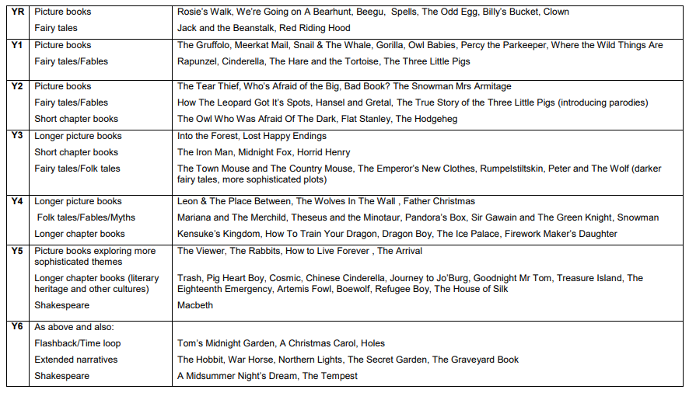

Non Fiction Range 1
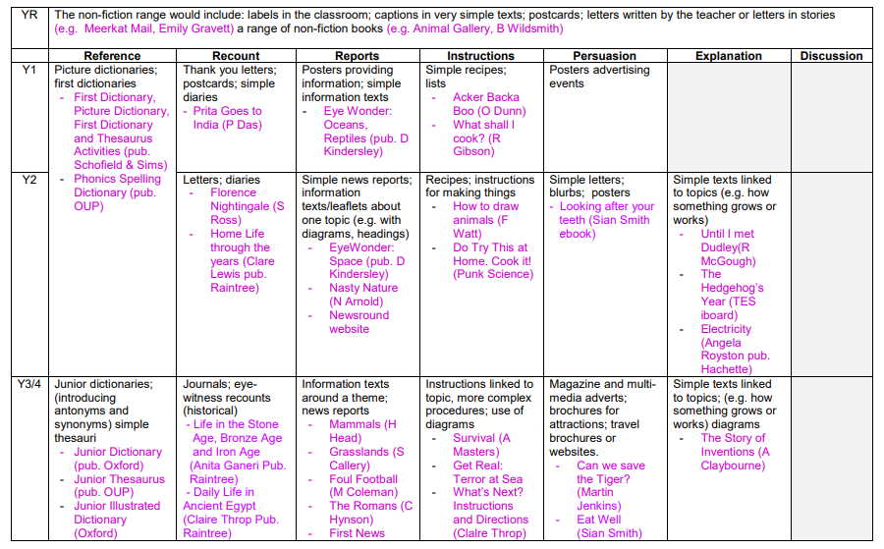

Non Fiction Range 2
