Curriculum Intent, Impact & Implementation - SEND
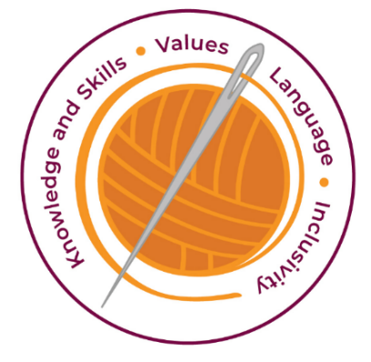

Our curriculum has four golden threads which are woven through all we do.
3R’s – Respect, Resilience and Responsilbity

Within these threads we have our 22 core values – understanding, unity and co-operation, freedom, appreciation and simplicity, hope, resilience, responsibility, thoughtfulness, tolerance, trust, friendship, perseverance, patience, peace, quality, love, humility, honesty, caring, happiness and courage.

Knowledge and Skills Intent & Implementation  Our intention is to develop lifelong learners who have the skills knowledge, and curiosity needed to take full advantage of every opportunity in life. | - All pupils have access to high quality teaching – good teaching for SEND pupils is good teaching for all.  - As a Dyslexia Friendly school, we promote multisensory learning which strengthens understanding, helps children make links and helps children retain their learning.  - Retrieval practise at the start or during lessons develop metacognition strategies which ensure all learners are active whilst developing resilience and perseverance.  - We use flexible groups to develop children’s collaboration and co-operation.  - As a DFS we promote metacognitive strategies by teaching children to acknowledge what they find difficult and then thinking about what helps them overcome their barriers.

Impact – All children are ready for the next part of their life whether that be the next year at primary or ready for their move to secondary and beyond. They understand the importance of learning and value all opportunities.
Values Intent & Implementation  Our intention is that all children recognise and maintain a shared set of values, which will allow them to make a positive difference to themselves and others in a rapidly changing world. | - As a Dyslexia Friendly School, we recognise and celebrate diverse leaners. By acknowledging and celebrating the fact we are all different we are teaching tolerance, kindness and humility.  - Our DLC acknowledges that some children find some things more challenging but with resilience, perseverance and courage we can achieve.  - DLC certificates value the effort children have put into their learning to achieve their best whatever their difficulties.  - Partner talk helps develop our values unity, co-operation, and friendship

Impact - All children have a core set of values which underpin every decision they make. They understand the importance of values and how these make us feel personally and how showing values allows children and young people to live positively in modern Britian.
Language Intent & Implementation  Our intention is that all children will acquire the language to allow them to express their thoughts, ideas and learning in a clear and coherent manner. | - High quality teaching is complemented with targeted interventions.  - SALT support develops communication.  - ELSA develops the vocabulary needed to honestly communicate emotions so children can develop trusting relationships and skills to self-regulate.  - Developing oracy allows lessons to be a conversation and children take more responsibility for their own learning within the lesson.  - Teachers use quality dialogue to support the conversation and model their own ‘expert learner’ thought processes to allow children to develop metacognitive skills.

Impact – All children have a language rich curriculum where they are encouraged to communicate effectively in full sentences. They are taught the skills to communicate efficiently within a vast range of situations and understand the need of listening attentively and responding appropriately to be a successful communicator
Inclusivity Intent & Implementation  Our intention is that no child is left behind. Every child, regardless of background, social, emotional, or educational need will achieve well and fulfil their potential. | - Being a DFS means we create a positive and supportive environment for all our pupils. The DLC ensures everyone is included and promotes unity. This removes barriers to participation, reduces passivity and promotes resilience.  - Following an Assess, Plan, Do, Review cycle means we build ongoing and holistic understanding of all our pupils.  - Equity and responding to individuals needs of all our diverse learners develops understanding, tolerance and thoughtfulness.

Impact – All children feel valued and consider themselves as equal while also developing a good understanding of the difference between equity and equality. Diversity is celebrated. Children are supported to show resilience and are proud of their achievements whatever their starting points.

Key Document Details
Author:E.Johnson | Approver: LGB
Owner:C.Neal | Version: 1.0
Date: May 2024 | Next Review: Sept 2024

