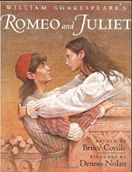  Research one of Shakespeare’s plays. Create a comic strip for it, including the key scenes. | 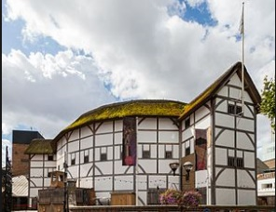  Design and make a model of The Globe Theatre. | 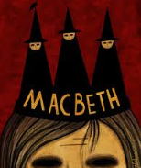  Choose a key speech from Macbeth. Learn it off by heart and present it to the class. Examples are: The Witches’ Spell, Macbeth’s soliloquy : ‘Is this a dagger I see before me?’
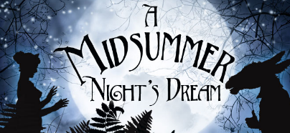  Design a poster advertising one of Shakespeare’s plays. Make it eye-catching and include key information. | Pick and mix homework  Term 3 | 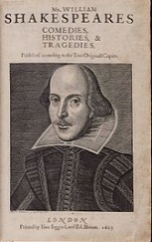  Create a quiz on William Shakespeare. It must have at least 15 questions and an answer sheet.
Tudors did have clocks but they were very expensive, so many people used sundials to tell the time.  Design and make a sundial. | 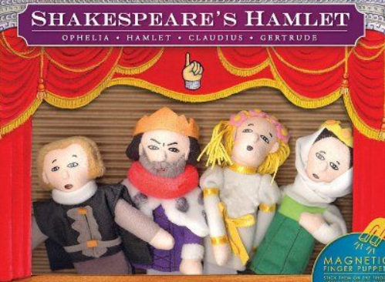  Create finger puppets to perform a famous scene from A Midsummer night’s dream! You could use lollipop sticks and paper or other materials to create the characters. | 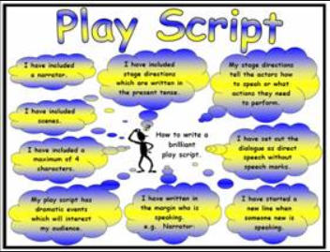  Write your own playscript!  This could be presented as a mini-book with a cast list and cover. Alternatively, you could present it as a script.

