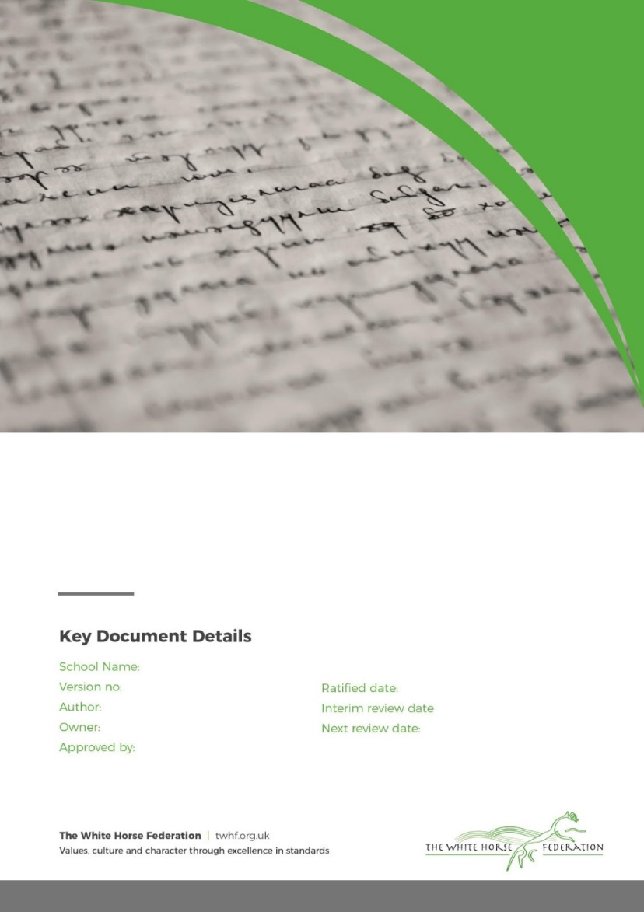

School Name: Haydon Wick Primary School

Version no: 1

Author: Lisa Davies

Approved by: Director of Education

Ratified by: Director of Education

**The White Horse Federation**

**Early Years Policy**

School:

Ratified date: July 2025

Interim review: July 2026

Next review date: July 2027

**Contents**

1. Aims 2

2. Legislation 3

3. Structure of the EYFS 3

4. Curriculum 3

5. Assessment 6

6. Working with parents and carers 7

7. Safeguarding and welfare procedures 8

8. Monitoring arrangements 9

Appendix 1. List of statutory policies and procedures for the EYFS 10

# **1. Aims**

This policy aims to ensure:

* That children access a broad and balanced curriculum that gives them the broad range of knowledge and skills needed for good progress through school and life
* Quality and consistency in teaching and learning so that every child makes good progress and no child gets left behind
* A close working partnership between staff and parents and/or carers
* Every child is included and supported through equality of opportunity and anti-discriminatory practice

# **Our TWHF Core Commitments: What Matters Most**

At Haydon Wick Primary School and The White Horse Federation, we are united by a shared ambition: *The Best Start in Life.*

Our eight EYFS Core Commitments are embedded to ensure that every child receives an equitable, high-quality early years offer. These commitments are not just statements; they are lived values that shape our daily practice and long-term vision.

Our Core Commitments:

1. A Nurturing, Inclusive Environment with a Strong Sense of Belonging
2. Exceptional Teaching, High-Quality CPD, and Meaningful Interactions
3. Oracy and Language-Rich Environments
4. Immersive Literacy and Numeracy: Books, Rhymes, Number and Storytelling
5. Child-Centred, Play-Based Learning
6. Equity for All Groups of Learners
7. Personal Development and Positive Behaviour Foundations
8. Strong Parent and Carer Partnerships

Across our school, we ensure that:

* Quality talk and meaningful discussion permeate every learning environment.
* Children are immersed in language-rich, playful experiences that support their communication, thinking, and creativity.
* A strong sense of belonging and community is nurtured—for both children and their families—so that every child feels safe, valued, and ready to thrive.
* Our staff team are empowered through high-quality CPD and collaboration, ensuring consistency and excellence in teaching and care.
* We foster equity, inclusion, and aspiration, giving every child the very best start in life.

# **2. Legislation**

This policy is based on requirements set out in the [statutory framework for the Early Years Foundation Stage (EYFS)](https://www.gov.uk/government/publications/early-years-foundation-stage-framework--2) for 2024.

# **3. Structure of the EYFS**

At the White Horse Federation, we have children from 2-5 years of age across our Early Years.

At Haydon Wick our EYFS setting is for children at reception age. We have a full reception class and a mix reception and year 1 class.

# **4. Curriculum**

4.1 Our early years follows the curriculum as outlined in the latest EYFS statutory framework, alongside our TWHF Early Years Common Curriculum.

The EYFS framework includes 7 areas of learning and development that are equally important and inter-connected. Three areas, known as the prime areas, are seen as particularly important for building children’s capacity to learn, form relationships and thrive.

The prime areas are:

* Communication and language
* Physical development
* Personal, social and emotional development

The prime areas are strengthened and developed, and children’s curiosity and enthusiasm are ignited, through 4 specific areas:

* Literacy
* Mathematics
* Understanding the world
* Expressive arts and design

Each area of learning and development is implemented through planned, purposeful play, and through a mix of adult-led and child-initiated activities.

4.2 TWHF ENRich Curriculum

At The White Horse Federation, we are committed to giving every child the best start in life. Our Early Years follows the TWHF ENRich curriculum from the age of 2-5. This ensures a consistent, high-quality offer across all our settings.

Language, Oracy and Literacy

We use the *Talk for Writing* approach across all EYFS age groups. This method supports children in developing their spoken language skills by encouraging them to orally rehearse sentences before writing them. Through this process, children build confidence, fluency, and a deeper understanding of sentence structure.

Each term, children are immersed in a carefully curated selection of high-quality texts. These include a mix of traditional tales and well-loved children’s classics. The chosen texts are not only engaging but also rich in vocabulary and storytelling techniques, helping to foster a genuine love of reading and storytelling.

Our curriculum is intentionally designed to be language-rich, ensuring that children are surrounded by meaningful vocabulary and expressive language throughout their day. This immersive environment helps to break down barriers to learning, enabling all children to access the curriculum and achieve well.

Phonics

Children follow their SSP in phonics, and the love of reading is further developed through the core text immersion, as well as book guides to help teachers reflect on key questions and tier 2 vocabulary when reading with their class . This approach ensures that children develop from the EYFS as confident emerging readers.

At Haydon Wick Primary School we believe that all our children can become fluent readers and writers. This is why we teach reading through *Little Wandle Letters and Sounds Revised,* which is a systematic synthetic phonics programme. We start teaching Little Wandle from Reception, we follow the [*Little Wandle Letters and Sounds Revised* progression,](https://www.littlewandlelettersandsounds.org.uk/wp-content/uploads/2021/12/Programme-Overview_Reception-and-Year-1-1.pdf) which ensures children build on their growing knowledge of the alphabetic code, mastering phonics to read and spell as they move through school. As a result, all our children are able to tackle any unfamiliar words as they read.

At Haydon Wick Primary School, we also model the application of the alphabetic code through phonics in shared reading and writing, both inside and outside of the phonics lesson and across the curriculum. We have a strong focus on language development for our children because we know that speaking and listening are crucial skills for reading and writing in all subjects.

We teach phonics for 30 minutes a day. In Reception, we build from 10-minute lessons, with additional daily oral blending games, to full-length lessons as quickly as possible. Each Friday, we review the week’s teaching to help children become fluent readers.

Children make a strong start in Reception: teaching begins in week 2 of the Autumn term.

Any child in Reception and Year 1 who needs additional practice has Daily Keep-up support and is taught by a fully trained adult.

Daily Keep-up lessons follow the Little Wandle progression and use the same procedures, resources and mantras, but in smaller steps with more repetition so that every child secures their learning.

We teach reading practice sessions three times a week. These sessions:

* + are taught by a fully trained adult to small groups of approximately six children
  + use books matched to the children’s secure phonic knowledge using the *Little Wandle Letters and Sounds Revised* assessments and book matching grids on pages 11 to 20 of ‘Application of phonics to reading’
  + are monitored by the class teacher, who rotates and works with each group on a regular basis.

Each reading practice session has a clear focus, so that the demands of the session do not overload the children’s working memory. The reading practice sessions have been designed to focus on three key reading skills:

* + decoding: teaching children to use phonic knowledge to read words
  + prosody: teaching children to read with understanding and expression
  + comprehension: using dialogic talk to help children to understand the text.

In Reception, these sessions start in week 4 of teaching at the latest. Initially, children will read wordless books. In these sessions, children review GPCs and are taught blending using teacher-led blending. Once children can blend, they progress onto decodable books matched to their secure phonic knowledge.

Children read each book three times to develop phonemic awareness, vocabulary and comprehension as well as book behaviours.

Mathematics

We follow our TWHF ENRich EYFS maths curriculum, ensuring children have a strong foundational knowledge of maths.

This is delivered through taught sessions and a number-rich learning environment where children can grow and develop their mathematical understanding.

Play Progressions

TWHF Play progressions have been produced to support effective play in the following 9 areas:

1. Small world
2. Construction
3. Role play
4. Malleable
5. Sand play
6. Water play
7. Mud kitchen play
8. Fine motor skills play
9. Stage, performance and drama

These are carefully constructed to take into account oracy, problem solving and language, alongside a child’s level of play.

4.3 Planning

We use carefully considered and well sequenced TWHF planning for :

* T4W
* Maths
* Continuous Provision Plans
* Book talk
* Play Progressions

TWHF continuous provision plans are carefully mapped out to enrich the stories and tales while still developing our children in all areas.

Our EYFS team also take into account the individual needs, interests, and stage of development of each child in their care, and use this information to plan a challenging and enjoyable experience. It is important that teachers use their baseline knowledge to also purposefully plan their provision to bridge any gaps and so that all children achieve well.

Enhanced provision is always inviting and stimulating, and carefully and well planned to support the needs or interests of the learners.

Where a child may have a special educational need or disability (SEND), staff consider whether specialist support is required, linking with relevant services from other agencies, where appropriate.

In planning and guiding children’s activities, staff reflect on the different ways that children learn and include these in their practice.

**4.3 Teaching**

Each area of learning and development is implemented through planned, purposeful play, and through a mix of adult-led and child-initiated activities. Staff respond to each child’s emerging needs and interests, guiding their development through warm, positive interaction.

At Haydon Wick, we recognise and value the fundamental role that learning environment plays in supporting and extending the children’s development. The reception classrooms’ indoor and outdoor area are well organised to allow children to explore and learn securely and safely.

As the children grow older, and as their development allows, the balance gradually shifts towards more adult-led activities to help the children prepare for more formal learning, ready for year 1.

# 5. Assessment

At The White Horse Federation, we use ongoing assessment as an integral part of the learning and development processes. Staff observe pupils to identify their level of achievement, interests and learning styles. These observations are used to shape future planning.

Staff also take into account observations shared by parents and/or carers.

Reception

Within the first 6 weeks thata child*starts reception*, staff will administer the reception baseline assessment (RBA).

We also complete our own TWHF baseline to support us understanding the needs of the children and help us plan purposeful provision.

In addition, all children will have a WELLCOM assessment when they start in Reception so we can identify any gaps in speech and language.

Phonics assessments are carried every six weeks to assess progress and to identify gaps in learning that need to be reviewed or retaught.

The assessment will establish if learning is secure for more than 70% of children before new content is taught. It also identifies any children needing additional support and to plan the Daily Keep-up support that they need. If a child is not on track, they are reassessed every three weeks.

*At the end of the EYFS*, staff complete the EYFS profile for each child. Pupils are assessed against the 17 early learning goals, indicating whether they are:

* Meeting expected levels of development
* Not yet reaching expected levels (‘emerging’)

The profile reflects ongoing observations, and discussions with parents and/or carers. The school shares the results of each child’s assessment with their parents and/or carers.

The profile is moderated internally (referring to the Development Matters [guidance](https://www.gov.uk/government/publications/development-matters--2)) and in partnership with TWHF schools, to ensure consistent assessment judgements. EYFS profile data is submitted to the local authority.

# 6. Working with parents and carers

We recognise that children learn and develop well when there’s a strong partnership between staff and parents and/or carers. This is why it is one of our TWHF Core Commitments for Early Years.

Parents and/or carers are kept up to date with their child’s progress and development. The EYFS profile helps to provide parents and/or carers with a well-rounded picture of their child’s knowledge, understanding and abilities.

In addition, we have regular:

- Stay and Play sessions

- Family celebration afternoons (such as Mother’s/Father’s Day, Grandparents Day)

- Workshops in phonics, storytime and mathematics

- Parent consultations twice a year.

# 7. Safeguarding and welfare procedures

We recognise that children learn best when they are healthy, safe and secure, when their individual needs are met and when they have positive relationships with the adults caring for them. We follow safeguarding and welfare requirements to provide a welcoming, safe and stimulating environment where children are able to enjoy learning and grow in confidence.

We follow guidance from KCSIE, as well as the EYFS Safeguarding Reforms:

[Early Years Foundation Stage safeguarding reforms - consultation response](https://assets.publishing.service.gov.uk/media/6705184530536cb927482dd6/Early_years_foundation_stage_safeguarding_reforms_-_response.pdf)

We make sure that the appropriate statutory staff:child ratios are maintained in our setting to meet the needs of all children and ensure their safety:

For Reception classes:

* + We comply with infant class size legislation and have at least 1 teacher per 30 pupils

When recruiting staff, we will follow the procedures set out in the latest EYFS framework guidance on checking the suitability of new recruits and recording information about staff qualifications and identity checks, vetting processes and references.

We have at least 1 person with a current paediatric first aid (PFA) certificate on the premises and available at all times when children are present, including on outings.

This PFA certificate is renewed every 3 years as required.

In addition, trainees, apprentices and students will hold a Level 2 Paediatric First Aid (PFA) certificate in order to be included in staff-to-child ratios, in line with EYFS statutory requirements.

We also have a designated lead practitioner who is responsible for safeguarding children. They are also responsible for:

* Liaising with local statutory children's services agencies, and with the LSP (local safeguarding partners)
* Providing support, advice and guidance to any other staff on an ongoing basis, and on any specific safeguarding issue as required
* Attending a child protection training course that enables them to identify, understand and respond appropriately to signs of possible abuse and neglect

All practitioners are alert to any issues of concern in children’s life at home or elsewhere.

7.1 Oral health and tooth brushing

We promote good oral health, as well as good health in general, in the early years by talking about the effects of eating too many sweet things and the importance of brushing your teeth. This is taught during our Healthy Me unit using the Jigsaw scheme and throughout the year.

The rest of our safeguarding and welfare procedures are outlined in our school’s child protection and safeguarding policy, which can be found here [Policies & Procedures | Haydon Wick Primary School](https://haydonwick.swindon.sch.uk/about-us/school-information/policies-procedures)

# 8. Monitoring arrangements

This policy will be reviewed and approved by Lisa Davies, Executive Headteacher every two years.

This policy will also be reviewed accordingly by the school’s headteacher and EYFS Lead.

At every review, the policy will be shared with the school’s governing board.

# 

# Appendix 1. List of statutory policies and procedures for the EYFS

This isn’t an exhaustive list of policies and only includes policies specific to the EYFS. For a full list of our policies, see [Policies & Procedures | Haydon Wick Primary School](https://haydonwick.swindon.sch.uk/about-us/school-information/policies-procedures)

| Statutory policy or procedure for the EYFS | Where can it be found? |
| --- | --- |
| Safeguarding policy and procedures | See child protection and safeguarding policy |
| Procedure for responding to illness | Attendance and absensce policy  Supporting children with medical conditions policy. |
| Administering medicines policy | See supporting pupils with First Aid Policy |
| Emergency evacuation procedure | (Not online) |
| Procedure for checking the identity of visitors | See child protection and safeguarding policy |
| Procedures for a parent/carer failing to collect a child and for missing children | See child protection and safeguarding policy |
| Procedure for dealing with concerns and complaints | See complaints policy |
| Intimate Care | See Intimate Care Policy |

Please also refer to our school’s handbook for more information about your school. This will be given out during inductions or available at the school office.