 | The White Horse Federation  Haydon Wick Primary School |  | 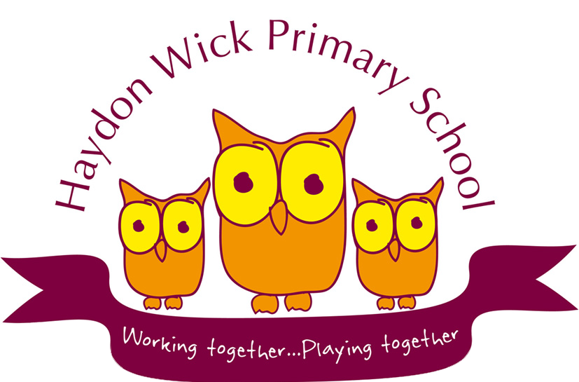
Pupil Name: ____________________ | HOME-SCHOOL-PUPIL AGREEMENT 2024-2025
Every school within The White Horse Federation will work in close partnership with children and their families in sharing responsibility for their learning, wellbeing, behaviour and safety. We believe in the unlimited potential of every child. Through working together as a partnership with children and their families we will unleash the potential in each individual, enabling every child to achieve their best and to be the best version of themselves all of the time.

School  We will:  - Uphold our 3 core values of respect, Responsibility and Resilience.  - Ensure all children are safe and secure during school time and that we provide a caring and stimulating environment where each child feels always valued as an individual.  - Encourage and support your child to achieve their full potential in all they do.  - Keep you informed about school news and your child’s progress.  - Provide a broad, balanced and exciting curriculum for all children in line with the National Curriculum and RE guidelines.  - Inform you what your child will be learning each term.  - Let you know early on if there are any concerns or problems that affect your child’s work or behaviour and to meet with parents to discuss any concerns.  - Treat everyone as an individual. We will care for your child as a valued member of the school community, irrespective of gender, race or religion.  - Encourage all children to understand the importance of being part of a school community. We will support them to take responsibility for themselves, each other and their school environment.  - Set high standards and provide a good, high-quality education for your child which provides high-quality teaching and learning opportunities which will support the individual needs of your child to enable them to thrive. | Pupil  I will:  - Uphold and demonstrate our core values in my behaviour, learning, attitude and interactions with others.  - Follow school rules and The Haydon Wick Way at all times.  - Listen to others.  - Respect other people and the differences between us and care about others’ feelings.  - Try my best in all I do and allow others to do their best too.  - Compete my school and homework as well as I can.  - Behave well in school, when travelling to and from school-on-school trips and activities. I understand and accept that the school will take action if I make poor choices.  - Take pride in and good care of our school environment and equipment.  - Make sure I am smartly dressed in my school uniform each day and I am ready to learn.  - Let my teachers or parents know if I have a problem.  - Use the internet safely as I have been taught in school. | Parents/Carers  I/We will:  - Positively support the school, embrace our core values, and encourage our child to always uphold these.  - Read with our child at home in line with school policy.  - Encourage our child to always do their best, including supporting them with any homework.  - Encourage our child to behave well in line with the school policy and follow The Haydon Wick Way at all times. I/We understand that poor choices which contravene our behaviour policy will result in consequences.  - Make sure our child is smartly dressed in the schools’ active uniform each day.  - Make sure my child arrives on time and with the necessary items.  - Collect my child on time. We will notify the school if we are unexpectedly delayed.  - Make sure my child has good attendance. We will provide an explanation before the start of the school day if our child is absent.  - Tell the school of any problems that might affect my child’s work, behaviour, health or happiness.  - Raise any concerns with a member of staff when we have them instead of speaking to others or posting on social media.  - Attend parent/teacher consultations to discuss my child’s progress and attend special school events where possible.  - Ensure that the school has up-to-date information for emergency contacts as well as making sure the school is informed of any end of day child collection arrangements.  - Take advantage of the opportunities offered by the school to learn about the teaching and learning in school.
Please sign to confirm you have read and understood the appropriate statements and agree to abide by them.
Signed Parent/Carer:  Print Name: | Signed:  Headteacher: | Signed Pupil:
Date Agreed: WB: 04.02.25

