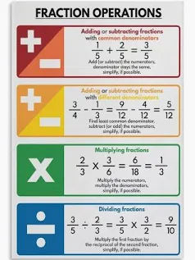
+
Research about the Mayans, tea-stain a piece of paper and create your own ‘old’ Mayan themed artwork.

Create a maths poster, showing the rules when adding and subtracting fractions. This could also be in a leaflet!

Pig Heart Boy: Write and design the front cover of a newspaper, with images and an article explaining the shocking story of Cam and his life-changing surgery.

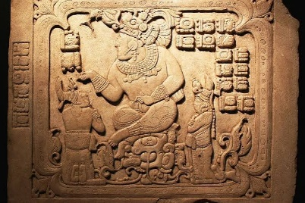

In Science, we are going to be learning about Evolution. Create a piece of artwork, showing the stages of the evolution of humans!

In PE, we will be focusing on yoga.
Keep a yoga diary for a week, the timings you did the yoga, how you felt before and how you felt afterwards.

Jaguar and Tiger Class
Pick and Mix Homework
Term 2
Remember you MUST do 2/3 of the activities
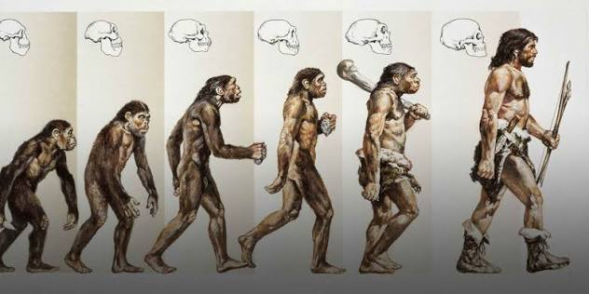

Essential Homework To be done EVERY DAY!
Read for 10 minutes
Learn and practise your spellings on Purple Mash.
Pracitse your times tables on TTRS.
DT – We will be making waistcoats this term. Grab an old piece of fabric from home and demonstrate and practice different types of stitching!

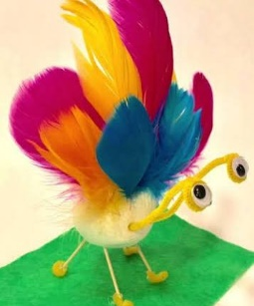
Science – create your own creature using craft materials. This could be a real creature, or something futuristic that an animal could look like in the future!

All work to be returned by Monday 14th December 2026

