What 2D and 3D shapes can you see around your home? Outside on a walk?
Can you sort the objects into the different shapes i.e. circle, square, triangle, rectangle or sphere, cube, cuboid, pyramid.
Can you use your new knowledge of adjectives to write a character description of your favourite character from a book, film or TV show?
All work to be returned on
Friday 8th December please
Create a winter wonderland picture. You can use any materials you like! Glitter, cotton wool, chalk, paint etc.

Year One
Pick and Mix Homework
Term 2

Create a poster/PowerPoint to tell us all the facts that you know about the winter season.

Look around your house and write/draw a list of household objects and the materials with which they are made.
e.g. A chair is made from plastic and metal.

Skills to practice EVERY DAY!
Read for 10 minutes.
Practise your old and new phonics sounds - keyring
Practise your new spellings - book
Practise your tricky words - sheet

Research Guy Fawkes and bonfire night and create a piece of firework art!
Can you show us your knowledge of the UK - the countries and capital cities? You can present it however you like.

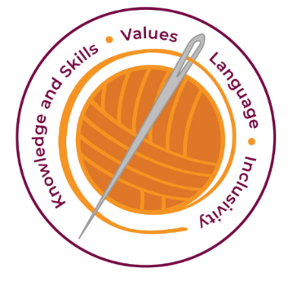
Year One Homework: Pick and Mix Home Learning

At Haydon Wick, we have four golden threads, which are woven through all we do and all the teaching decisions we make.
We are a values-based school, and we have 22 core values we focus on but at the heart of our values we have the 3R’s –
Respect, Resilience and Responsibility.
With these golden threads and core values at the heart of everything we do, we have considered our homework and have developed a clear plan of our expectations for the year 2023 – 2024.
Weekly Expectations in Frogs Class
Each week we expect the children to:
- Read to an adult at least 3 times a week and record this in the reading record.
- Practise phonics sounds at least 3 times a week.
- Play on NUMBOTS at least once a week – log in is in the back of your child’s reading record.
Practising reading and playing on NUMBOTS will help develop our children in English and Maths and help them to become lifelong learners, who have the skills knowledge, and curiosity needed to take full advantage of every opportunity in life. Talking about their reading or having discussions about spellings and their meanings or how they can be used in sentences will help ensure our children’s language is developed.
Pick and Mix Homework
At Haydon Wick, we also set Pick and Mix homework once a term. We aim to send these out before the holidays or in the first week of the new term to ensure sufficient time to complete it. We believe this homework enriches our children allowing them to gain further knowledge of the topics in school. We feel that the pick and mix style homework is inclusive as it allows every child to achieve and demonstrate their own potential and gives children responsibility in choosing the homework style which suits them best.
We expect ALL children to complete at least one of the activities from the pick and mix offer. Children are responsible for making sure that the work they complete at home is consistent to the work we see from the child in class. We want everyone to try their best.
We hope you all understand our vision for homework. We look forward to seeing wonderful work from the children this year and sharing this with all our parents.

Please bring your completed homework to school on Friday 8th December Parents are welcome to join us in our classroom from 3pm on Monday 11th December to celebrate the children’s wonderful home learning.

