In writing, we are always trying to build our vocabulary. Find the meaning of 10 words you didn’t know before, and make a one-page thesaurus.
In PSHE, our focus is ‘Dreams and Goals’. Can you try and make a dream catcher, with different dreams on the end of each piece of string?
Year 5 will be focusing on long multiplication and division.
Year 6 will be finishing their fractions unit.
Can you create a step-by-step poster to help other children remember the steps for these skills?

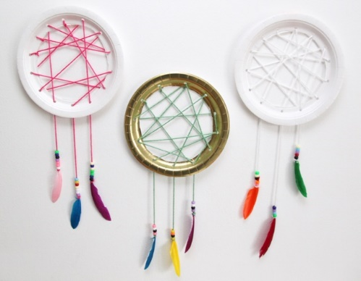

In Geography, we will be looking at the area surrounding our school. Can you look at our school area on Google Maps and then draw and label your own map?

Jaguars and Tigers Class
Pick and Mix Homework
Term 3
Remember you don’t need to do all 6!

In Science, we are going to be looking at different materials.
Can you use 3 different materials to create a vase of flowers for the classroom?

Essential Homework To be done EVERY DAY!
Read for 10 minutes
Learn and practise your spellings,
Practice your times tables and use maths rockstars

In Art, we will be looking at different activism artists. Can you research your own and create a fact file about their life and their artwork?
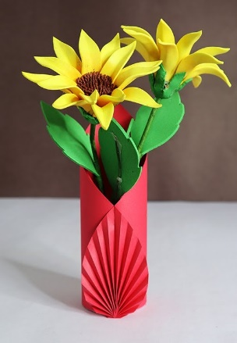

All work to be returned by 2nd February please!

